

User Interface Design | 23CSE113
LAB MANUAL

Submitted to
Name | Dr. Rajkumar Batchu
Department | CSE
Designation | Assistant Professor
Submitted by
Name | Paidi Bala Bhaskar
Roll No | av.sc.u4cse25137
Year/Sem/Section | 1st year | sem-2 | cse-B

INDEX
S. No | Title | Page No. | Remarks
1. | WEEK-1  a) To understand the installation process of a VS code and get familiar with its environment for web development  b) To learn the basic structure of an HTML document and create a simple webpage using headings and paragraphs.  c) To understand and implement basic HTML tags such as image, hyperlink, text formatting, and inline styling to design a simple webpage. | 5-12
2. | WEEK-2  a) To design a simple web page using HTML that demonstrates the use of background color, background image, heading styling, and preformatted text.  b) To create a static webpage using only HTML that displays basic information about Amrita Vishwa Vidyapeetham, including a heading, descriptive text, background styling through HTML attributes, and a table showing the list of campuses in different states.  c) To design a restaurants menu webpage using HTML and displaying menu items in a table format with proper layout and visual styling. | 13-18
3. | WEEK-3  a) To design and develop an academic timetable using HTML tables by applying row span, column span, and styling for proper structure and presentation.  b) To create a comprehensive webpage that includes an academic timetable along with syllabus representation using images and structured HTML elements. | 19-30
4. | WEEK-4  a) To understand the concept of forms and design a structured student registration form using HTML tables, including various input types such as text fields, radio buttons, checkboxes, file upload, and dropdown lists.  b) To understand the concept of forms and design user login and registration webpages using HTML, and to display them within a single interface using iframe for better layout and user interaction. | 31-36
5. | WEEK-5  a) To create a responsive card layout using HTML and CSS with three cards, each containing an image, title, and button.  b) To design a mini website using iframe with navigation links (Home, About, Contact), where clicking on each link displays the respective content within the same page using internal or external CSS.  c) To design an Amrita login page using HTML and CSS that displays different campuses, where clicking on each campus shows its details on the same page. | 37-42
6. | WEEK-6  a) Design a responsive e-commerce application using the grid layout. This application should contain different categories of products such as electronics, clothing, home-appliances, books. Based on the category we select corresponding products should be displayed on the sidebar. | 44-48
7. | WEEK-7  a) Saving codes in GitHub | 48-53
8. | WEEK-8  a) to create a webpage that displays a square that continuously rotates 360 degrees using CSS Animation.  b) to create a webpage that displays a ball that moves up and down continuously using CSS Animation.  c) to create a webpage that displays a circle that moves horizontally and rotates at the same time. | 54-61
9. | WEEK-9  a) to create a webpage that displays weather a number is even/odd or prime/composite or factorial of the number and is Armstrong number or not with HTML, CSS, JS. | 62-67
10 | WEEK-10  a) write a Java script conditional statement to find the sign of product of three numbers using function. Display an alert box with specific sign  b) To Sort 3 number using functions. Display on alert box to show the result.  c) To find the biggest of 5 numbers.  d) To lterate the form 0 to 15, for each iteration to check if the current number is odd or even, and display the message to the screen.  e) To write a JS program to read 6 subject marks of a student and then compute the average marks of the student. Then the average is used to determine the corresponding grade.  f) stylesheet for a, b, c, d, e. | 68-79
11 | WEEK-11  a) A website requires users to enter a username. The system should display a message while typing if the username is less than 5 characters  b) A registration form should validate email format before submission. If invalid, the form should not be submitted.  c) A system should check password strength while typing and display whether it is weak or strong.  d) A form should validate a mobile number when the user leaves the input field. The number must be exactly 10 digits.  e) Design an HTML page, such that the registration form must validate:  Name (not empty)  Email (valid format)  Password (minimum 6 characters) | 80-97
12 | WEEK-12  Downloading Node.js and installing electron | 98-101

WEEK | 1

1.Aim: To Download and Install VS code
Procedure:

Step-1: Visit the official VS code website to get the downloadable file.

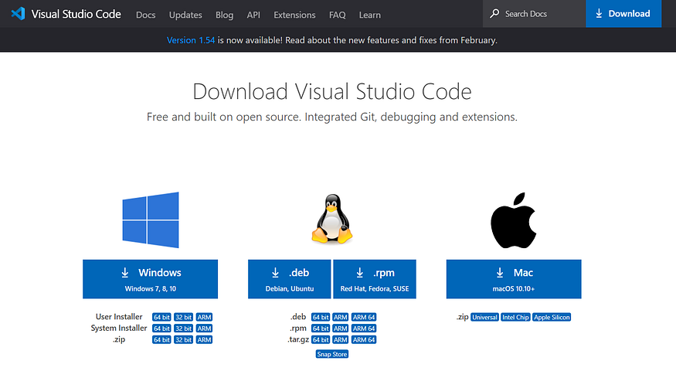

Step-2: Click on the download Option based on the Operating system.

Step-3: Click on the downloaded file to Install.

Step-4: Accept the agreement and click on “Next”.
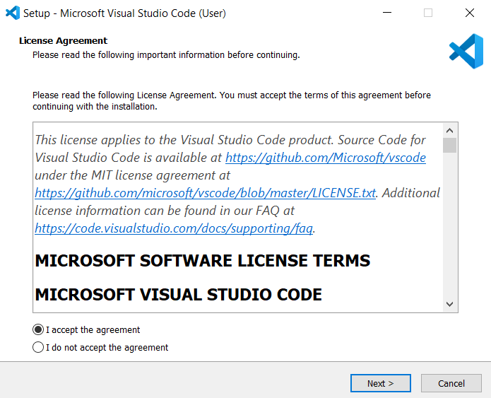

Step-5: Select a folder. Click “Next”.
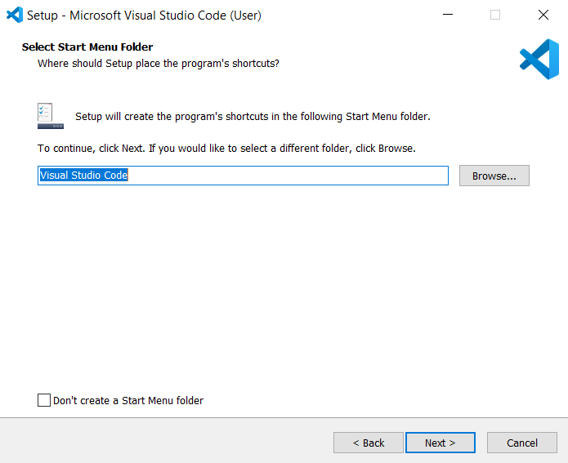

Step-6: Select the required options and click “Next”.
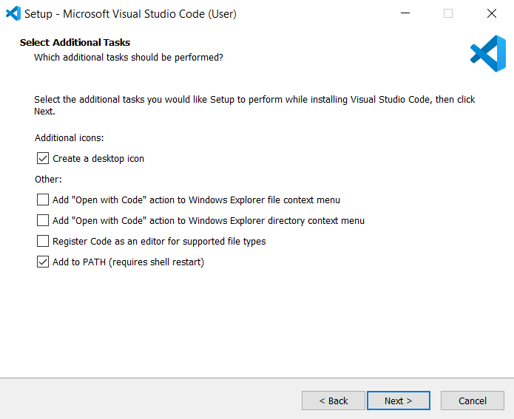

Step-7: Select “Install”.

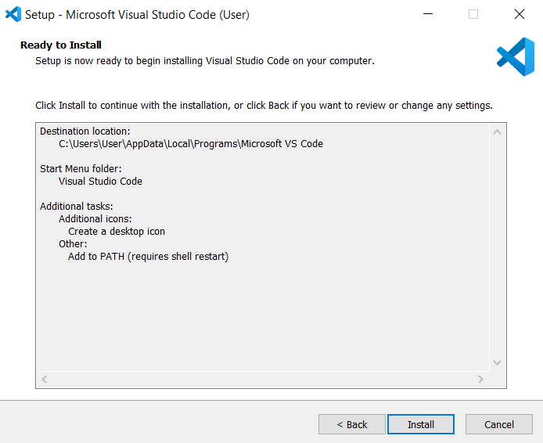
Step-8: Click “Finish” after installing successfully.

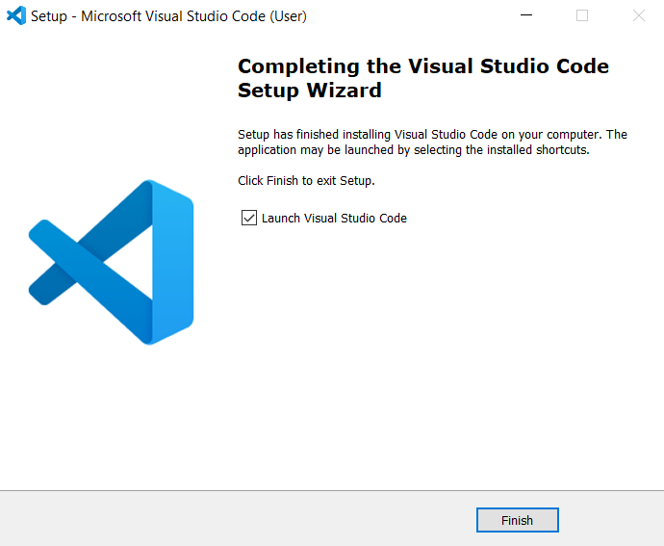

Step-9: Open VS code and go to Extensions tab on the left side panel, search for “Open in browser” extension and download that extension.
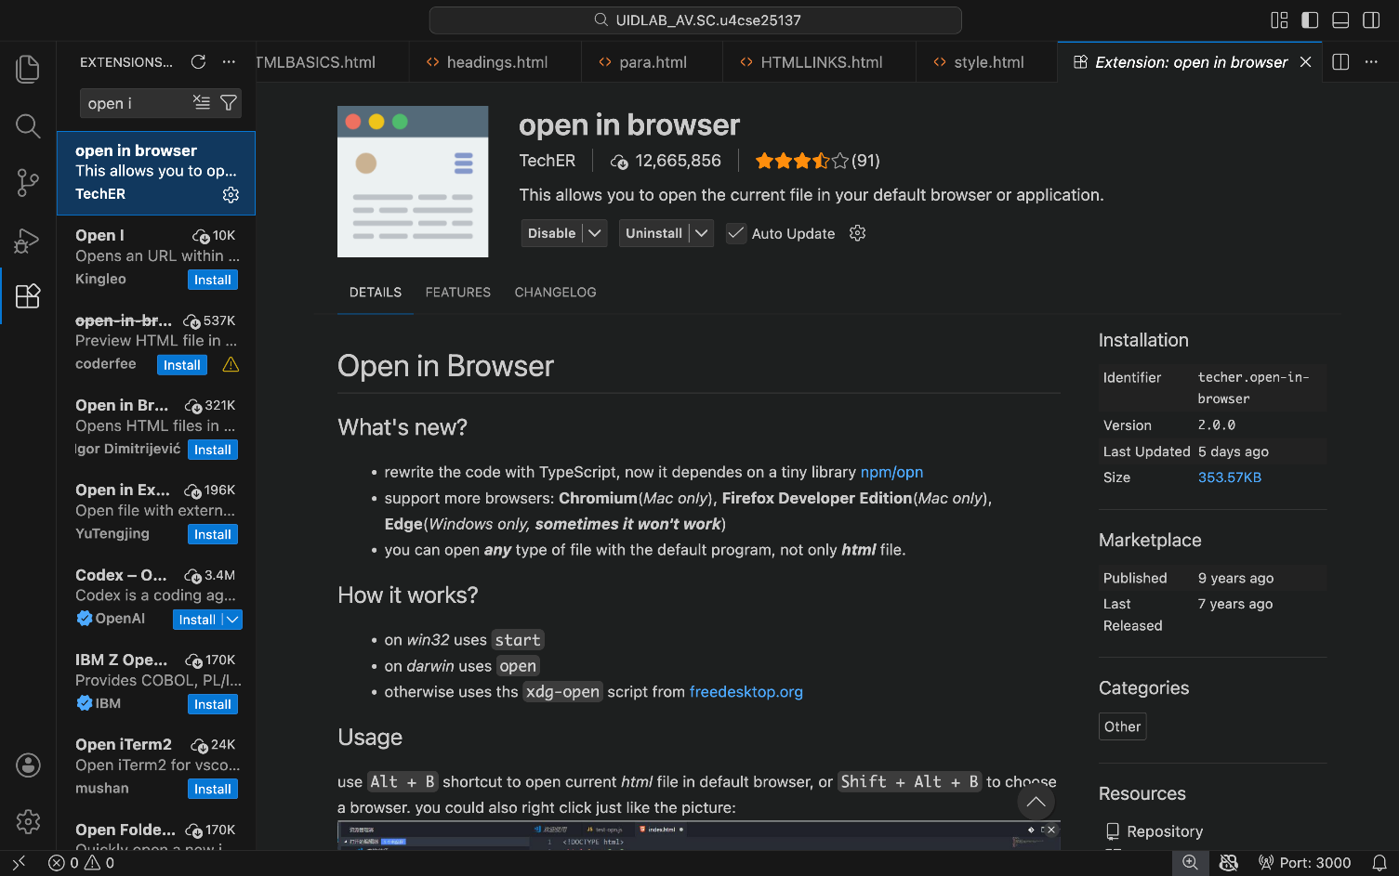

2.Aim: To understand the structure of HTML
Program:
Input:
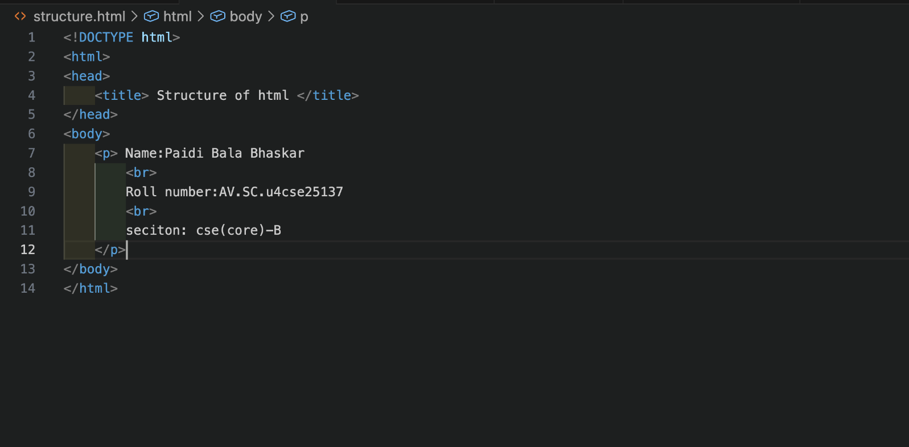
Output:
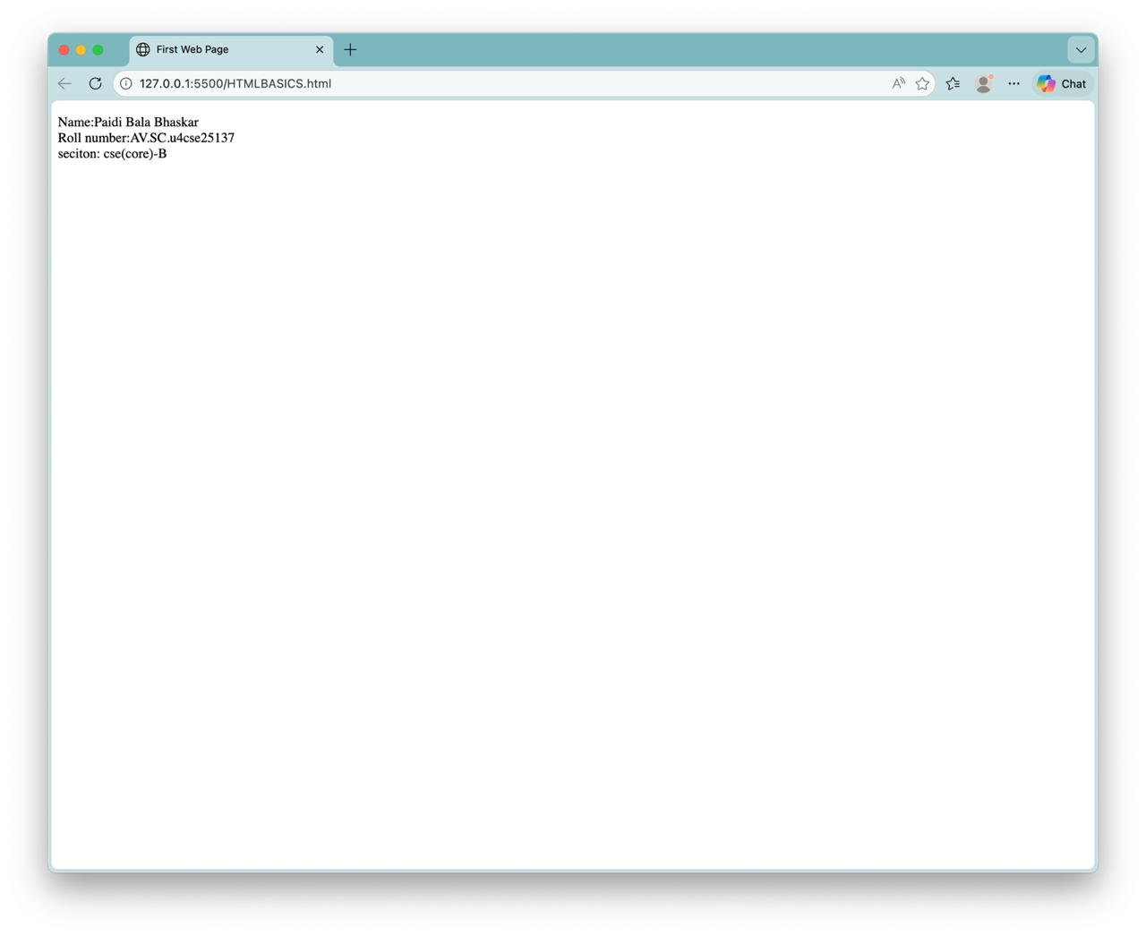

Explanation:
<!DOCTYPE html>
This tells the browser that the document is written in HTML5.

<html></html>
This is the main element of the HTML document.
Everything on the webpage goes inside this tag.

<head></head>
The head section contains meta information about the page.
Things here are not shown directly on the webpage.
This contains information that is applied to whole webpage like images or colour to the web page.

<title></title>
Sets the title of the webpage.
This text appears on the Browser tab.

<body></body>
This is the visible part of the webpage.
Everything the user sees (text, images, buttons, forms, etc.) goes here.
3.Aim: To understand the basic html tags
Program:
Input:
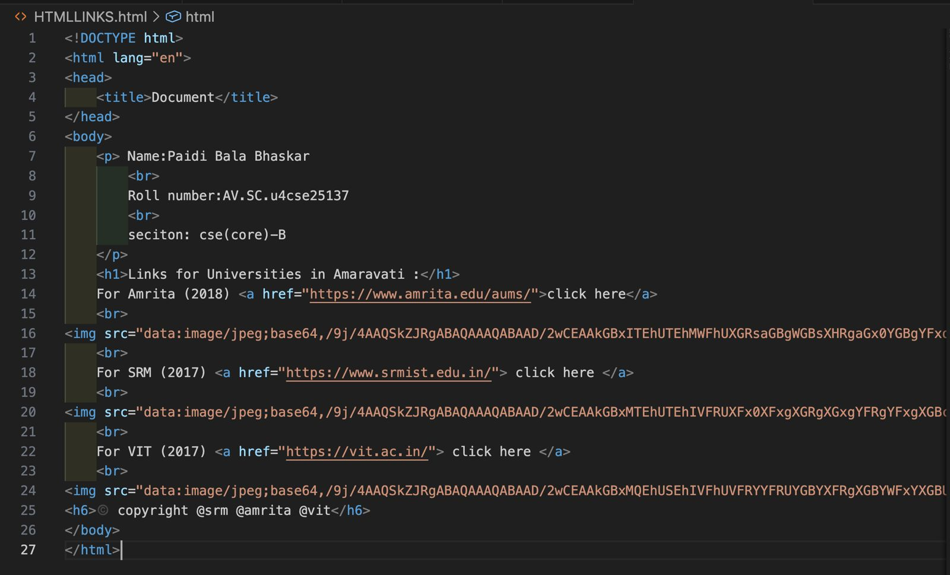
Output:
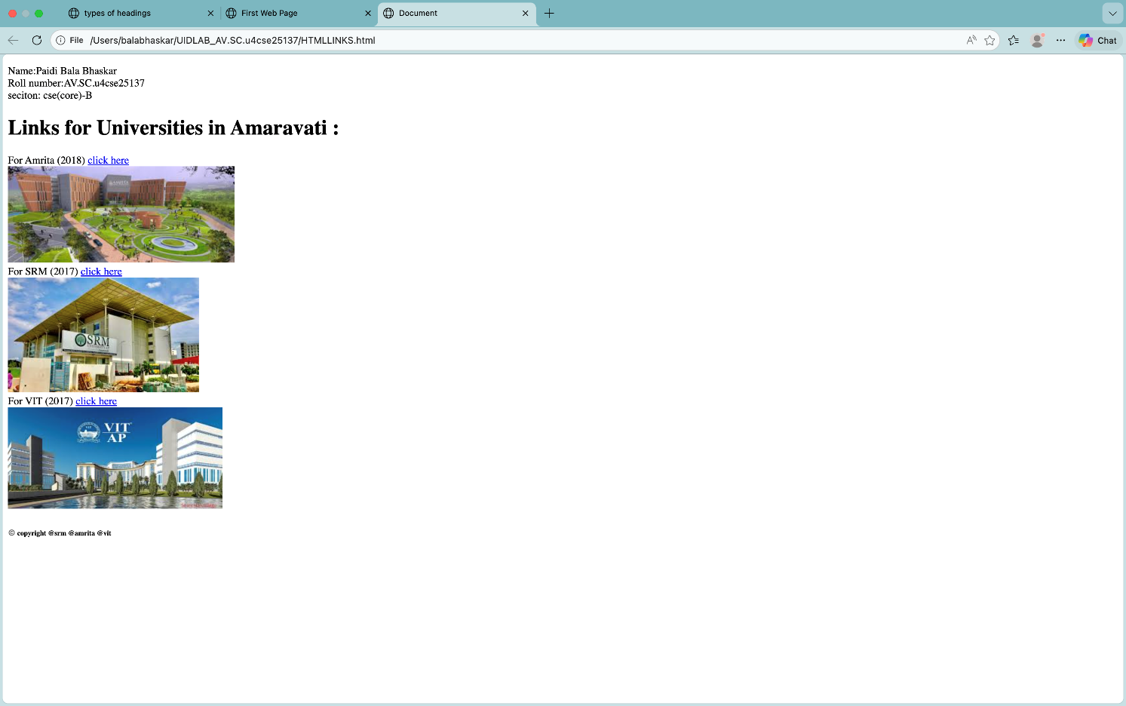

Explanation:

<h1></h1>
It Is Heading tag.
There are total of 6 heading tags from h1 to h6, h1 is highest and h6 is smallest.
Used for main titles of a page.

<p></p>
Paragraph tag.
Used for normal text content.
Any extra spaces than 1 space is removed automatically in-between sentence.

<a href=""></a>
Anchor tag → used to create links.
href = Hypertext Reference (link address).

<br>
It is Line break tag.
Moves content to the next line.
It has no closing tag.

<img>
Used to display images.
“src” attribute contains source of image (image URL).
“alt” attribute contains alternate text to display if image is not displayed.
“width” and “height” attributes of the image are also passed into this tag.

WEEK-2

2(A) Aim:
To design a simple web page using HTML that demonstrates the use of
background color, background image, heading styling, and preformatted text.
Input:
1. <!DOCTYPE html>
2. <html style="background-color:rgb(210, 181, 238);">
3. <head>
4. <title>styling</title>
5. </head>
6. <body>
7. <p> Name:Paidi Bala Bhaskar
8. <br>
9. Roll number:AV.SC.u4cse25137
10. <br>
11. seciton: cse(core)-B
12. </p>
13. <h3 style ="font-size: medium ;color: rgb(245, 252, 252); background-color: rgb(120, 73, 164) ; text-align: center; padding: 50px;"> The Style Atribute</h3>
14. <p style="font-style: italic; background-color: rgb(250, 252, 253);text-align: center;">The HTML style attribute provides inline styling for individual HTML elements using CSS property-value pairs. It overrides styles set in external stylesheets or style tags, offering a way to quickly format elements like colors or fonts directly within the tag, although it is considered bad practice for large, maintainable works.
15. </p>
16. <img src="https://encrypted-tbn0.gstatic.com/images?q=tbn:ANd9GcQUJ9wI7Fhdh15zWy_9Ay-dmjoP_fzod72pBg&s">
17. <pre>Inline Styling: The style attribute applies CSS rules directly within the element's opening tag,
18. making the styles specific only to that element.
19. Syntax: The value of the attribute is one or more
20. CSS property: value; pairs, separated by semicolons.
21. Precedence: Inline styles have high priority and will override styles set in an internal
22. style sheet or an external style sheet, unless !important is used in the external/internal CSS.
23. Global Attribute: It can be used on any HTML element, such as etc..
24. </pre>
25. <p style="color:blue;background-color: aliceblue;text-align: center;">
26. html
27. style="color: blue; font-size: 16px; background-color: lightgray;">
28. </p>
29. <h6>(This is a paragraph with inline styles.)
30. </h6>
31. </body>
32. </html>
33.

OUTPUT
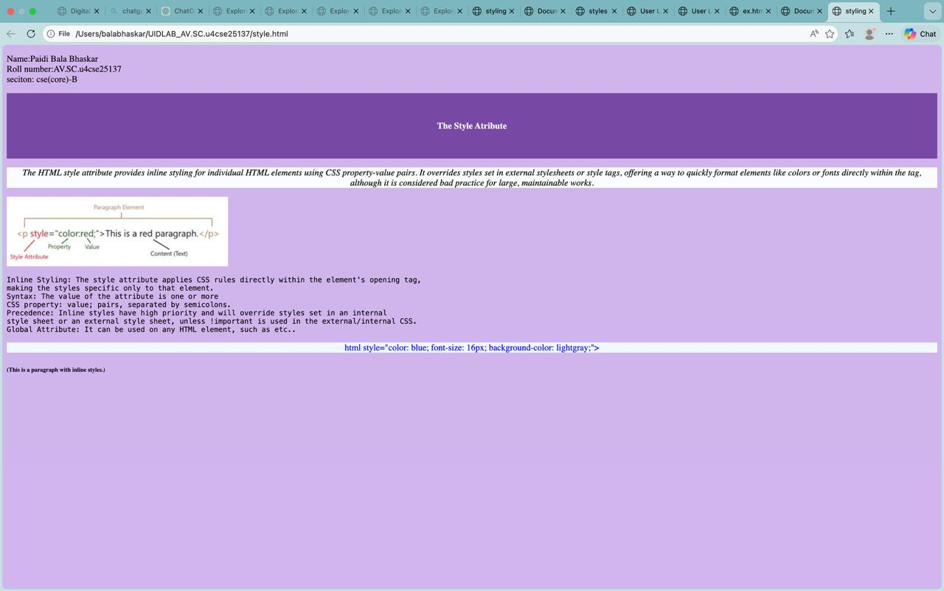

Explanation:
This HTML code demonstrates the use of inline styling using the style attribute in HTML. The webpage sets a background color for the entire page and displays personal information such as name, roll number, and section. Different elements like headings and paragraphs are styled using CSS properties such as color, font size, text alignment, padding, and background color directly within the HTML tags. An image is also included, and the <pre> tag is used to display formatted text while preserving spaces and line breaks. Overall, the page shows how the style attribute can be used to apply quick formatting to individual HTML elements.

2(B) Aim:
To create a static webpage using only HTML that displays basic information about Amrita Vishwa Vidyapeetham, including a heading, descriptive text, background styling through HTML attributes, and a table showing the list of campuses in different states
Program:
Input:
1. <!DOCTYPE html>
2. <html style="background-image: url(https://www.qschina.cn/sites/default/files/profiles-slideshow/amrita-vishwa-image-1.jpg); background-size: cover; background-repeat: no-repeat;">
3. <head>
4. <title>styles</title>
5. </head>
6. <body>
7. <h2 style="text-align: center; color:white; border: 0.8px solid rgb(254, 252, 252);background-color: rgb(194, 49, 100);border-radius: 10px;font-family:'Segoe UI', Tahoma, Geneva, Verdana, sans-serif;">
8. AMRITA VISHWAVIDYAPEEETHAM
9. </h2>
10. <pre style="font-style: italic;font-size:medium;color:rgb(0, 0, 0);font-family: Georgia, 'Times New Roman', Times, serif;text-align: center; background-color: aliceblue;">
11. <br>
12. Amrita Vishwa Vidyapeetham is a top-ranked, multi-campus private university in India, accredited with an A++ grade by NAAC.
13. Elite Rankings: Consistently ranked among India's top 10 universities by NIRF (8th in 2025) and placed among the top 50 globally in the Impact Rankings 2025.
14. Expansive Network: Operates across 10 campuses in six states, including Coimbatore (headquarters), Bengaluru, Kochi, and Faridabad.
15. Diverse Programs: Offers over 300 undergraduate, postgraduate, and doctoral programs in fields like Engineering, Medicine, Management, and Ayurveda.
16. Research Focus: A research-intensive institution with over 150 patents granted and partnerships with nearly 290 funded projects.
17. Strong Placements: Maintains a high placement rate, with a 92% success rate in 2024 and average packages around ₹9.08 LPA for engineering graduates.
18. <br>
19. </pre>
20. <br>
21. <br>
22. <br>
23. <table cellpadding="10" cellspacing="0" width="60%" align="center" bgcolor="#C23164" style="color: aliceblue;border-radius: 20px;">
24. <tr style="background-color: white; border-radius: 20px;color: rgb(194, 49, 100) ;">
25. <th>S.No</th>
26. <th>Branches</th>
27. <th>location</th>
28. <th>established(year)</th>
29. <th>customercare</th>
30. <tr>
31. <td>1</td>
32. <td>coimbatore</td>
33. <td>Ettimadai,Coimbatore,Tamil Nadu</td>
34. <td>1994</td>
35. <td>tel:914222685000</td>
36. </tr>
37. <tr>
38. <td>2</td>
39. <td>amritpuri</td>
40. <td>Amritpuri,Kollam,Kerala</td>
41. <td>2002</td>
42. <td>tel:4762801280</td>
43. </tr>
44. </table>
45. </body>
46. </html>
47.

Output
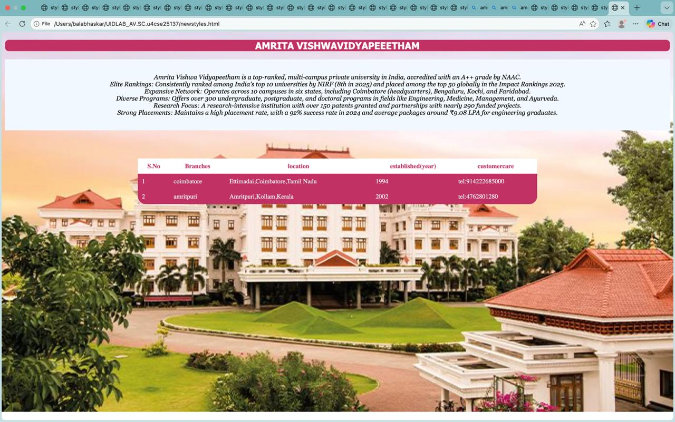

Explanation:
This HTML code creates a simple webpage about Amrita Vishwa Vidyapeetham using inline CSS styling. The page sets a background image that covers the entire screen and displays a styled heading with a colored background, border, and centered text. A <pre> element is used to present information about the university, including its rankings, campuses, programs, research activities, and placement statistics, while preserving the formatting of the text. The page also includes a table that lists details of some Amrita campuses such as their location, year of establishment, and contact information. Overall, the webpage demonstrates the use of inline styles, background images, formatted text, and tables to organize and present information visually.

2(C) Aim:
To design a restaurants menu webpage using HTML and displaying menu items in a table format with proper layout and visual styling.
Program:
Input:
1. <!DOCTYPE html>
2. <html>
3. <head>
4. <title>Our Restaurant Menu</title>
5. </head>
6. <body style="font-family: 'Segoe UI', Tahoma, Geneva, Verdana, sans-serif; background-image: url('https://wallpapercave.com/wp/wp5021690.jpg'); background-size: cover; background-position: center; background-attachment: fixed; color: #f8f9fa; margin: 0; padding: 40px 20px; text-align: center;">
7.
8. <div style="position: fixed; top: 20px; left: 20px; border-radius: 15px; padding: 20px; box-shadow: 0 4px 8px rgba(0,0,0,0.1); background-color:black; border: 1px solid red; font-family: sans-serif; display: inline-block; line-height: 1.6; color:white;">
9. <p style="margin: 0;">
10. <b>Name:</b> Paidi Bala Bhaskar<br>
11. <b>Roll Number:</b> AV.SC.u4cse25137<br>
12. <b>Section:</b> CSE(Core)-B
13. </p>
14. </div>
15.
16. <h1 style="color:red ; background-color: rgba(20, 20, 20, 0.85); font-size: 40px; border: 2px solid red; border-radius: 15px; width: 100%; max-width: 700px; margin: 0 auto 30px auto; padding: 10px 0; box-sizing: border-box; text-shadow: 1px 1px 4px rgba(0,0,0,0.5);">
17. Bistro Delights
18. </h1>
19.
20. <table style="width: 100%; max-width: 700px; margin: 0 auto; background-color: rgba(20, 20, 20, 0.85); border-radius: 15px; overflow: hidden; box-shadow: 0 12px 24px rgba(0, 0, 0, 0.6); border-spacing: 0;">
21. <th>
22. <tr>
23. <th style="background-color:red; color: #141414; padding: 15px 20px; text-align: left; font-size: 20px;">Item Name</th>
24. <th style="background-color:red; color: #141414; padding: 15px 20px; text-align: left; font-size: 20px;">Description</th>
25. <th style="background-color:red; color: #141414; padding: 15px 20px; text-align: right; font-size: 20px;">Price</th>
26. </tr>
27. </th>
28. <tb>
29. <tr>
30. <td style="padding: 15px 20px; border-bottom: 1px solid rgba(255, 255, 255, 0.15); text-align: left; color: #ffffff;"><strong>Garlic Bruschetta</strong></td>
31. <td style="padding: 15px 20px; border-bottom: 1px solid rgba(255, 255, 255, 0.15); text-align: left; color: #cccccc;">Toasted baguette topped with fresh tomatoes and basil.</td>
32. <td style="padding: 15px 20px; border-bottom: 1px solid rgba(255, 255, 255, 0.15); text-align: right; font-weight: bold; color: #fca311; font-size: 20px;">$8.50</td>
33. </tr>
34. <tr>
35. <td style="padding: 15px 20px; border-bottom: 1px solid rgba(255, 255, 255, 0.15); text-align: left; color: #ffffff;"><strong>Grilled Salmon</strong></td>
36. <td style="padding: 15px 20px; border-bottom: 1px solid rgba(255, 255, 255, 0.15); text-align: left; color: #cccccc;">Wild-caught salmon with a lemon butter sauce.</td>
37. <td style="padding: 15px 20px; border-bottom: 1px solid rgba(255, 255, 255, 0.15); text-align: right; font-weight: bold; color: #fca311; font-size: 20px;">$24.00</td>
38. </tr>
39. <tr>
40. <td style="padding: 15px 20px; border-bottom: 1px solid rgba(255, 255, 255, 0.15); text-align: left; color: #ffffff;"><strong>Mushroom Risotto</strong></td>
41. <td style="padding: 15px 20px; border-bottom: 1px solid rgba(255, 255, 255, 0.15); text-align: left; color: #cccccc;">Creamy arborio rice with wild mushrooms and parmesan.</td>
42. <td style="padding: 15px 20px; border-bottom: 1px solid rgba(255, 255, 255, 0.15); text-align: right; font-weight: bold; color: #fca311; font-size: 20px;">$18.50</td>
43. </tr>
44. <tr>
45. <td style="padding: 15px 20px; border-bottom: none; text-align: left; color: #ffffff;"><strong>Tiramisu</strong></td>
46. <td style="padding: 15px 20px; border-bottom: none; text-align: left; color: #cccccc;">Espresso-soaked ladyfingers with mascarpone cream.</td>
47. <td style="padding: 15px 20px; border-bottom: none; text-align: right; font-weight: bold; color: #fca311; font-size: 1.1rem;">$9.00</td>
48. </tr>
49. </tb>
50. </table>
51.
52. </body>
53. </html>
54.

OUTPUT:
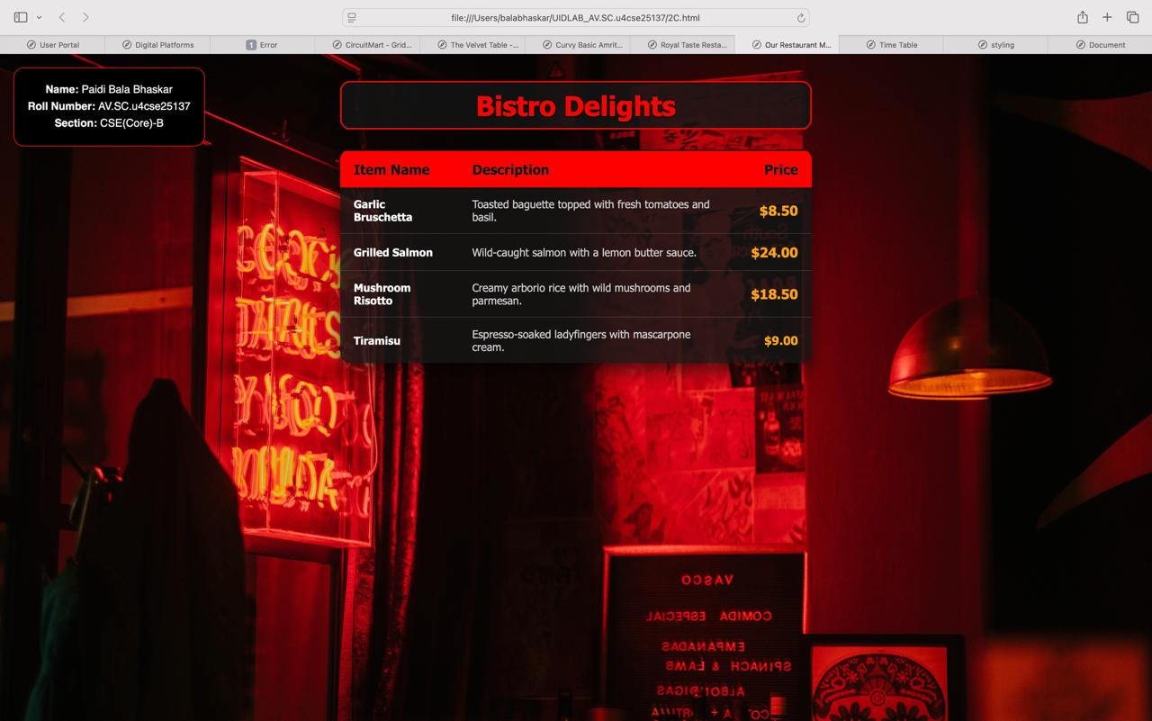
Explanation;
This HTML code creates a restaurant menu webpage using tables and inline CSS styling. The page includes a background image and a styled heading titled Bistro Delights. A fixed information box displays the student's name, roll number, and section. The menu is presented using a table that lists different food items along with their descriptions and prices. Inline styles are used to control the layout, colors, fonts, borders, and shadows to give the webpage a modern and attractive appearance. Overall, the webpage demonstrates how HTML tables and inline CSS can be used to design a visually appealing menu layout.

WEEK-3

3(A) Aim:
To design and develop an academic timetable using HTML tables by applying row span, column span, and styling for proper structure and presentation.
Program:
Input:
1. <!DOCTYPE html>
2. <html>
3. <head>
4. <title>Time Table</title>
5. </head>
6. <body>
7. <table style="width:100%" border="1" cellpadding="1.5" cellspacing="0">
8. <caption style="font-family: 'Times New Roman', Times, serif; font-weight: 500; font-size: x-large; background-color: yellow; border: 0.1mm solid black; border-bottom: 0.1mm solid yellow; color:rgb(0, 0, 0);">CSE-B TIME TABLE</caption>
9. <tr>
10. <th colspan="12" style="background-color: yellow;">Master Time Table CSE II Semester B Section</th>
11. <tr>
12. <td colspan="4">Dept. CSE</td>
13. <td rowspan="3" colspan="8">Class Room Venue:511</td>
14. </tr>
15. <tr>
16. <td colspan="4"> Class: B. Tech. CSE-B</td>
17. </tr>
18. <tr>
19. <td colspan="4">Semester-II</td>
20. </tr>
21. <tr>
22. <td colspan="4"><p>
23. Class Advisors:<br>
24. 1. Name: Dr. Kurmala Gowri Raghavendra Narayan<br>
25. Email : kgr_narayan@av.amrita.edu<br>
26. Mobile Number : +91-9705409393</p></td>
27. <td colspan="8"><p>
28. 2. Name: Dr. Ankit Sachan<br>
29. Email : s_ankit@av.amrita.edu<br>
30. Mobile Number :+91-8381800129
31. </p>
32. </td>
33. </tr>
34. <tr>
35. <td rowspan="2">TIME/DAY</td>
36. <td style="text-align: center;background-color: #f2f2f2">Slot 1</td>
37. <td style="text-align: center;background-color: #f2f2f2">Slot 2</td>
38. <td style="text-align: center;background-color: #f2f2f2;" rowspan="2">10.35am-10.45am</td>
39. <td style="text-align: center;background-color: #f2f2f2">Slot 3</td>
40. <td style="text-align: center;background-color: #f2f2f2">Slot 4</td>
41. <td style="text-align: center;background-color: #f2f2f2">Slot 5</td>
42. <td style="text-align: center; background:#f2f2f2;" rowspan="2">01.15pm-02.05pm</td>
43. <td style="text-align: center;background-color: #f2f2f2">Slot 6</td>
44. <td style="text-align: center;background-color:#f2f2f2" rowspan="2"> 3.00pm-3.10pm</td>
45. <td style="text-align: center;background-color: #f2f2f2">Slot 7</td>
46. <td style="text-align: center;background-color: #f2f2f2">Slot 8</td>
47. </tr>
48. <tr style="background-color:#f2f2f2;">
49. <td style="text-align: center;"> 08.55-09.45am</td>
50. <td style="text-align: center;"> 09.45-10.35am</td>
51. <td style="text-align: center;"> 10.45-11.35am</td>
52. <td style="text-align: center;"> 11.35am-12.25pm</td>
53. <td style="text-align: center;"> 12.25am-01.15pm</td>
54. <td style="text-align: center;"> 02.10-03.00pm</td>
55. <td style="text-align: center;"> 03.10-04.00pm</td>
56. <td style="text-align: center;"> 04.00-04.50pm</td>
57. </tr>
58. <tr>
59. <td>Monday</td>
60. <td colspan="2">23MAT117 Linear Algebra LAB(BYOD)</td>
61. <td rowspan="5" bgcolor="yellow" style="text-align: center;"><p style="transform: rotate(-90deg);">SHORT BREAK</p></td>
62. <td>22ADM111<br> Glimpses of<br> Glorious India</td>
63. <td>23PHY115 Modern <br> Physics</td>
64. <td style="text-align: center;"> LIBRARY</td>
65. <td rowspan="5" bgcolor="yellow" style="text-align: center;"><p style="transform: rotate(-90deg);">LUNCH</p></td>
66. <td>23MEE115 <br>Manufacturing Practice <br>LAB</td>
67. <td rowspan="5" bgcolor="yellow" style="text-align: center;"><p style="transform: rotate(-90deg);">SHORT BREAK</p></td>
68. <td colspan="2">23MEE115 Manufacturing Practice LAB</td>
69. </tr>
70. <tr>
71. <td>Tuesday</td>
72. <td> 23MAT116 Discrete <br>Mathematics</td>
73. <td>23MAT117 Linear <br>Algebra</td>
74. <td>23PHY115 <br>Modern Physics</td>
75. <td>23CSE111Object <br> Oriented Programming</td>
76. <td>23CSE113 User <br>Interface Design</td>
77. <td>22ADM111Glimpses of Glorious India(P)</td>
78. <td style="text-align: center;" colspan="2">Library/Sport</td>
79. </tr>
80. <tr>
81. <td>Wednesday</td>
82. <td style="text-align: center;" colspan="2">23CSE111Object Oriented Programming_lab2</td>
83. <td>23MAT116 <br>Discrete <br>Mathematics</td>
84. <td>23CSE113 User <br>Interface Design</td>
85. <td>22ADM111Glimpses <br>of Glorious India</td>
86. <td style="text-align: center;">Library/Sports</td>
87. <td style="text-align: center;" colspan="2">Library/Sport</td>
88. </tr>
89. <tr>
90. <td>Thursday</td>
91. <td style="text-align: center;">23MAT117 Linear Algebra</td>
92. <td> 23CSE111 Object <br>Oriented Programming</td>
93. <td>23MAT116 <br>Discrete<br> Mathematics</td>
94. <td style="text-align: center;color: red;">COUNSELLING</td>
95. <td style="text-align: center;">LIBRARY </td>
96. <td>23PHY115 Modern <br>Physics(T)</td>
97. <td style="text-align: center;" colspan="2">Library/Sport</td>
98. </tr>
99. <tr>
100. <td>Friday</td>
101. <td style="text-align: center;" colspan="2">23CSE113 User Interface Design Lab BYOD</td>
102. <td> 23MAT117 <br>Linear Algebra</td>
103. <td> 23CSE111 Object <br>Oriented Programming</td>
104. <td style="text-align: center;">Library/Sports</td>
105. <td style="text-align: center; color: red;">COUNSELLING</td>
106. <td style="text-align: center;" colspan="2">23MAT116 Discrete Mathematics_lab_lab1</td>
107. </tr>
108. <tr style="background-color: #f2f2f2;">
109. <td style="text-align: center;">Cource Code</td>
110. <td style="text-align: center;" colspan="2">Cource Name</td>
111. <td></td>
112. <td style="text-align: center;">L-T-P</td>
113. <td>credits</td>
114. <td colspan="3" style="text-align: center;"> Faculty Name</td>
115. <td></td>
116. <td style="text-align: center;" colspan="2"> Assisting Faculty</td>
117. </tr>
118. <tr>
119. <td style="text-align: center;"">23MAT116</td>
120. <td style="text-align: center;" colspan="2">Discrete Mathematics</td>
121. <td></td>
122. <td style="text-align: center;">3-0-2</td>
123. <td style="text-align: center;">4</td>
124. <td style="text-align: center;" colspan="3"> Dr.Srivivasa Rao Thota</td>
125. <td></td>
126. <td style="text-align: center;" colspan="2"></td>
127. </tr>
128.
129. <tr>
130. <td style="text-align: center;">23CSE111</td>
131. <td style="text-align: center;" colspan="2">Object Oriented Programming</td>
132. <td></td>
133. <td style="text-align: center;">3-0-2</td>
134. <td style="text-align: center;">4</td>
135. <td style="text-align: center;" colspan="3">Dr. Balaji TK</td>
136. <td></td>
137. <td style="text-align: center;" colspan="2"></td>
138. </tr>
139. <tr>
140. <td style="text-align: center;">23PHY115</td>
141. <td style="text-align: center;" colspan="2">Modern Physics</td>
142. <td></td>
143. <td style="text-align: center;">2-1-0</td>
144. <td style="text-align: center;">3</td>
145. <td style="text-align: center;" colspan="3">Dr. C R Kesavalu</td>
146. <td></td>
147. <td style="text-align: center;" colspan="2"></td>
148. </tr>
149. <tr>
150. <td style="text-align: center;">23CSE113</td>
151. <td style="text-align: center;" colspan="2">User Interface Design</td>
152. <td></td>
153. <td style="text-align: center;">2-0-2</td>
154. <td style="text-align: center;">3</td>
155. <td style="text-align: center;" colspan="3"> Dr.Rajkumar Batchu</td>
156. <td></td>
157. <td style="text-align: center;" colspan="2"> Mr. Barge Bharadwaj</td>
158. </tr>
159. <tr>
160. <td style="text-align: center;">23MEE115</td>
161. <td style="text-align: center;" colspan="2">Manufacturing Practice</td>
162. <td></td>
163. <td style="text-align: center;">0-0-3</td>
164. <td style="text-align: center;">1</td>
165. <td style="text-align: center;" colspan="3"> Dr. Sathies S.</td>
166. <td></td>
167. <td style="text-align: center;" colspan="2"></td>
168. </tr>
169. <tr>
170. <td style="text-align: center;">22ADM111</td>
171. <td style="text-align: center;" colspan="2">Glimpses of Glorious India</td>
172. <td></td>
173. <td style="text-align: center;">2-0-1</td>
174. <td style="text-align: center;">2</td>
175. <td style="text-align: center;" colspan="3"> Dr. Siva Panuganti</td>
176. <td></td>
177. <td style="text-align: center;" colspan="2"></td>
178. </tr>
179. <tr>
180. <td></td>
181. <td colspan="2" style="text-align: center;">Total (15L + 1Tut +12P =28 hrs)</td>
182. <td></td>
183. <td style="text-align: center;">15-1-12</td>
184. <td style="text-align: center;">21</td>
185. </tr>
186. </table>
187. </body>
188. </html>
189.

Output:
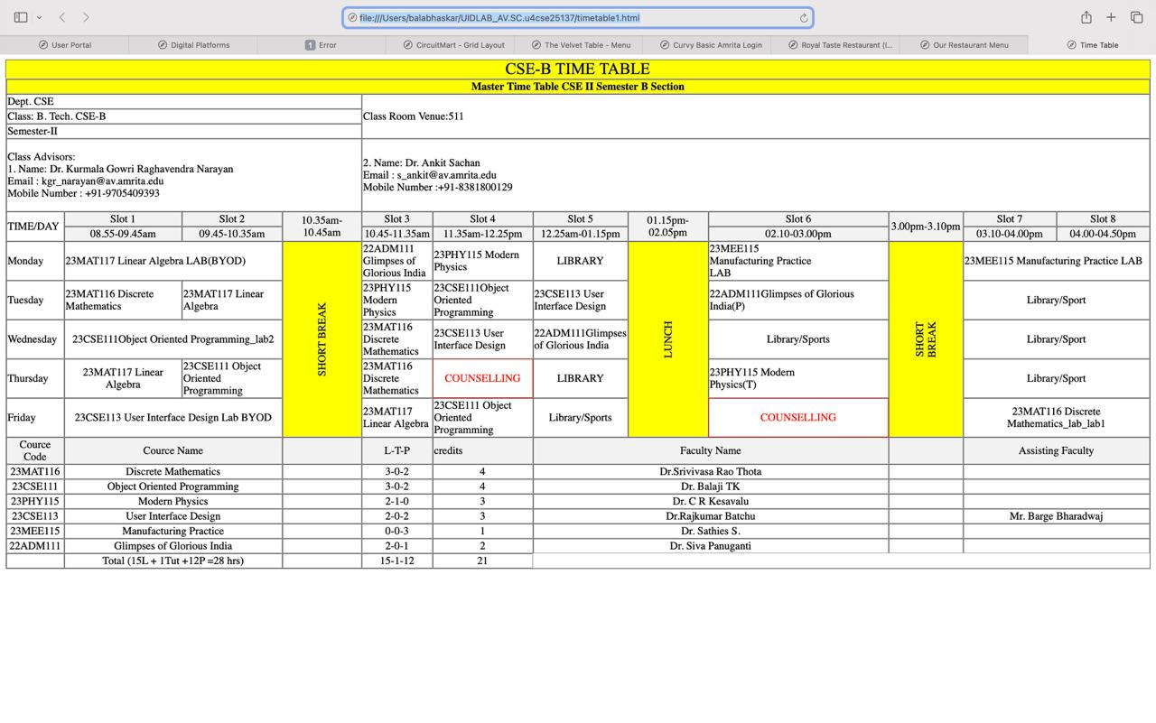
Explanation ;
This HTML code creates a detailed class timetable webpage using the <table> element and inline CSS styling. The table displays the schedule for CSE-B II Semester, including time slots, subjects, laboratory sessions, breaks, and faculty information. Various HTML features such as rowspan and colspan are used to merge cells for breaks, labs, and headings, making the timetable organized and easy to read. Inline styles are applied to control colors, borders, alignment, and formatting of the table elements. The page also includes course details such as course codes, credits, L-T-P structure, and faculty names, demonstrating how HTML tables can effectively present structured academic information.

3(B) Aim:
To create a comprehensive webpage that includes an academic timetable along with syllabus representation using images and structured HTML elements.
Program:
1. Input:
2. <!DOCTYPE html>
3. <html>
4. <head>
5. <title>AMRITA CSE</title>
6. <style>
7. body {
8. font-family: 'Segoe UI', Arial, sans-serif;
9. margin: 0;
10. padding: 0;
11. background-color: #f4f7f6;
12. color: #333;
13. }
14.
15. .main-header {
16. background-color: #721c24;
17. color: white;
18. padding: 20px;
19. text-align: center;
20. box-shadow: 0 2px 5px rgba(0,0,0,0.1);
21. }
22.
23. .sem-badge {
24. background-color: white;
25. color: #721c24;
26. padding: 5px 25px;
27. border-radius: 50px;
28. display: inline-block;
29. font-weight: bold;
30. margin-top: 10px;
31. border: 2px solid #721c24;
32. }
33.
34. /* Section Containers */
35. .content-wrapper {
36. max-width: 1550px;
37. margin: 20px auto;
38. padding: 0 15px;
39. }
40.
41. .flex-row {
42. display: flex;
43. gap: 20px;
44. margin-bottom: 25px;
45. justify-content: center;
46. }
47.
48. .course-card {
49. background: white;
50. border: 1px solid #ddd;
51. border-radius: 8px;
52. overflow: hidden;
53. flex: 1;
54. max-width: 760px;
55. box-shadow: 0 4px 6px rgba(0,0,0,0.05);
56. }
57.
58. .course-card h3 {
59. background-color: #96465f;
60. color: white;
61. margin: 0;
62. padding: 15px;
63. text-align: center;
64. font-size: 1.2rem;
65. }
66.
67. .course-card img {
68. width: 100%;
69. height: auto;
70. display: block;
71. }
72.
73. .tt-header {
74. background-color: #96465f;
75. color: white;
76. padding: 15px;
77. margin-top: 40px;
78. border-radius: 8px 8px 0 0;
79. }
80.
81. .footer-container {
82. display: flex;
83. gap: 40px;
84. background-color: #2c3e50;
85. padding: 40px 5%;
86. font-size: 13px;
87. color: #ecf0f1;
88. margin-top: 50px;
89. }
90.
91. .footer-container a {
92. color: #3498db;
93. text-decoration: none;
94. font-weight: bold;
95. }
96.
97. .footer-container pre {
98. font-family: 'Courier New', Courier, monospace;
99. background: rgba(255,255,255,0.05);
100. padding: 10px;
101. border-radius: 4px;
102. }
103.
104. hr {
105. border: 0;
106. height: 1px;
107. background: #ddd;
108. margin: 30px 0;
109. }
110. </style>
111. </head>
112. <body>
113.
114. <div class="main-header">
115. <h1>AMRITA CSE CURRICULUM</h1>
116. <div class="sem-badge">SEM-2</div>
117. </div>
118.
119. <div class="content-wrapper">
120.
121. <div class="flex-row">
122. <section class="course-card">
123. <h3>Curriculum</h3>
124. <img src="Screenshot 2026-02-11 193116.png">
125. </section>
126. <section class="course-card">
127. <h3>Discrete Mathematics</h3>
128. <img src="Screenshot 2026-02-07 224406.png">
129. </section>
130. </div>
131.
132. <div class="flex-row">
133. <section class="course-card">
134. <h3>Linear Algebra</h3>
135. <img src="Screenshot 2026-02-07 225311.png">
136. </section>
137. <section class="course-card">
138. <h3>OOPS</h3>
139. <img src="Screenshot 2026-02-09 220748.png">
140. </section>
141. </div>
142.
143. <div class="flex-row">
144. <section class="course-card">
145. <h3>UID</h3>
146. <img src="Screenshot 2026-02-09 221054.png">
147. </section>
148. <section class="course-card">
149. <h3>Modern Physics</h3>
150. <img src="Screenshot 2026-02-09 222340.png">
151. </section>
152. </div>
153.
154. <div class="flex-row">
155. <section class="course-card">
156. <h3>Manufacturing Practice</h3>
157. <img src="Screenshot 2026-02-11 190759.png">
158. </section>
159. <section class="course-card">
160. <h3>Glimpse of Glorious India</h3>
161. <img src="Screenshot 2026-02-11 204842.png">
162. </section>
163. </div>
164.
165. <div class="tt-header">
166. <h2 style="margin:0">TIME TABLE</h2>
167. </div>
168.
169. <table style="width: 100%; text-align: center; border-bottom-right-radius: 8px; border-bottom-left-radius: 8px;" border="1" cellpadding="1" cellspacing="3" bgcolor="white">
170. <caption style="font-family: 'Times New Roman', Times, serif; font-weight: 500; font-size: x-large; background-color: yellow; border: 0.1mm solid black; border-bottom: 0.1mm solid yellow; color:rgb(0, 0, 0); border-top-left-radius: 8px; border-top-right-radius: 8px;">CSE-B TIME TABLE</caption>
171. <tr>
172. <th colspan="12">Master Time Table CSE II Semester B Section</th>
173. <tr>
174. <td colspan="4">Dept. CSE</td>
175. <td rowspan="3" colspan="8">Class Room Venu:511</td>
176. </tr>
177. <tr>
178. <td colspan="4"> Class: B. Tech. CSE-B</td>
179. </tr>
180. <tr>
181. <td colspan="4">Semester-II</td>
182. </tr>
183. <tr>
184. <td colspan="4"><p>
185. Class Advisors:<br>
186. 1. Name: Dr. Kurmala Gowri Raghavendra Narayan<br>
187. Email : kgr_narayan@av.amrita.edu<br>
188. Mobile Number : +91-9705409393</p></td>
189. <td colspan="8"><p>
190. 2. Name: Dr. Ankit Sachan<br>
191. Email : s_ankit@av.amrita.edu<br>
192. Mobile Number :+91-8381800129
193. </p>
194. </td>
195. </tr>
196. <tr>
197. <td rowspan="2">TIME/DAY</td>
198. <td style="text-align: center;">Slot 1</td>
199. <td style="text-align: center;">Slot 2</td>
200. <td style="text-align: center;" rowspan="2">10.35am-10.45am</td>
201. <td style="text-align: center;">Slot 3</td>
202. <td style="text-align: center;">Slot 4</td>
203. <td style="text-align: center;">Slot 5</td>
204. <td style="text-align: center;" rowspan="2">01.15pm-02.05pm</td>
205. <td style="text-align: center;">Slot 6</td>
206. <td style="text-align: center;" rowspan="2"> 3.00pm-3.10pm</td>
207. <td style="text-align: center;">Slot 7</td>
208. <td style="text-align: center;">Slot 8</td>
209. </tr>
210. <tr>
211. <td style="text-align: center;"> 08.55-09.45am</td>
212. <td style="text-align: center;"> 09.45-10.35am</td>
213. <td style="text-align: center;"> 10.45-11.35am</td>
214. <td style="text-align: center;"> 11.35am-12.25pm</td>
215. <td style="text-align: center;"> 12.25am-01.15pm</td>
216. <td style="text-align: center;"> 02.10-03.00pm</td>
217. <td style="text-align: center;"> 03.10-04.00pm</td>
218. <td style="text-align: center;"> 04.00-04.50pm</td>
219. </tr>
220. <tr>
221. <td>Monday</td>
222. <td colspan="2">23MAT117 Linear Algebra LAB(BYOD)</td>
223. <td rowspan="5" bgcolor="yellow" style="text-align: center; writing-mode: vertical-lr;">Short Break</td>
224. <td>22ADM111<br> Glimpses of<br> Glorious India</td>
225. <td>23PHY115 Modern <br> Physics</td>
226. <td style="text-align: center;"> LIBRARY</td>
227. <td rowspan="5" bgcolor="yellow" style="text-align: center; writing-mode: vertical-lr">Lunch Break</td>
228. <td>23MEE115 <br>Manufacturing Practice <br>LAB</td>
229. <td rowspan="5" bgcolor="yellow" style="text-align: center; writing-mode: vertical-lr;">Short Break</td>
230. <td colspan="2">23MEE115 Manufacturing Practice LAB</td>
231. </tr>
232. <tr>
233. <td>Tuesday</td>
234. <td> 23MAT116 Discrete <br>Mathematics</td>
235. <td>23MAT117 Linear <br>Algebra</td>
236. <td>23PHY115 <br>Modern Physics</td>
237. <td>23CSE111Object <br> Oriented Programming</td>
238. <td>23CSE113 User <br>Interface Design</td>
239. <td>22ADM111Glimpses of Glorious India(P)</td>
240. <td style="text-align: center;" colspan="2">Library/Sport</td>
241. </tr>
242. <tr>
243. <td>Wednesday</td>
244. <td style="text-align: center;" colspan="2">23CSE111Object Oriented Programming_lab2</td>
245. <td>23MAT116 Discrete Mathematics</td>
246. <td>23CSE113 User Interface Design</td>
247. <td>22ADM111Glimpses of Glorious India</td>
248. <td style="text-align: center;">Library/Sports</td>
249. <td style="text-align: center;" colspan="2">Library/Sport</td>
250. </tr>
251. <tr>
252. <td>Thursday</td>
253. <td style="text-align: center;">23MAT117 Linear Algebra</td>
254. <td> 23CSE111 Object Oriented Programming</td>
255. <td>23MAT116 Discrete Mathematics</td>
256. <td style="text-align: center;" bgcolor="red">COUNSELLING</td>
257. <td style="text-align: center;">LIBRARY </td>
258. <td>23PHY115 Modern Physics(T)</td>
259. <td style="text-align: center;" colspan="2">Library/Sport</td>
260. </tr>
261. <tr>
262. <td>Friday</td>
263. <td style="text-align: center;" colspan="2">23CSE113 User Interface Design Lab BYOD</td>
264. <td> 23MAT117 Linear Algebra</td>
265. <td> 23CSE111 Object Oriented Programming</td>
266. <td style="text-align: center;">Library/Sports</td>
267. <td style="text-align: center;" bgcolor="red">COUNSELLING</td>
268. <td style="text-align: center;" colspan="2">23MAT116 Discrete Mathematics_lab_lab1</td>
269. </tr>
270. <tr>
271. <td style="text-align: center;">Cource Code</td>
272. <td style="text-align: center;" colspan="2">Cource Name</td>
273. <td></td>
274. <td style="text-align: center;">L-T-P</td>
275. <td>credits</td>
276. <td colspan="3" style="text-align: center;"> Faculty Name</td>
277. <td></td>
278. <td style="text-align: center;" colspan="2"> Assisting Faculty</td>
279. </tr>
280. <tr>
281. <td style="text-align: center;">23MAT116</td>
282. <td style="text-align: center;" colspan="2">Discrete Mathematics</td>
283. <td></td>
284. <td style="text-align: center;">3-0-2</td>
285. <td style="text-align: center;">4</td>
286. <td style="text-align: center;" colspan="3"> Dr.Srivivasa Rao Thota</td>
287. <td></td>
288. <td style="text-align: center;" colspan="2"></td>
289. </tr>
290. <tr>
291. <td style="text-align: center;">23CSE111</td>
292. <td style="text-align: center;" colspan="2">Object Oriented Programming</td>
293. <td></td>
294. <td style="text-align: center;">3-0-2</td>
295. <td style="text-align: center;">4</td>
296. <td style="text-align: center;" colspan="3">Dr. Balaji TK</td>
297. <td></td>
298. <td style="text-align: center;" colspan="2"></td>
299. </tr>
300. <tr>
301. <td style="text-align: center;">23PHY115</td>
302. <td style="text-align: center;" colspan="2">Modern Physics</td>
303. <td></td>
304. <td style="text-align: center;">2-1-0</td>
305. <td style="text-align: center;">3</td>
306. <td style="text-align: center;" colspan="3">Dr. C R Kesavalu</td>
307. <td></td>
308. <td style="text-align: center;" colspan="2"></td>
309. </tr>
310. <tr>
311. <td style="text-align: center;">23CSE113</td>
312. <td style="text-align: center;" colspan="2">User Interface Design</td>
313. <td></td>
314. <td style="text-align: center;">2-0-2</td>
315. <td style="text-align: center;">3</td>
316. <td style="text-align: center;" colspan="3"> Dr.Rajkumar Batchu</td>
317. <td></td>
318. <td style="text-align: center;" colspan="2"> Mr. Barge Bharadwaj</td>
319. </tr>
320. <tr>
321. <td style="text-align: center;">23MEE115</td>
322. <td style="text-align: center;" colspan="2">Manufacturing Practice</td>
323. <td></td>
324. <td style="text-align: center;">0-0-3</td>
325. <td style="text-align: center;">1</td>
326. <td style="text-align: center;" colspan="3"> Dr. Sathies S.</td>
327. <td></td>
328. <td style="text-align: center;" colspan="2"></td>
329. </tr>
330. <tr>
331. <td style="text-align: center;">22ADM111</td>
332. <td style="text-align: center;" colspan="2">Glimpses of Glorious India</td>
333. <td></td>
334. <td style="text-align: center;">2-0-1</td>
335. <td style="text-align: center;">2</td>
336. <td style="text-align: center;" colspan="3"> Dr. Siva Panuganti</td>
337. <td></td>
338. <td style="text-align: center;" colspan="2"></td>
339. </tr>
340. <tr>
341. <td style="border-bottom-left-radius: 6px;"></td>
342. <td colspan="2" style="text-align: center;">Total (15L + 1Tut +12P =28 hrs)</td>
343. <td></td>
344. <td style="text-align: center;">15-1-12</td>
345. <td style="text-align: center;">21</td>
346. </tr>
347. </table>
348. </div>
349.
350. <div class="footer-container">
351. <div>
352. <img src="WhQq1FiB-amrita-vishwa-vidyapeetham-university-logo-colored-version.svg" width="180px" style="background:white; padding:10px; border-radius:4px;">
353. <p style="margin-top:20px;"><b>Contact Information:</b></p>
354. </div>
355. <div style="margin-left:auto; align-self: flex-end;">
356. <p>Privacy • Terms of use • © 2026</p>
357. </div>
358. </div>
359. </body>
360. </html>
361.

Output:
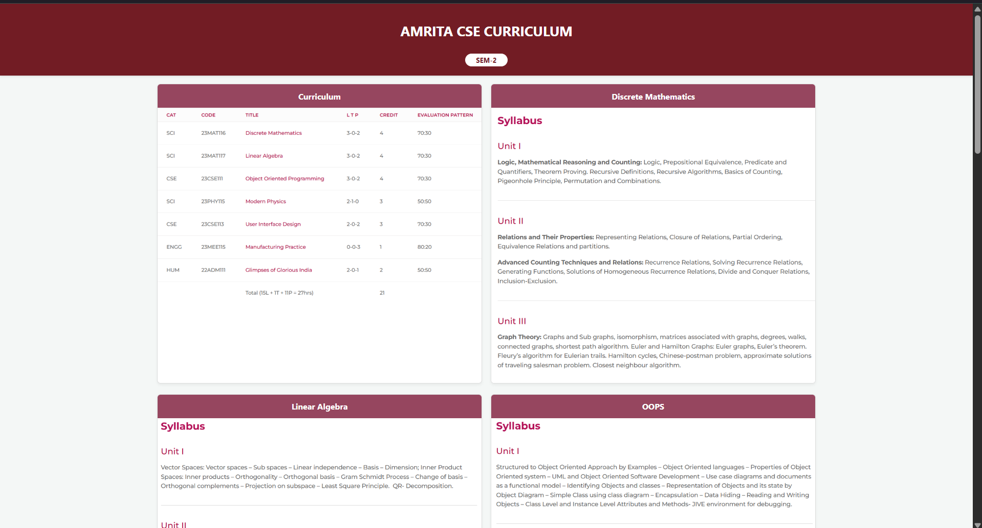
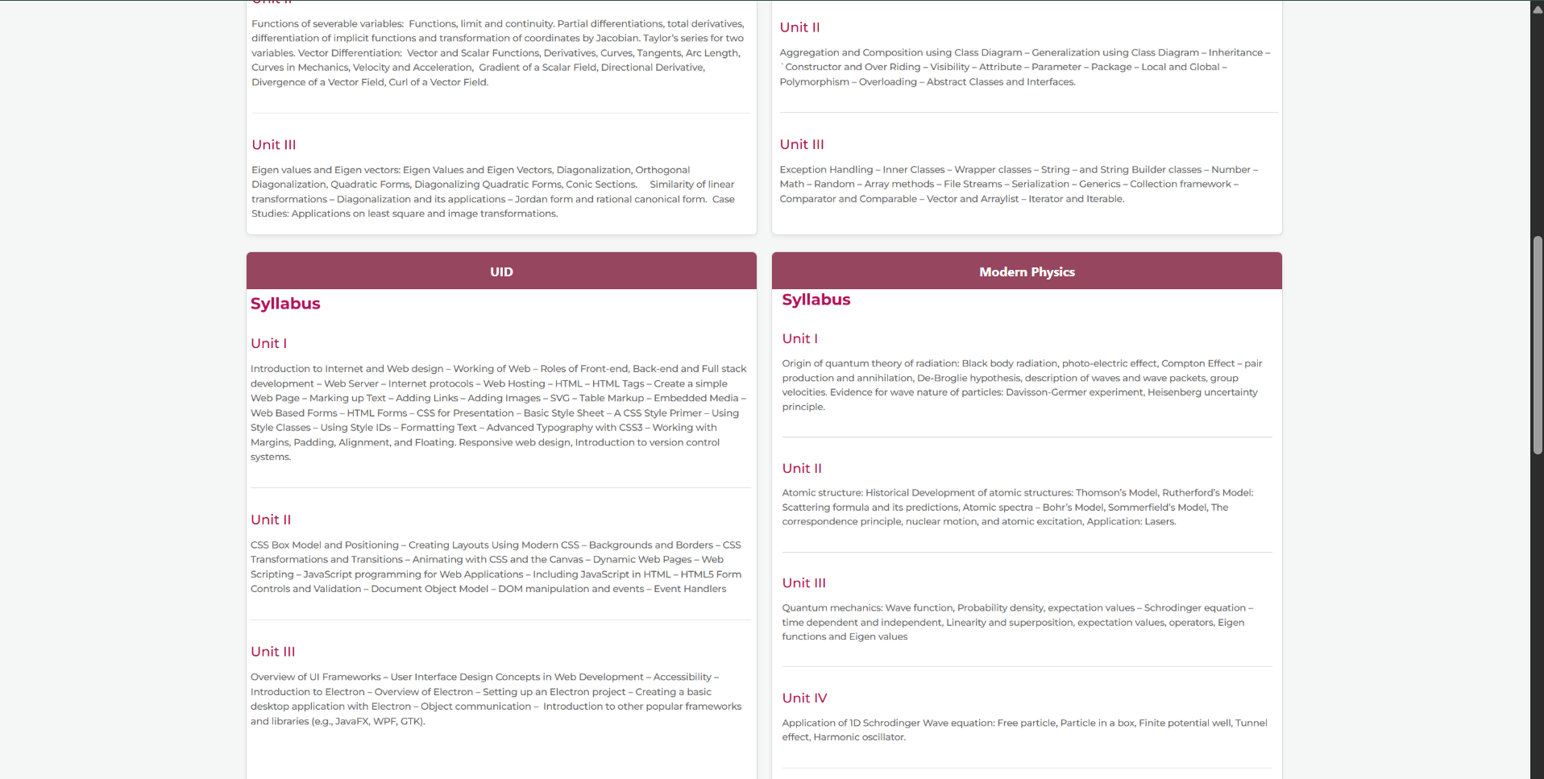
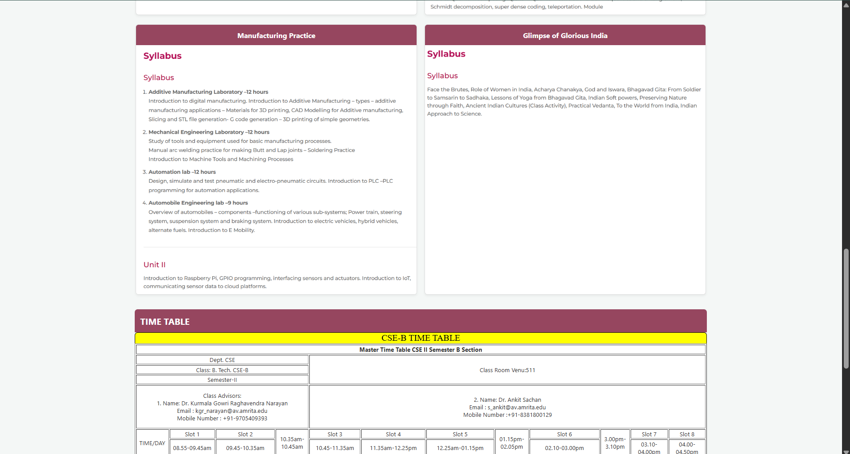
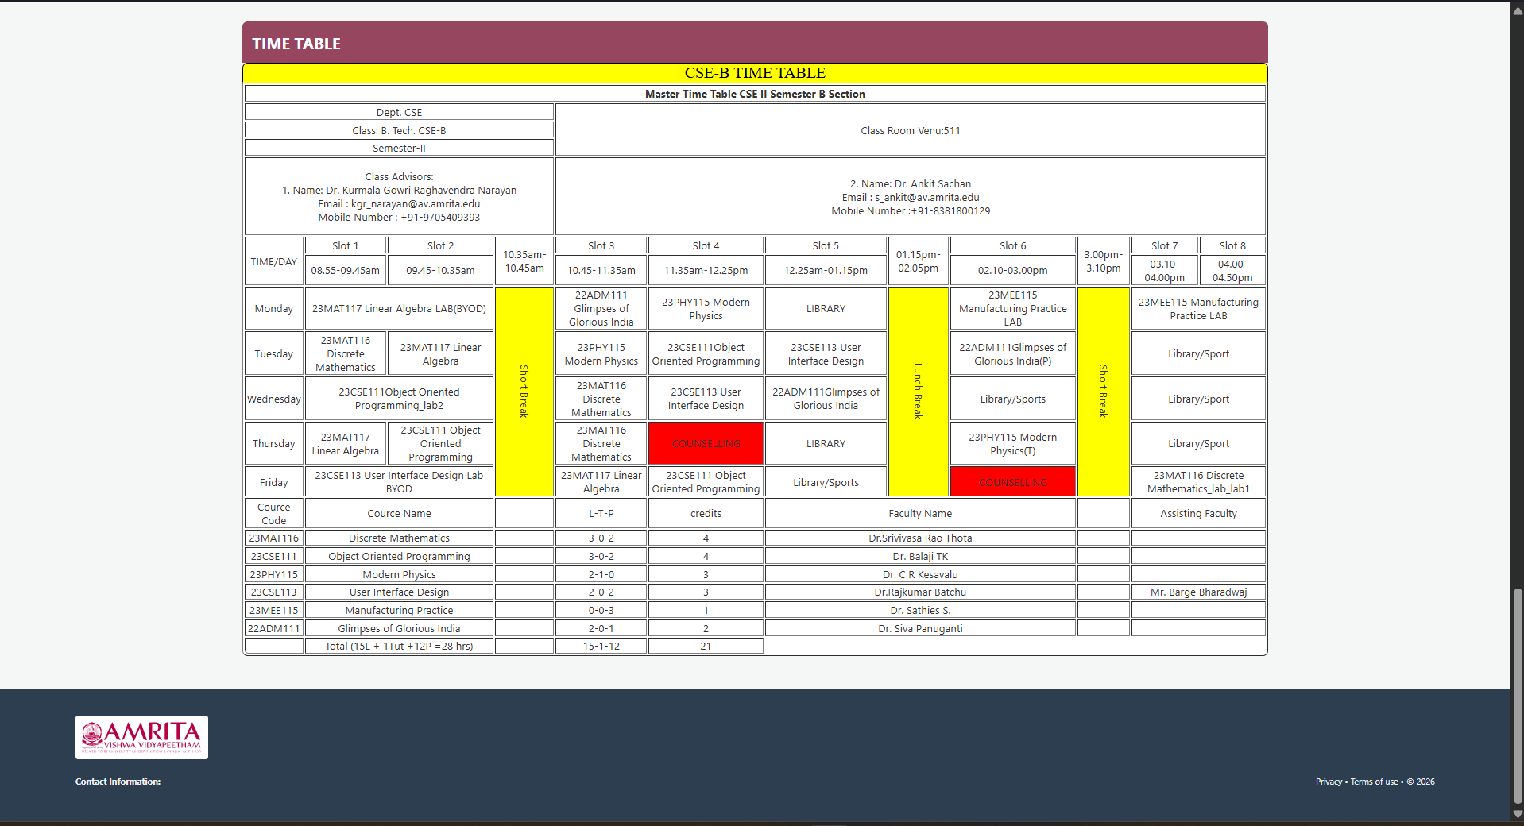

Explanation:

This program is an HTML webpage that shows the 2nd semester syllabus and CSE-B timetable in one page. It starts with the basic HTML structure and sets the page title. CSS is used to add borders and collapse lines for all tables so they look neat. The page background color is set to orange, and a centered heading “SYLLABUS” is displayed at the top.
Next, the program lists each subject name using <h2> headings and shows the syllabus images using <img> tags. The images are loaded from a folder named SY_IMG and displayed with a fixed width, so each subject’s syllabus appears visually on the page.
After the syllabus section, the program creates a large timetable using an HTML table. It uses rows and columns to show class details, advisors, time slots, subjects, labs, breaks, and faculty information. Features like colspan and rowspan are used to merge cells for breaks and lab hours, and some cells are colored to highlight breaks and counselling. Overall, the program combines images and tables to present both syllabus content and the weekly timetable in a structured format.

WEEK-4
4(A) Aim:
To understand the concept of forms and design a structured student registration form using HTML tables, including various input types such as text fields, radio buttons, checkboxes, file upload, and dropdown lists.
Program:
Input:
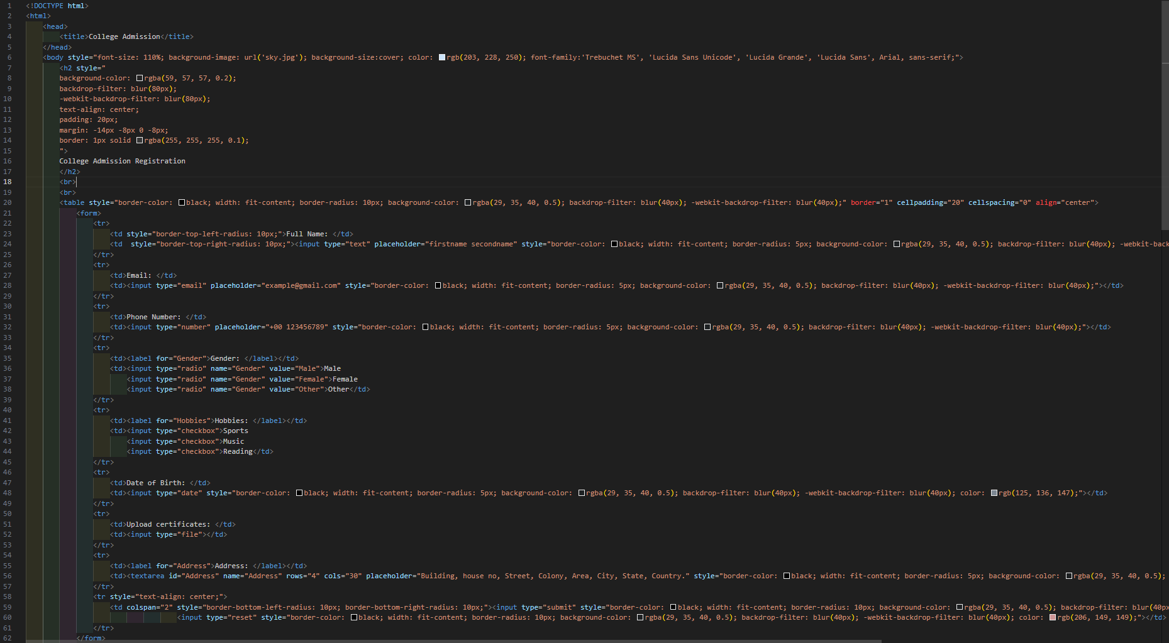
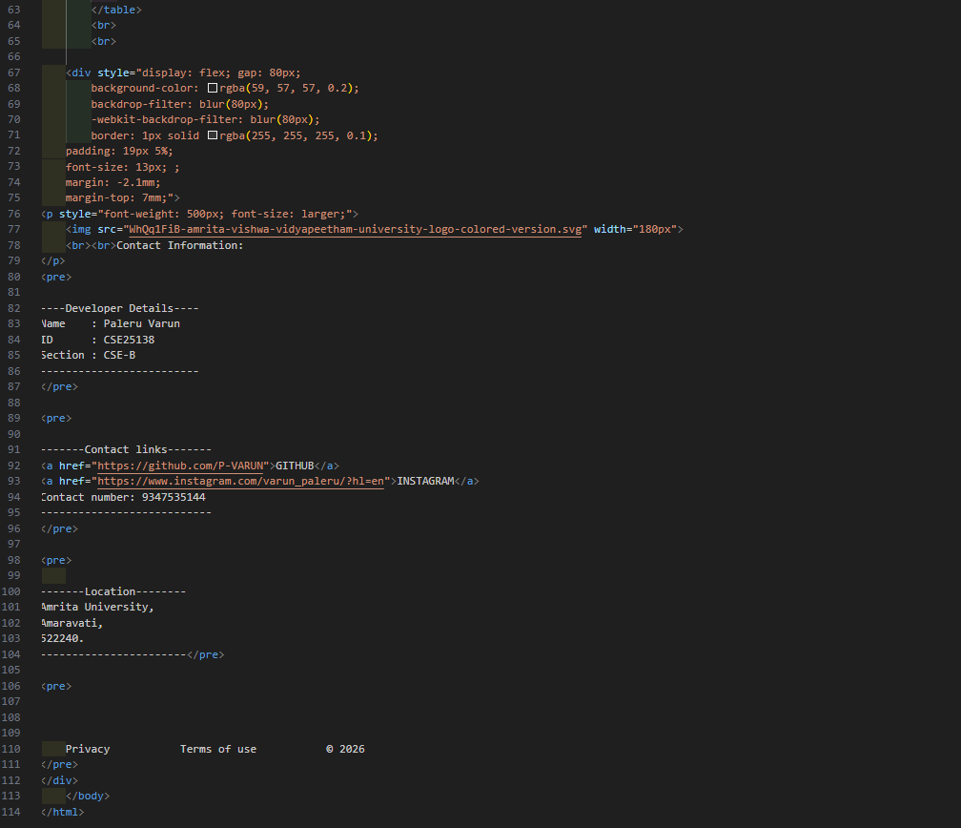
Output:
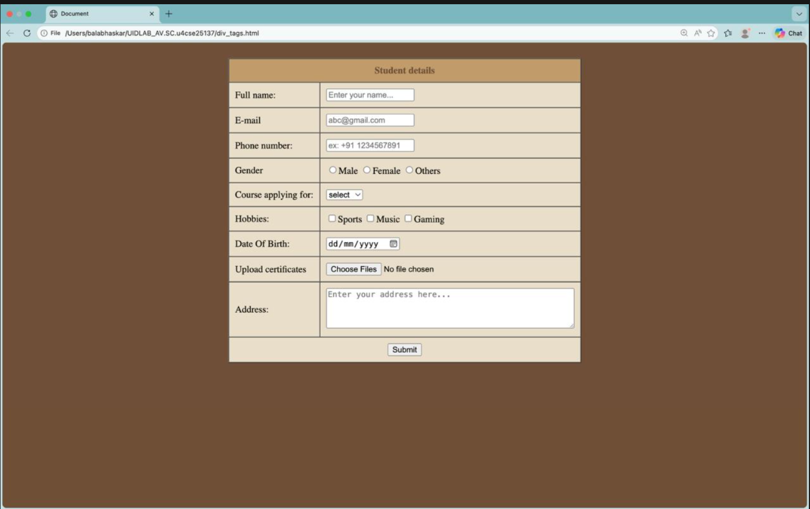

Explanation:
<form>: this tag is used to create a form using different attributes in this form tag.
• <center>: this tag is used to shift the content or form into centre of the web page.
• <table>: this tag is used to create a table with rows and columns in our own webpages.
• <tr>: for rows in table
• <td>: for columns in table.
• <label>: provides connection with label and input field and provides the label for the input field.
• <input>: creates a field for collect the user details in webpage.
• <select>: this tag is used to create a dropdown list for user preferences.
• <option>: this tag is used to display options to user and to collect the information from the user.
• <text area>: creates a multiline field for user input.
• <button>: creates button in webpages.
• Type=”name”: attribute used for collect name from user.
• Type = “email”: attribute used for collect mail from user.
• Type= radio: attribute used for provide options for user.
• Type= date: attribute used for collect date from user.
• Type = file: attribute used for collect file from user.
• Type= reset: attribute used to create reset button in webpage.
4(B) Aim:
To understand the concept of forms and design user login and registration webpages using HTML, and to display them within a single interface using iframe for better layout and user interaction.
Program:
Input:
1. <!DOCTYPE html>
2. <html>
3. <body style="font-family: Arial; display: flex; justify-content: center; background: transparent;">
4.
5. <table style="width:80%; background: white; border: 1px solid #ccc; border-radius: 25px; border-collapse: separate; padding: 25px; box-shadow: 0px 4px 10px rgba(0,0,0,0.1);">
6. <tr><td style="padding:8px;">Full Name:</td><td><input type="text" style="width:100%; padding:8px; border-radius:10px; border:1px solid #ccc;"></td></tr>
7. <tr><td style="padding:8px;">Email:</td><td><input type="email" style="width:100%; padding:8px; border-radius:10px; border:1px solid #ccc;"></td></tr>
8. <tr><td style="padding:8px;">Phone:</td><td><input type="text" style="width:100%; padding:8px; border-radius:10px; border:1px solid #ccc;"></td></tr>
9. <tr><td style="padding:8px;">Password:</td><td><input type="password" style="width:100%; padding:8px; border-radius:10px; border:1px solid #ccc;"></td></tr>
10. <tr>
11. <td colspan="2" align="center" style="padding-top:20px;">
12. <input type="submit" value="Register Now" style="width:100%; padding:10px; border-radius:20px; border:none; background-color:#8B0037; color:white; cursor:pointer; font-weight:bold; margin-bottom:5px;">
13. <input type="reset" value="Clear" style="background:none; border:none; color:gray; cursor:pointer; font-size:12px;">
14. </td>
15. </tr>
16. </table>
17.
18. </body>
19. </html>
20.
1. <!DOCTYPE html>
2. <html>
3. <head><title>User Portal</title></head>
4. <body style="margin:0; font-family: Arial, sans-serif; background-color: #f4f7f6;">
5. <div style="display:flex; height:100vh;">
6. <div style="width:50%; border-right: 1px solid #ddd; display:flex; flex-direction:column; align-items:center;align-content:center">
7. <h2 style="margin-top:40px; color:#333;">Welcome!</h2>
8. <iframe src="loginn.html" style="width:100%; height:400px; border:none;"></iframe>
9. </div>
10.
11. <div style="width:50%; display:flex; flex-direction:column; align-items:center;align-content:center;">
12. <h2 style="margin-top:40px; color:#333;">Create Your Account here!</h2>
13. <iframe src="register.html" style="width:100%; height:500px; border:none;"></iframe>
14. </div>
15. </div>
16.
17. </body>
18. </html>
19.
1. <!DOCTYPE html>
2. <html>
3. <body style="font-family: Arial; display: flex; justify-content: center; background: transparent;">
4.
5. <table style="width:80%; background: white; border: 1px solid #ccc; border-radius: 20px; border-collapse: separate; padding: 20px; box-shadow: 0px 4px 10px rgba(0,0,0,0.1);">
6. <tr>
7. <td style="padding:10px;">Username:</td>
8. <td><input type="text" style="width:100%; padding:8px; border-radius:10px; border:1px solid #ccc;"></td>
9. </tr>
10. <tr>
11. <td style="padding:10px;">Password:</td>
12. <td><input type="password" style="width:100%; padding:8px; border-radius:10px; border:1px solid #ccc;"></td>
13. </tr>
14. <tr>
15. <td colspan="2" align="center" style="padding-top:20px;">
16. <input type="submit" value="Login" style="width:100%; padding:10px; border-radius:20px; border:none; background-color:#8B0037; color:white; cursor:pointer; font-weight:bold;">
17. </td>
18. </tr>
19. </table>
20.
21. </body>
22. </html>
23.
Output:
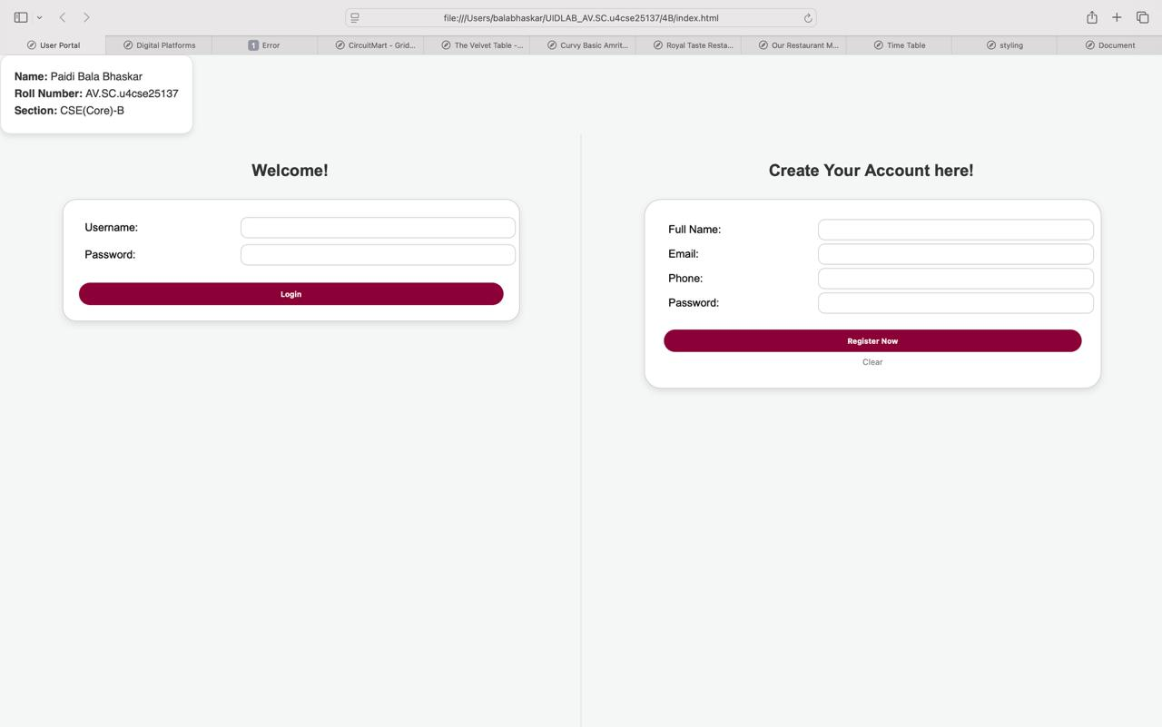

Explanation:
• <div>: this tag is used to create a section or divides specific part in webpage.
• <iframe>: this tag is used to provide separate webpages in same webpage.
• Width: this is attribute used to set the width of the iframe.
• Height: attribute used to set the height of the iframe.
• Display flex: attribute used for displaying webpages side by side.

WEEK-5
5(A) Aim:
To create a responsive card layout using HTML and CSS with three cards, each containing an image, title, and button.
Program:
Input:
1. <!DOCTYPE html>
2. <html>
3. <head>
4. <title>Digital Platforms</title>
5.
6. <link href="https://fonts.googleapis.com/css2?family=Poppins:wght@300;400;600&display=swap" rel="stylesheet">
7.
8. <style>
9. body {
10. min-height: 100vh;
11. margin: 0;
12. padding: 20px;
13. font-family: 'Poppins', sans-serif;
14. color: #ffffff;
15. }
16.
17. .bg-video {
18. position: fixed;
19. top: 0;
20. left: 0;
21. width: 100vw;
22. height: 100vh;
23. object-fit: cover;
24. z-index: -2;
25. }
26.
27. .video-overlay {
28. position: fixed;
29. top: 0;
30. left: 0;
31. width: 100vw;
32. height: 100vh;
33. background-color: rgba(0, 0, 0, 0.4);
34. z-index: -1;
35. }
36.
37. .mainheading {
38. text-align: center;
39. background-color: rgba(255, 255, 255, 0.15);
40. backdrop-filter: blur(10px);
41. border: 1px solid rgba(255, 255, 255, 0.4);
42. padding: 20px;
43. margin: 0 auto 40px auto;
44. border-radius: 15px;
45. max-width: 600px;
46. box-shadow: 0 8px 32px 0 rgba(0, 0, 0, 0.3);
47. letter-spacing: 2px;
48. }
49.
50. .card-container {
51. display: flex;
52. justify-content: center;
53. gap: 40px;
54. flex-wrap: wrap;
55. }
56.
57. .music-card {
58. background-color: rgba(255, 255, 255, 0.15);
59. backdrop-filter: blur(16px);
60. border: 1px solid rgba(255, 255, 255, 0.4);
61. border-radius: 20px;
62. padding: 25px;
63. width: 300px;
64. display: flex;
65. flex-direction: column;
66. align-items: center;
67. text-align: center;
68. box-shadow: 0 8px 32px 0 rgba(0, 0, 0, 0.3);
69. transition: transform 0.3s ease, box-shadow 0.3s ease;
70. }
71.
72. .music-card:hover {
73. transform: translateY(-10px);
74. box-shadow: 0 12px 40px 0 rgba(0, 0, 0, 0.5);
75. }
76.
77. .music-card h2 {
78. margin-top: 0;
79. font-size: 24px;
80. }
81.
82. .music-card img {
83. width: 100%;
84. height: 200px;
85. object-fit: cover;
86. border-radius: 15px;
87. margin-bottom: 15px;
88. box-shadow: 0 4px 15px rgba(0,0,0,0.2);
89. }
90.
91. .music-card p {
92. font-size: 14px;
93. line-height: 1.6;
94. margin-bottom: 25px;
95. color: #f1f1f1;
96. }
97.
98. button {
99. margin-top: auto;
100. padding: 12px 30px;
101. border: none;
102. border-radius: 25px;
103. background-color:white;
104. color:black;
105. font-weight: 600;
106. font-family: 'Poppins', sans-serif;
107. cursor: pointer;
108. transition: background-color 0.3s, transform 0.2s;
109. }
110.
111. button:hover {
112. background-color:rgb(255, 255, 255);
113. transform: scale(1.05);
114. }
115. </style>
116. </head>
117. <body>
118. <div style="position: fixed; top: 20px; left: 20px; border-radius: 15px; padding: 20px; box-shadow: 0 4px 8px rgba(0,0,0,0.1); background-color:black; border: 1px solid white; font-family: sans-serif; display: inline-block; line-height: 1.6; color:white;">
119. <p style="margin: 0;">
120. <b>Name:</b> Paidi Bala Bhaskar<br>
121. <b>Roll Number:</b> AV.SC.u4cse25137<br>
122. <b>Section:</b> CSE(Core)-B
123. </p>
124. </div>
125.
126. <video autoplay loop muted playsinline class="bg-video">
127. <source src="/Users/balabhaskar/Downloads/12421542_3840_2160_30fps.mp4" type="video/mp4">
128. </video>
129.
130. <div class="video-overlay"></div>
131.
132. <nav>
133. <h1 class="mainheading">-DIGITAL PLATFORMS-</h1>
134. </nav>
135.
136. <div class="card-container">
137. <article class="music-card">
138. <h2>Spotify</h2>
139. <img src="https://i.pinimg.com/736x/a8/9a/9e/a89a9e7d33dfbd9a83363c4c88eedf1c.jpg" alt="Spotify Concept">
140. <p>Spotify is a popular digital music streaming service that allows users to listen to millions of songs, podcasts, and audio content online. Founded in 2006, it lets users create playlists, discover new music, and follow their favorite artists anywhere. 🎧🎶</p>
141. <button>Know more</button>
142. </article>
143.
144. <article class="music-card">
145. <h2>Netflix</h2>
146. <img src="https://static.vecteezy.com/system/resources/previews/020/336/027/non_2x/netflix-logo-netflix-icon-free-free-vector.jpg" alt="Music Streaming">
147. <p>Netflix is a popular streaming platform where users can watch movies, TV shows, and documentaries online. It offers a wide range of content in different languages and genres. People can watch Netflix on devices like smartphones, computers, and smart TVs through a monthly subscription. 🎬📺
148. </p>
149. <button>Know more</button>
150. </article>
151.
152. <article class="music-card">
153. <h2>Pintrest</h2>
154. <img src="https://i.pinimg.com/1200x/8d/19/2b/8d192b51f0f8a396cf583ee0c68f7e4d.jpg" alt="Headphones">
155. <p>Pinterest is a popular social media platform where users can discover and save ideas through images and videos. People use Pinterest to find inspiration for topics like fashion, recipes, home decoration, travel, and DIY projects. Users can create boards to organize their favorite “pins” and share them with others. The platform helps people explore creative ideas and plan projects visually. 📌📷</p>
156. <button>Know more</button>
157. </article>
158. </div>
159.
160. </body>
161. </html>
162.
OUTPUT:
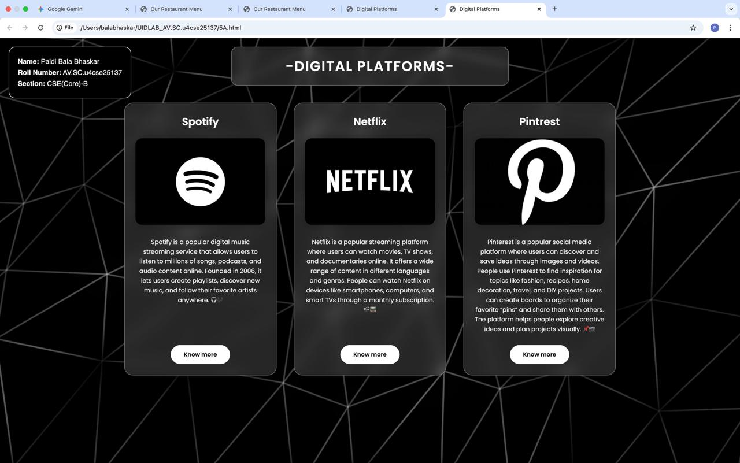
EXPLANATION:
This HTML code creates a modern Digital Platforms webpage using HTML and internal CSS styling. The page includes a background video with a dark overlay, which enhances the visual appearance of the website. A heading titled Digital Platforms is displayed at the top, and information about platforms such as Spotify, Netflix, and Pinterest is presented using card-style sections. Each card contains an image, a short description, and a button. CSS features like flexbox layout, hover effects, custom fonts from Google Fonts, and glassmorphism styling are used to make the design interactive and visually appealing. Overall, the webpage demonstrates how HTML and CSS can be combined to create a modern and responsive web interface.

5(C) Aim:
To design an Amrita login page using HTML and CSS that displays different campuses, where clicking on each campus shows its details on the same page.
Program:
Input:
1. <!DOCTYPE html>
2. <html >
3. <head>
4. <title> Amrita Login</title>
5. <style>
6. body {
7. font-family: Arial, sans-serif;
8. background-color: #f0f4f8;
9. color: #333;
10. padding: 20px;
11. }
12.
13. .container {
14. background-color: #ffffff;
15. border: 1px solid #ccc;
16. border-radius: 20px;
17. width: 100%;
18. max-width: 500px;
19. margin: 0 auto;
20. padding: 30px;
21. }
22.
23. h2 {
24. color: #8B0037;
25. margin-top: 0;
26. }
27.
28. label {
29. display: block;
30. margin-top: 15px;
31. font-weight: bold;
32. font-size: 14px;
33. margin-left: 5px;
34. }
35.
36. input {
37. width: 95%;
38. padding: 12px;
39. margin-top: 5px;
40. border: 1px solid #ccc;
41. border-radius: 10px;
42. box-sizing: border-box;
43. }
44.
45. .login-btn {
46. margin-top: 25px;
47. padding: 12px 20px;
48. background-color: #8B0037;
49. color: white;
50. border: none;
51. border-radius: 25px;
52. cursor: pointer;
53. width: 100%;
54. font-size: 16px;
55. font-weight: bold;
56. }
57.
58. .login-btn:hover {
59. background-color: #6a002a;
60. }
61.
62. hr {
63. margin: 30px 0;
64. border: 0;
65. border-top: 1px solid #ddd;
66. }
67.
68. h3 {
69. margin-top: 0;
70. }
71.
72. .campus-info {
73. background-color: #fafbfc;
74. padding: 15px 20px;
75. border: 1px solid #eee;
76. border-radius: 15px;
77. margin-bottom: 15px;
78. }
79.
80. .campus-info h4 {
81. color: #8B0037;
82. margin-top: 0;
83. margin-bottom: 8px;
84. }
85.
86. .campus-info p {
87. font-size: 14px;
88. margin: 0;
89. line-height: 1.5;
90. }
91. </style>
92. </head>
93. <body>
94.
95.
96. <div class="container">
97.
98. <h2>AUMS Login</h2>
99. <form action="#">
100. <label>Roll Number</label>
101. <input type="text" placeholder="e.g. AV.SC.U4CSE25XXX" required>
102.
103. <label>Password</label>
104. <input type="password" placeholder="Enter password" required>
105.
106. <button type="submit" class="login-btn">Sign In</button>
107. </form>
108.
109. <hr>
110.
111. <h3>Explore Campuses</h3>
112.
113. <div class="campus-info">
114. <h4>Amaravati Campus</h4>
115. <p>Located in the capital region of Andhra Pradesh, offering cutting-edge programs.</p>
116. </div>
117.
118. <div class="campus-info">
119. <h4>Coimbatore Campus</h4>
120. <p>The headquarters of Amrita Vishwa Vidyapeetham set at the foothills of the Western Ghats.</p>
121. </div>
122.
123. <div class="campus-info">
124. <h4>Bengaluru Campus</h4>
125. <p>Situated in India's Silicon Valley with strong industry ties and IT opportunities.</p>
126. </div>
127.
128. <div class="campus-info">
129. <h4>Amritapuri Campus</h4>
130. <p>Nestled between the Arabian Sea and the Kerala backwaters with international research centers.</p>
131. </div>
132.
133. </div>
134.
135. </body>
136. </html>
137.

OUTPUT:
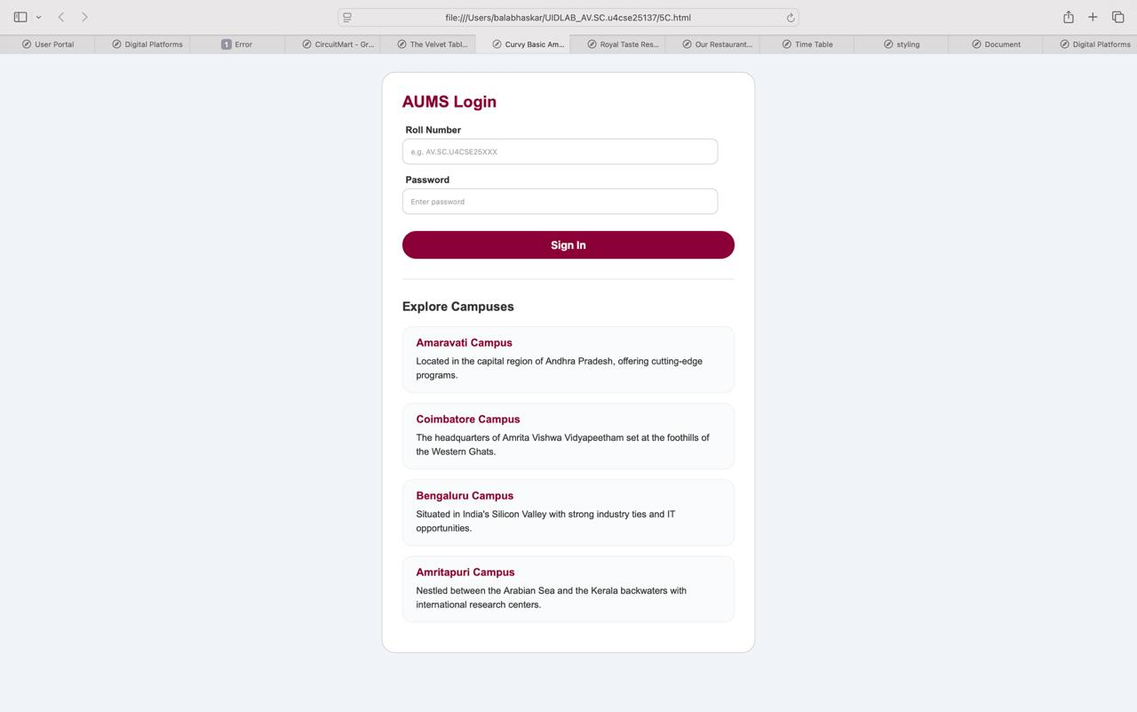
Explanation:
This HTML code creates a simple Amrita AUMS Login webpage using HTML and internal CSS styling. The page contains a centered login form where users can enter their roll number and password to sign in. The design uses CSS to style the layout with a clean container, rounded input fields, and a colored login button for better user experience.Overall, the webpage demonstrates how HTML forms and CSS styling can be used to design a structured and visually appealing login interface.

WEEK-6
(6)
Aim: Design a responsive e-commerce application using the grid layout. This application should contain different categories of products such as electronics, clothing, home-appliances, books. Based on the category we select corresponding products should be displayed on the sidebar.
Program:
Input
1. 1. <!DOCTYPE html>
2. 2. <html lang="en">
3. 3. <head>
4. 4. <meta charset="UTF-8">
5. 5. <meta name="viewport" content="width=device-width, initial-scale=1.0">
6. 6. <title>TechNova - White Edition</title>
7. 7. <style>
8. 8. * {
9. 9. box-sizing: border-box;
10. 10. margin: 0;
11. 11. padding: 0;
12. 12. }
13. 13.
14. 14. body {
15. 15. font-family: 'Segoe UI', sans-serif;
16. 16. color: #333;
17. 17. min-height: 100vh;
18. 18. background-color: #f8fafc;
19. 19. background-image:
20. 20. radial-gradient(at 0% 0%, rgba(37, 99, 235, 0.03) 0px, transparent 50%),
21. 21. radial-gradient(at 100% 100%, rgba(30, 64, 175, 0.03) 0px, transparent 50%);
22. 22. }
23. 23.
24. 24. .container {
25. 25. display: grid;
26. 26. grid-template-areas:
27. 27. "nav header"
28. 28. "nav promo"
29. 29. "nav content"
30. 30. "footer footer";
31. 31. grid-template-columns: 260px 1fr;
32. 32. gap: 15px;
33. 33. padding: 20px;
34. 34. }
35. 35.
36. 36. /* Clean White Panel Style */
37. 37. .panel {
38. 38. background: #ffffff;
39. 39. border: 1px solid #e2e8f0;
40. 40. border-radius: 8px;
41. 41. padding: 20px;
42. 42. box-shadow: 0 4px 6px -1px rgba(0, 0, 0, 0.05);
43. 43. }
44. 44.
45. 45. header {
46. 46. grid-area: header;
47. 47. display: flex;
48. 48. justify-content: space-between;
49. 49. align-items: center;
50. 50. border-left: 5px solid #2563eb;
51. 51. }
52. 52.
53. 53. header h1 {
54. 54. font-size: 1.8rem;
55. 55. letter-spacing: 1px;
56. 56. color: #1e293b;
57. 57. text-transform: uppercase;
58. 58. }
59. 59.
60. 60. .promo-bar {
61. 61. grid-area: promo;
62. 62. background: #2563eb;
63. 63. color: #fff;
64. 64. text-align: center;
65. 65. font-weight: 700;
66. 66. font-size: 0.85rem;
67. 67. padding: 12px;
68. 68. text-transform: uppercase;
69. 69. border-radius: 8px;
70. 70. box-shadow: 0 4px 12px rgba(37, 99, 235, 0.2);
71. 71. }
72. 72.
73. 73. nav {
74. 74. grid-area: nav;
75. 75. height: fit-content;
76. 76. }
77. 77.
78. 78. nav h2 {
79. 79. margin-bottom: 20px;
80. 80. color: #1e293b;
81. 81. font-size: 1.1rem;
82. 82. text-transform: uppercase;
83. 83. border-bottom: 2px solid #f1f5f9;
84. 84. padding-bottom: 10px;
85. 85. }
86. 86.
87. 87. .nav-links a {
88. 88. display: block;
89. 89. color: #64748b;
90. 90. text-decoration: none;
91. 91. padding: 12px;
92. 92. margin: 5px 0;
93. 93. border-radius: 6px;
94. 94. transition: all 0.2s ease;
95. 95. font-size: 0.95rem;
96. 96. font-weight: 500;
97. 97. }
98. 98.
99. 99. .nav-links a:hover {
100. 100. background: #f1f5f9;
101. 101. color: #2563eb;
102. 102. padding-left: 20px;
103. 103. }
104. 104.
105. 105. .content-area {
106. 106. grid-area: content;
107. 107. min-height: 600px;
108. 108. background: #ffffff;
109. 109. border: 1px solid #e2e8f0;
110. 110. border-radius: 8px;
111. 111. box-shadow: 0 4px 6px -1px rgba(0, 0, 0, 0.05);
112. 112. overflow: hidden;
113. 113. }
114. 114.
115. 115. iframe {
116. 116. width: 100%;
117. 117. height: 100%;
118. 118. border: none;
119. 119. }
120. 120.
121. 121. footer {
122. 122. grid-area: footer;
123. 123. text-align: center;
124. 124. font-size: 0.8rem;
125. 125. color: #94a3b8;
126. 126. padding: 20px;
127. 127. margin-top: 10px;
128. 128. }
129. 129. </style>
130. 130. </head>
131. 131. <body>
132. 132.
133. 133. <div class="container">
134. 134. <header class="panel">
135. 135. <h1>TechNova</h1>
136. 136. <div style="font-weight: bold; color: #2563eb;">[ CART: 0 ]</div>
137. 137. </header>
138. 138.
139. 139. <div class="promo-bar">
140. 140. Flash Alert: Get 30% Off using code 'WHITE26'
141. 141. </div>
142. 142.
143. 143. <nav class="panel">
144. 144. <h2>Directory</h2>
145. 145. <div class="nav-links">
146. 146. <a href="products.html" target="view-frame">01. All Products</a>
147. 147. <a href="#" target="view-frame">02. Cloud Infrastructure</a>
148. 148. <a href="#" target="view-frame">03. Neural Networks</a>
149. 149. <a href="#" target="view-frame">04. Data Analytics</a>
150. 150. <a href="#" target="view-frame">05. UI Strategy</a>
151. 151. </div>
152. 152. </nav>
153. 153.
154. 154. <main class="content-area">
155. 155. <iframe name="view-frame" src="products.html"></iframe>
156. 156. </main>
157. 157.
158. 158. <footer>
159. 159. <p>© 2026 TechNova • Terminal ID: CSE25138 • Dev: Paleru Varun</p>
160. 160. </footer>
161. 161. </div>
162. 162.
163. 163. </body>
164. 164. </html>
165. 165.
166.
1. <!DOCTYPE html>
2. <html>
3. <head>
4. <style>
5. * {
6. box-sizing: border-box;
7. }
8.
9. body {
10. margin: 0;
11. padding: 20px;
12. font-family: 'Segoe UI', sans-serif;
13. color: #334155;
14. background: #ffffff;
15. }
16.
17. .grid {
18. display: grid;
19. grid-template-columns: repeat(auto-fill, minmax(260px, 1fr));
20. gap: 20px;
21. }
22.
23. /* Minimal White Card Style */
24. .item-card {
25. background: #ffffff;
26. border: 1px solid #e2e8f0;
27. border-radius: 12px;
28. overflow: hidden;
29. transition: all 0.3s ease;
30. box-shadow: 0 2px 4px rgba(0,0,0,0.02);
31. }
32.
33. .item-card:hover {
34. transform: translateY(-5px);
35. box-shadow: 0 10px 15px -3px rgba(0, 0, 0, 0.1);
36. border-color: #2563eb;
37. }
38.
39. .item-card img {
40. width: 100%;
41. height: 180px;
42. object-fit: cover;
43. border-bottom: 1px solid #f1f5f9;
44. transition: 0.5s;
45. }
46.
47. .card-info {
48. padding: 20px;
49. text-align: left;
50. }
51.
52. .card-info h3 {
53. margin: 0 0 10px 0;
54. font-size: 1.1rem;
55. color: #1e293b;
56. font-weight: 700;
57. }
58.
59. .price-container {
60. display: flex;
61. align-items: baseline;
62. gap: 10px;
63. margin-bottom: 20px;
64. }
65.
66. .price-tag {
67. font-size: 1.25rem;
68. color: #2563eb;
69. font-weight: 800;
70. }
71.
72. .old-price {
73. text-decoration: line-through;
74. color: #94a3b8;
75. font-size: 0.9rem;
76. }
77.
78. .buy-btn {
79. background: #2563eb;
80. color: #ffffff;
81. border: none;
82. padding: 12px;
83. font-weight: 600;
84. border-radius: 8px;
85. cursor: pointer;
86. width: 100%;
87. transition: background 0.2s;
88. text-transform: uppercase;
89. font-size: 0.85rem;
90. letter-spacing: 0.5px;
91. }
92.
93. .buy-btn:hover {
94. background: #1e40af;
95. }
96. </style>
97. </head>
98. <body>
99.
100. <div class="grid">
101. <div class="item-card">
102. <img src="https://images.unsplash.com/photo-1498050108023-c5249f4df085?auto=format&fit=crop&w=500&q=60">
103. <div class="card-info">
104. <h3>React Masterclass</h3>
105. <div class="price-container">
106. <span class="price-tag">₹799</span>
107. <span class="old-price">₹1,499</span>
108. </div>
109. <button class="buy-btn">Enroll Now</button>
110. </div>
111. </div>
112.
113. <div class="item-card">
114. <img src="https://images.unsplash.com/photo-1550751827-4bd374c3f58b?auto=format&fit=crop&w=500&q=60">
115. <div class="card-info">
116. <h3>Cyber Security Pro</h3>
117. <div class="price-container">
118. <span class="price-tag">₹1,299</span>
119. <span class="old-price">₹2,999</span>
120. </div>
121. <button class="buy-btn">Enroll Now</button>
122. </div>
123. </div>
124.
125. <div class="item-card">
126. <img src="6.jpg">
127. <div class="card-info">
128. <h3>Data Visualization</h3>
129. <div class="price-container">
130. <span class="price-tag">₹599</span>
131. <span class="old-price">₹999</span>
132. </div>
133. <button class="buy-btn">Enroll Now</button>
134. </div>
135. </div>
136.
137. <div class="item-card">
138. <img src="https://images.unsplash.com/photo-1561070791-2526d30994b5?auto=format&fit=crop&w=500&q=60">
139. <div class="card-info">
140. <h3>Graphic Mastery</h3>
141. <div class="price-container">
142. <span class="price-tag">₹899</span>
143. <span class="old-price">₹1,200</span>
144. </div>
145. <button class="buy-btn">Enroll Now</button>
146. </div>
147. </div>
148. </div>
149.
150. </body>
151. </html>
152.

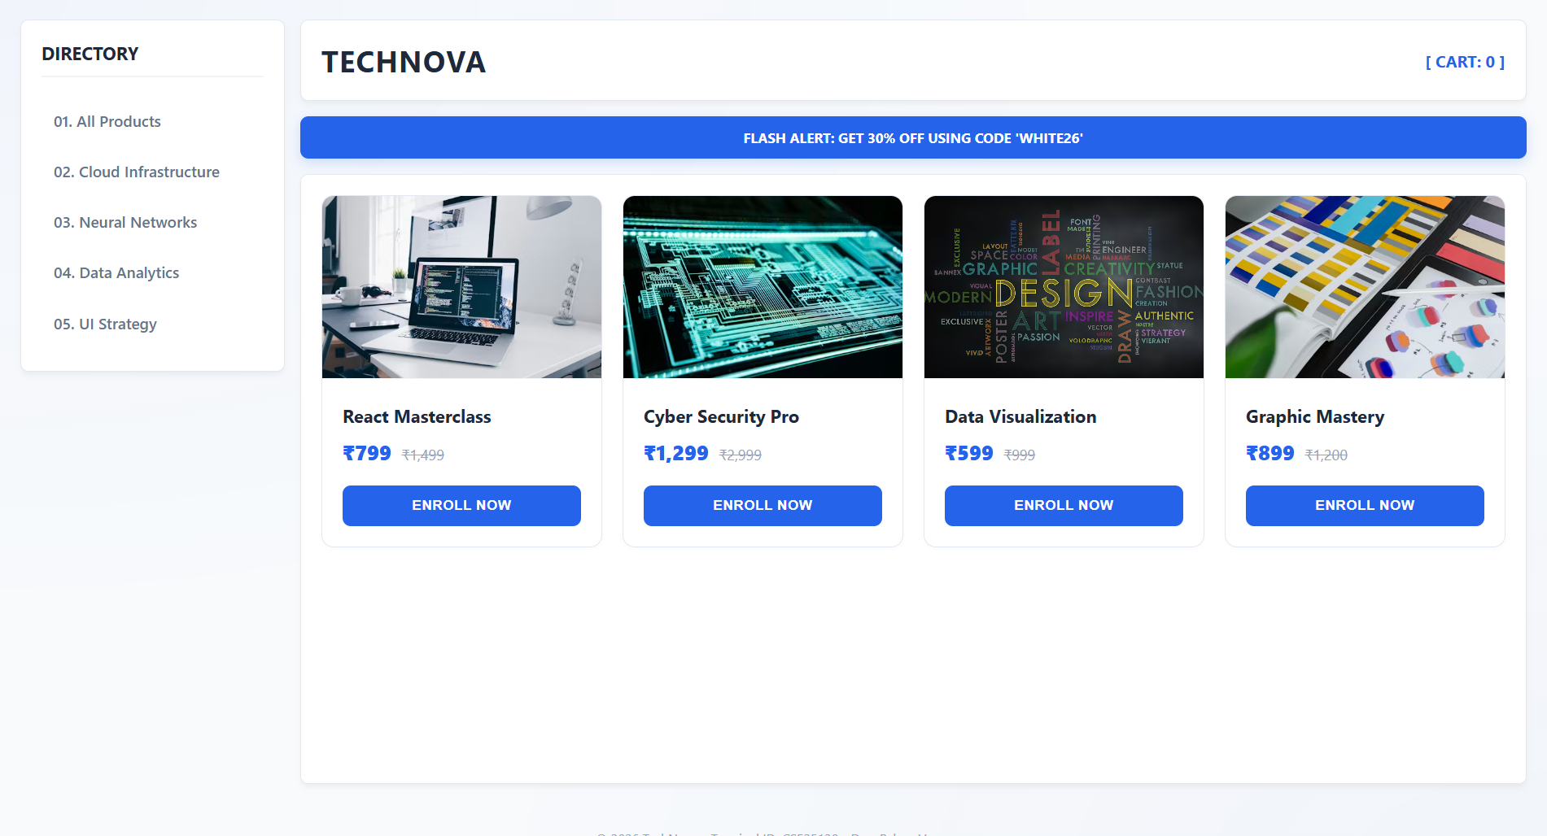
EXPLANATION:

This HTML structure creates a professional, minimalist dashboard interface using a CSS Grid layout. The design employs a "White Edition" aesthetic, utilizing a clean white and light-gray color palette with a vibrant blue (#2563eb) as an accent for key interactive elements like the header border and promo bar. By using a two-column grid system, it effectively separates navigation from content, while the iframe integration allows for dynamic page loading without refreshing the entire dashboard. The inclusion of Glassmorphism-inspired shadows and a subtle radial gradient background adds modern depth, ensuring the UI remains high-contrast and easy to navigate across different screen sizes.

WEEK – 7
AIM: passing code to github
Step 1: Setting Up Your GitHub Account
If you haven’t already, head over to [GitHub](https://github.com) and create an account. It’s free and will be your central hub for version-controlled repositories.
Step 2: Creating a New Repository
1. Once logged in, click the ‘+’ icon in the top right corner and select “New Repository.”
2. Provide a name for your repository and, optionally, a description.
3. Choose the repository’s visibility (public or private).
4. Add a .gitignore file if needed, based on the programming language you’re using.
5. Choose an open-source license if applicable.
6. Finally, click “Create Repository.”
Press enter or click to view image in full size
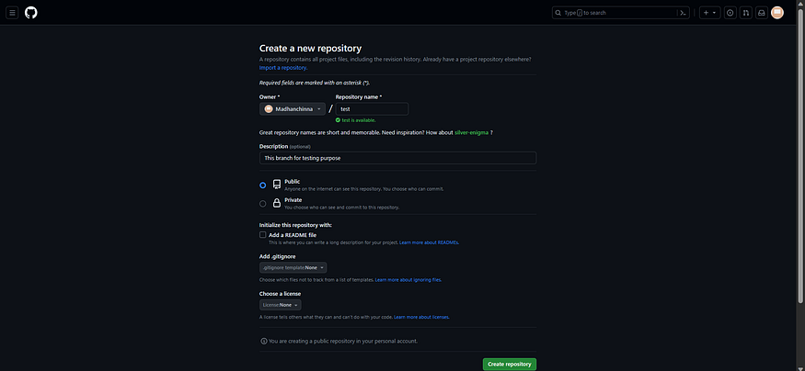
Create a git repo with the name of test
Part 2: Pushing Local Code to GitHub
Step 1: Cloning the Repository
- On your GitHub repository’s main page, click the green “Code” button to copy the repository URL.
Press enter or click to view image in full size
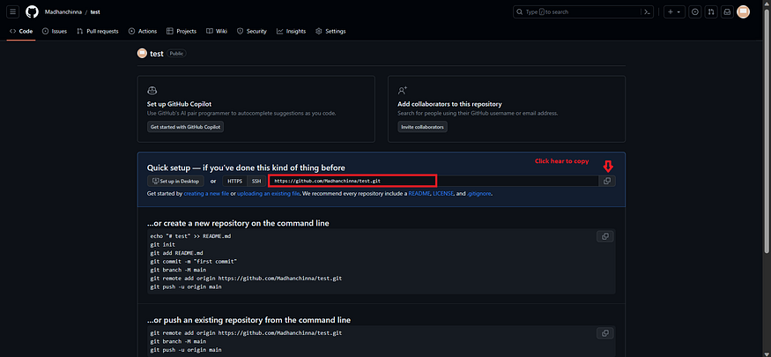
2. Open your terminal and navigate to the directory where you want to store your local repository.
3. Use the following command to clone the repository:
git clone <repository_url>
#Example
git clone https://github.com/Madhanchinna/test.git
Press enter or click to view image in full size
It will show Warning because we are cloning the Emoty repository
Step 2: Making and Committing Changes
1. Open the cloned repository in your favourite code editor and make the necessary changes to your code.
2. In your terminal, navigate to the repository directory.
Get Madhan Chinnasamy’s stories in your inbox
Join Medium for free to get updates from this writer.
Subscribe
Remember me for faster sign in
Adding some files to the repo directory
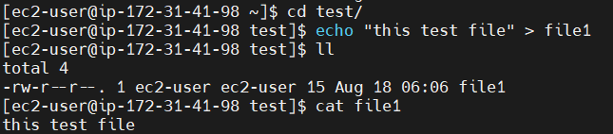
3. Use the `git status` command to check the status of the repository files
Press enter or click to view image in full size
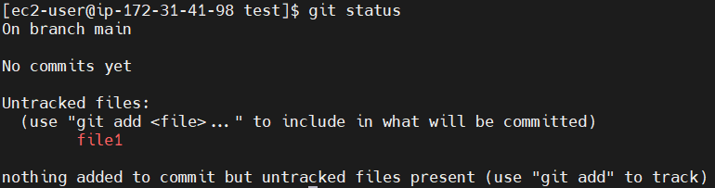
3. Use the `git add` command to stage the changes you want to commit:
# To add all the files to the repo directory
git add .
4. Commit the staged changes with a descriptive message:
git commit -m "First commit"
Press enter or click to view image in full size
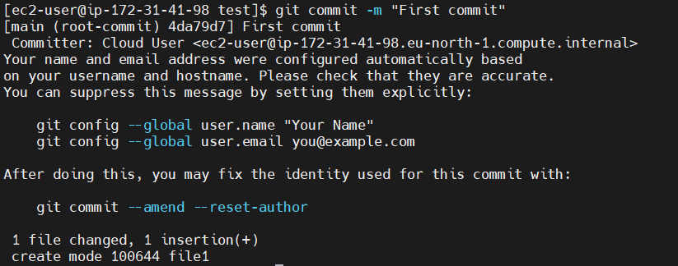
Step 3: Pushing Changes to GitHub
- Now, it’s time to push your local changes to the remote GitHub repository. Use the following command, replacing “main” with your branch name if needed:
git push origin main
If you enter the GitHub credentials it will show the error

WEEK-8
(8)A
Aim: to create a webpage that displays a square that continuously rotates 360 degrees using CSS Animation.
Program:
Input
1. <!DOCTYPE html>
2. <html>
3. <head>
4. <title>lab8a</title>
5. <style>
6. body {
7. display: flex;
8. justify-content: center;
9. align-items: center;
10. height:850px;
11. margin: 0;
12. background-color:white;
13. }
14.
15. div{
16. width: 80px;
17. height: 80px;
18. background: linear-gradient(45deg, rgb(255,0,204), rgb(51,51,255));
19. border-radius: 15px;
20.
21. animation:
22. spin 4s linear infinite,
23. pulse 2s ease-in-out infinite alternate;
24. }
25.
26.
27. @keyframes spin {
28. from {
29. rotate: 0deg;
30. }
31. to {
32. rotate: 360deg;
33. }
34. }
35.
36. @keyframes pulse {
37. 0% {
38. scale: 1;
39. box-shadow: 0 0 20px rgba(255, 0, 204, 0.4);
40. }
41. 100% {
42. scale: 1.4;
43. box-shadow: 0 0 60px rgba(51, 51, 255, 0.9);
44. }
45. }
46. </style>
47. </head>
48. <body>
49.
50. <div></div>
51.
52. </body>
53. </html>
54.

OUTPUT
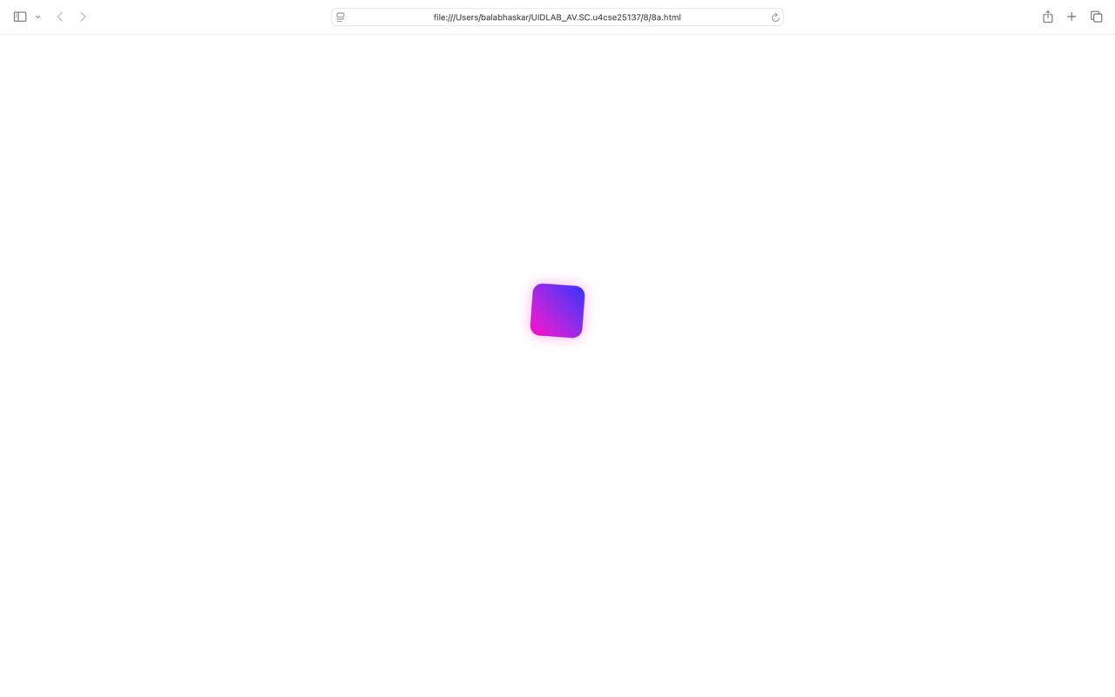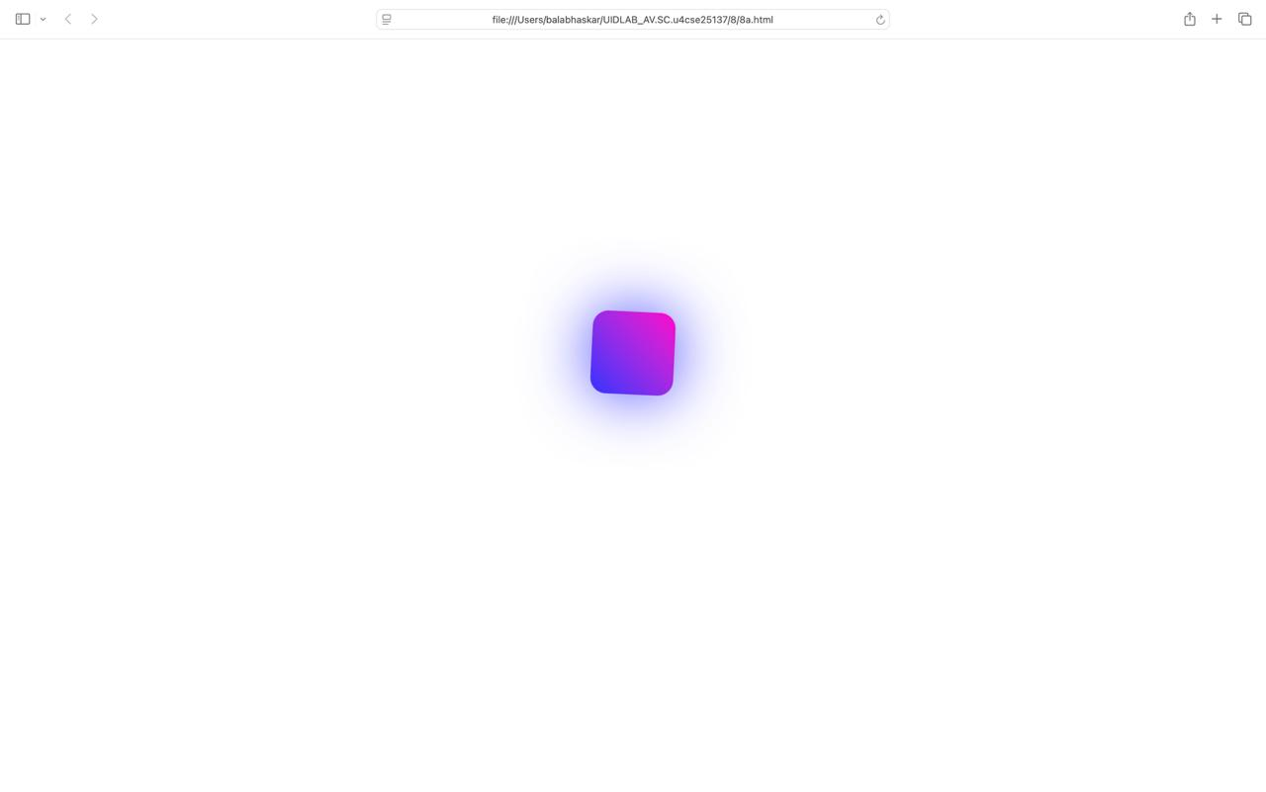
Explanation
The design centers a single div element on a white background using CSS Flexbox within the body tag. The square itself is 80px in size and features a 45-degree linear gradient that blends magenta into a deep blue. To soften the appearance, a 15px border-radius is applied, creating a smooth, rounded shape.
• Spin Animation: Utilizing the @keyframes spin, the element rotates from 0 to 360 degrees. This is set to a 4s (4-second) duration with a linear timing function, ensuring the rotation remains perfectly constant and seamless as it loops infinitely.
• Pulse Animation: Driven by @keyframes pulse, this effect scales the element from its original size (scale: 1) up to 140% (scale: 1.4). Simultaneously, the box-shadow expands and becomes more intense, creating a glowing neon effect.
• Timing: The pulse animation is set to alternate, which makes the square smoothly "breathe" in and out every two seconds.

(8)B
Aim: to create a webpage that displays a ball that moves up and down continuously using CSS Animation.
Program:
1. <!DOCTYPE html>
2. <html>
3. <head>
4. <title>Lab8b</title>
5. <style>
6. body {
7. display: flex;
8. justify-content: center;
9. align-items: center;
10. height:850px ;
11. margin: 0;
12. background-color:white;
13. }
14.
15. div {
16. width: 60px;
17. height: 60px;
18. background:linear-gradient(45deg, rgb(22, 191, 213), rgb(21, 93, 117));;
19. border-radius: 50%;
20.
21. animation: bounce 0.8s ease-in-out infinite alternate;
22. }
23.
24. @keyframes bounce {
25. 0% {
26. transform: translateY(-100px);
27. box-shadow: 0 0 20px rgba(22, 191, 213,0.4)
28. }
29. 100% {
30. transform: translateY(100px);
31. box-shadow:0 0 20px rgba(21, 93, 117,0.9);
32. }
33. }
34. </style>
35. </head>
36. <body>
37.
38. <div></div>
39.
40. </body>
41. </html>
42.
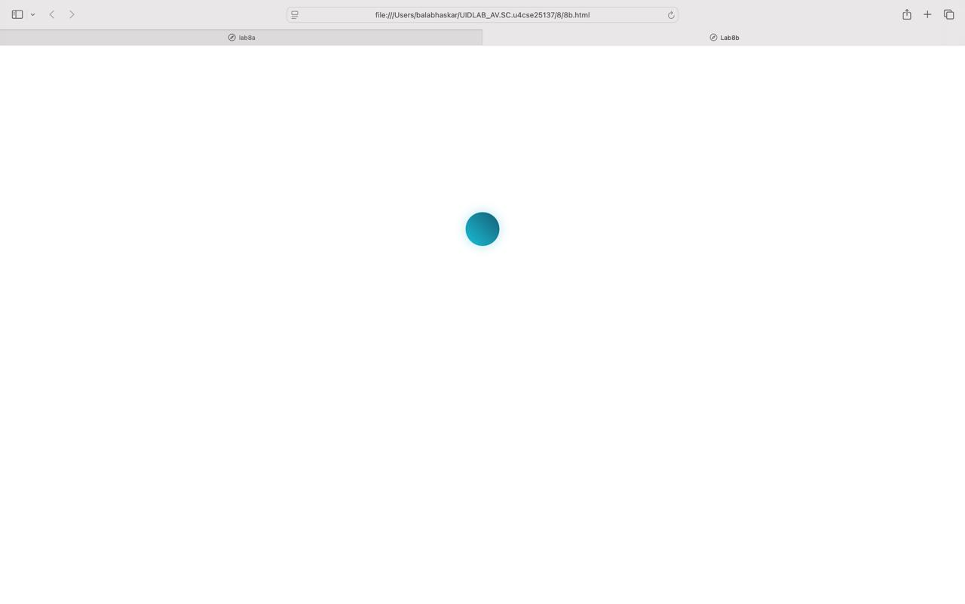
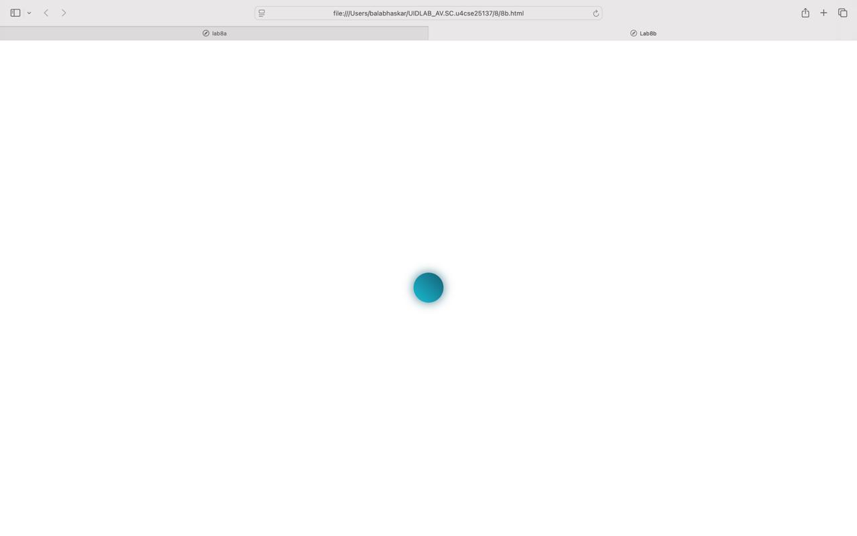

EXPLANATION
The body is configured as a flex container to perfectly center the content both horizontally and vertically within a fixed viewport height of 850px. The div itself is styled to look like a sphere by using a border-radius: 50% and a 45-degree linear gradient that transitions from a bright cyan (rgb(22, 191, 213)) to a darker teal (rgb(21, 93, 117)).
(8)C
Aim: to create a webpage that displays a circle that moves horizontally and rotates at the same time.
Program:
1. <!DOCTYPE html>
2. <html>
3. <head>
4. <title>lab8c</title>
5. <style>
6. body {
7. display: flex;
8. justify-content: center;
9. align-items: center;
10. height: 850px;
11. margin: 0;
12. background-color: white;
13. }
14.
15. .circle {
16. width: 80px;
17. height: 80px;
18. border-radius: 50%;
19. border: 5px dotted rgba(165, 165, 165, 1);
20.
21. animation:
22. moveho 2.5s ease-in-out infinite alternate,
23. spin 3s linear infinite alternate;
24. }
25.
26. @keyframes moveho {
27. 0% {
28. translate: -200px;
29. }
30. 100%{
31. translate: 200px;
32. }
33. }
34.
35. @keyframes spin {
36. 0% {
37. rotate: 0deg;
38. }
39. 100%{
40. rotate: 360deg;
41. }
42. }
43. </style>
44. </head>
45. <body>
46.
47. <div class="circle"></div>
48.
49. </body>
50. </html>
51.
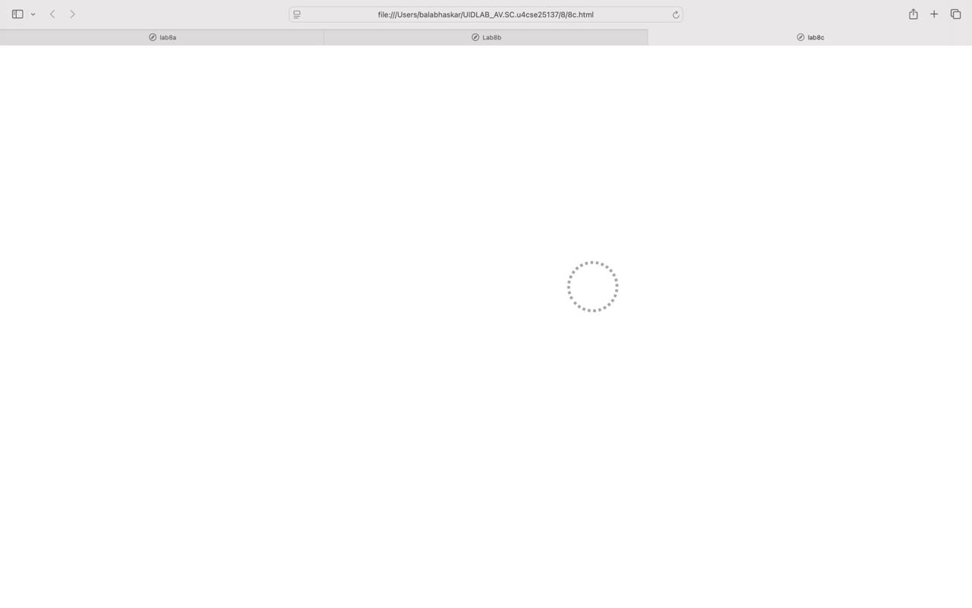
EXPLANATION
The body uses CSS Flexbox to center the element within a fixed vertical height of 850px. The element, defined by the .circle class, is styled as an 80px by 80px square with a border-radius: 50% to form a perfect circle. Instead of a solid fill, it features a 5px dotted border in a solid gray color, which makes the rotation visible to the viewer.
WEEK-9
(9)A
Aim: to create a webpage that displays weather a number is even/odd or prime/composite or factorial of the number and is Armstrong number or not with HTML, CSS, JS.
Program:
1. <!DOCTYPE html>
2. <html>
3. <head>
4. <title>lab9</title>
5. <style>
6. button{
7. display: inline;
8. justify-content: center;
9. align-items: center;
10. text-align: center;
11. align-content: center;
12. border:5px solid #ccc;
13. border-radius: 18px;
14. padding: 20px;
15. margin: 15px;
16. color: white;
17. }
18. </style>
19. </head>
20. <body>
21.
22. <input type="number" id="numInput" placeholder="Enter a number" style="border: 5px;border-radius: 18px; padding: 20px; margin: 15px;display:inline;justify-content: center;align-items: center;background-color:#8B0037 ;box-shadow: 0 5px 12px 0 rgba(0, 0, 0, 0.3);color: white;">
23. <br><br>
24.
25. <button onclick="checkEven()">Check Even</button>
26. <button onclick="checkOdd()">Check Odd</button>
27. <button onclick="checkPrime()">Check Prime</button>
28. <button onclick="getFactorial()">Factorial</button>
29. <button onclick="checkArmstrong()">Check Armstrong</button>
30.
31. <br><br>
32. <div id="output"></div>
33.
34. <script>
35. var display = document.getElementById("output");
36.
37. // input calling with id
38. function getNumber() {
39. return Number(document.getElementById("numInput").value);
40. }
41.
42. // 1. Check Even
43. function checkEven() {
44. var num = getNumber();
45. if (num % 2 == 0) {
46. display.innerHTML = num + " is Even.";
47. } else {
48. display.innerHTML = num + " is NOT Even.";
49. }
50. }
51.
52. // 2. Check Odd
53. function checkOdd() {
54. var num = getNumber();
55. if (num % 2 != 0) {
56. display.innerHTML = num + " is Odd.";
57. } else {
58. display.innerHTML = num + " is NOT Odd.";
59. }
60. }
61.
62. // 3. Check Prime
63. function checkPrime() {
64. var num = getNumber();
65. var isPrime = true;
66.
67. if (num < 2) {
68. isPrime = false; // 0 and 1 are not prime
69. } else {
70. // Try dividing by every number up to the number itself
71. for (var i = 2; i < num; i++) {
72. if (num % i == 0) {
73. isPrime = false; // We found a match, so it's not prime
74. }
75. }
76. }
77.
78. if (isPrime == true) {
79. display.innerHTML = num + " is Prime.";
80. } else {
81. display.innerHTML = num + " is NOT Prime.";
82. }
83. }
84.
85. // 4. Calculate Factorial
86. function getFactorial() {
87. var num = getNumber();
88. var answer = 1;
89.
90. for (var i = 1; i <= num; i++) {
91. answer = answer * i;
92. }
93.
94. display.innerHTML = "The Factorial is " + answer;
95. }
96.
97. // 5. Check Armstrong
98. function checkArmstrong() {
99. var num = getNumber();
100. var textNum = num.toString();
101. var totalDigits = textNum.length;
102. var sum = 0;
103.
104. for (var i = 0; i < totalDigits; i++) {
105. var singleDigit = Number(textNum[i]);
106. sum = sum + Math.pow(singleDigit, totalDigits);
107. }
108.
109. if (sum == num) {
110. display.innerHTML = num + " is an Armstrong Number.";
111. } else {
112. display.innerHTML = num + " is NOT an Armstrong Number.";
113. }
114. }
115. </script>
116.
117. </body>
118. </html>
119.
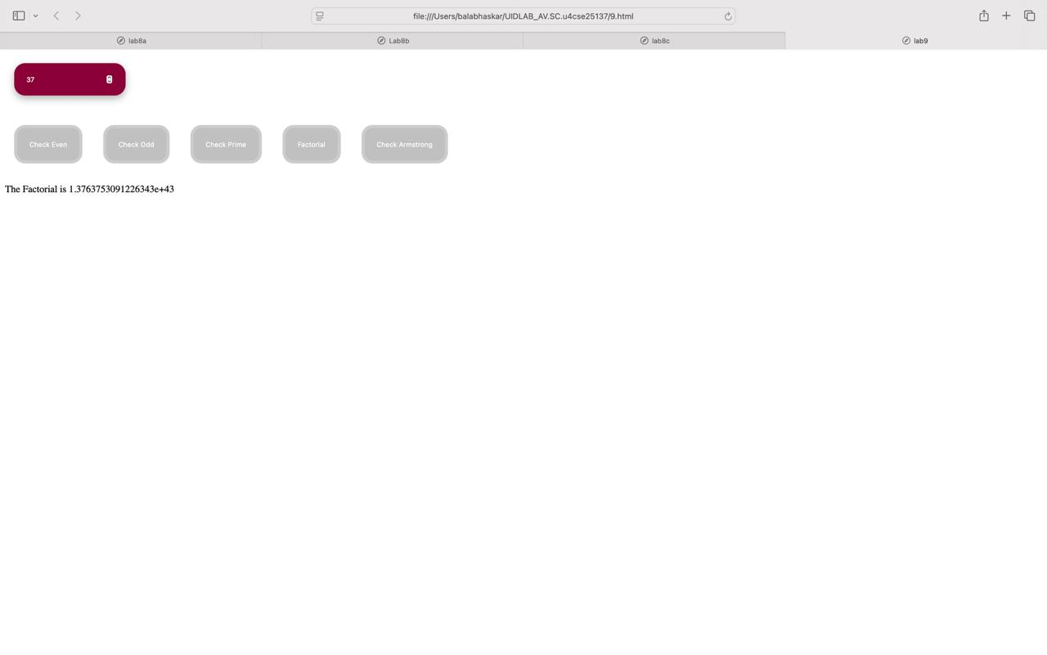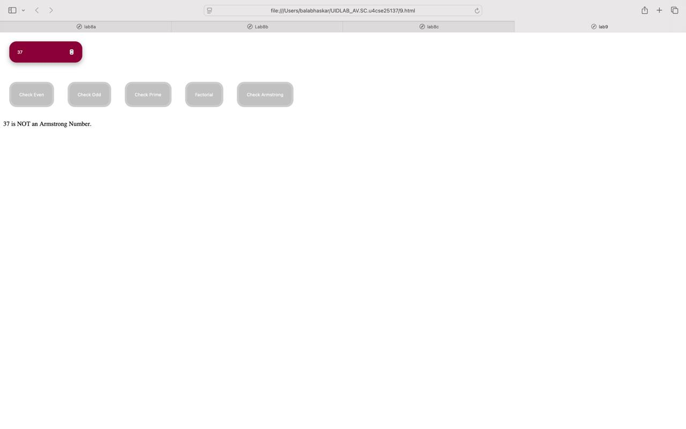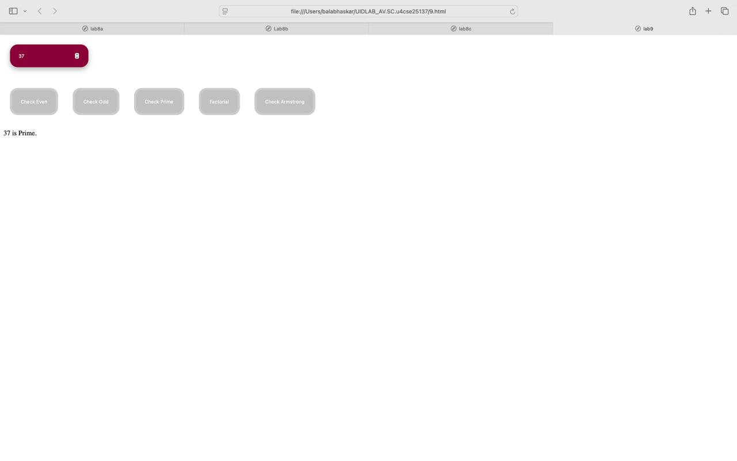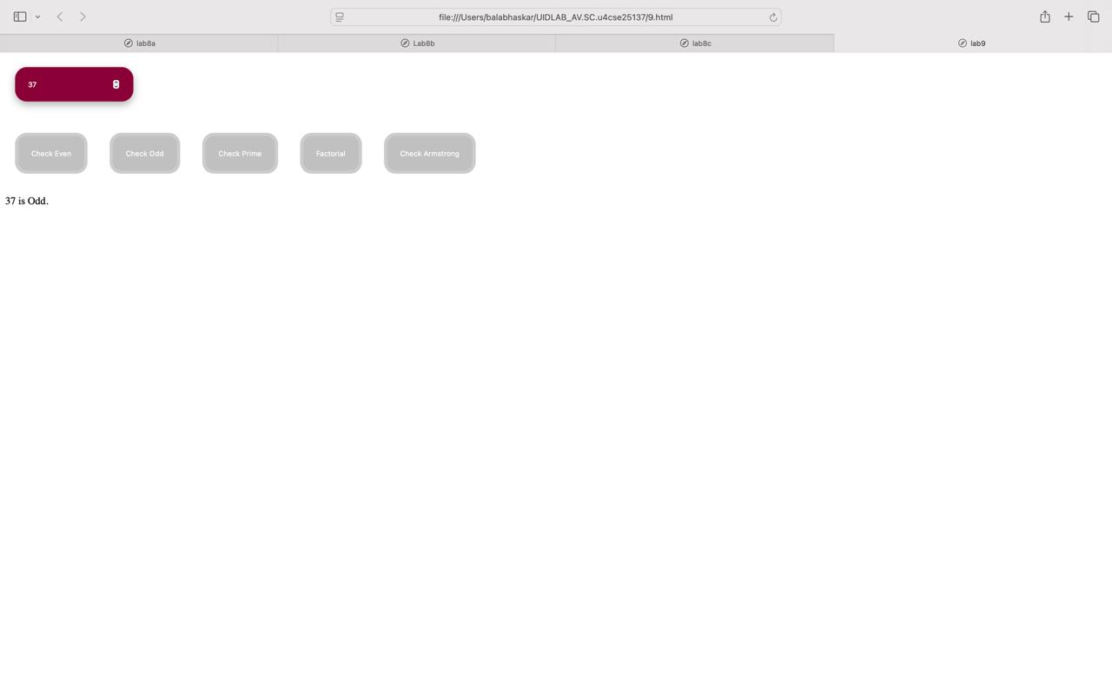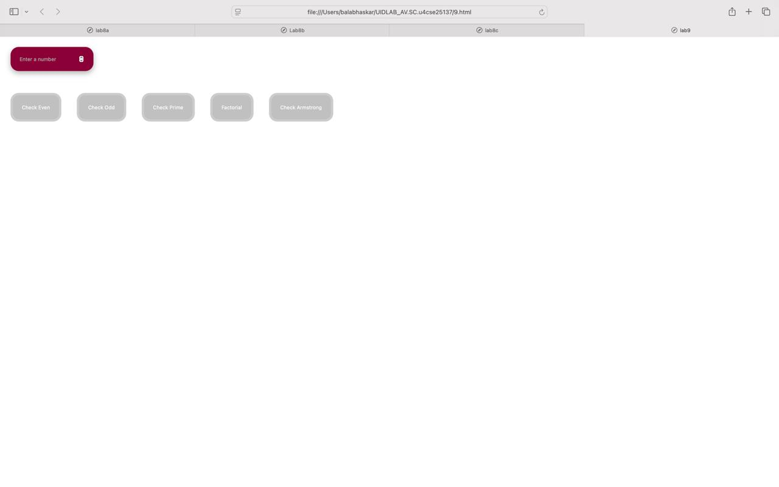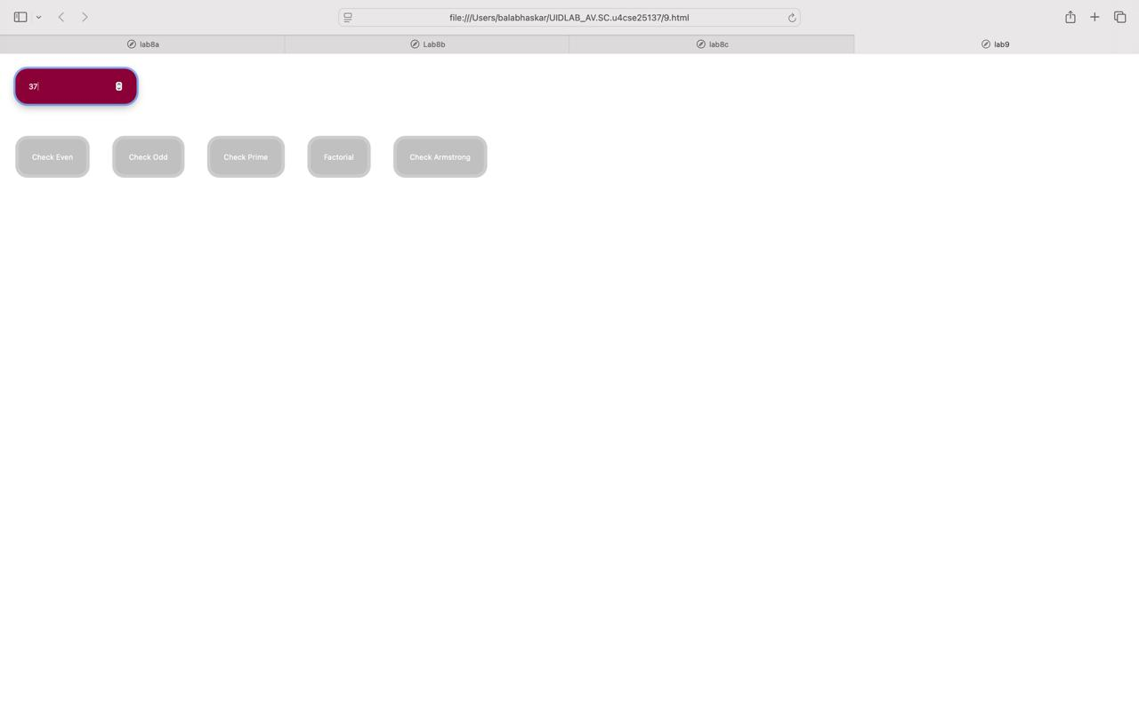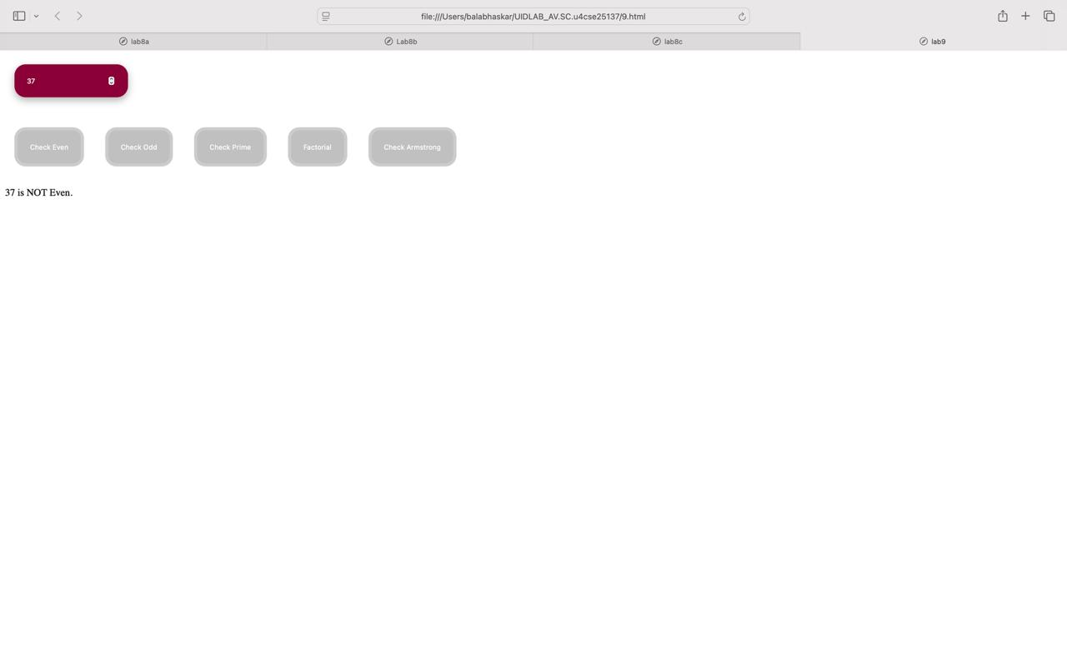

EXPLANATION:
The interface features a stylized number input box and a series of buttons. The input field is designed with a deep maroon background (#8B0037), rounded corners, and a subtle box shadow to give it a modern, elevated look. Each button is styled with consistent padding, rounded borders, and white text, arranged in a row to provide a clear set of action

WEEK-10

a)AIM: write a Java script conditional statement to find the sign of product of three numbers using function. Display an alert box with specific sign
1. CODE:
<html>
2. <head>
3. <title>Product Check</title>
4.
5. <script>
6. function product(a, b, c)
7. {
8. return a * b * c;
9. }
10.
11. function checkSign()
12. {
13. let p = parseInt(document.getElementById("p").value);
14. let q = parseInt(document.getElementById("q").value);
15. let r = parseInt(document.getElementById("r").value);
16.
17. let result = product(p,q,r);
18.
19. if(result >= 0)
20. {
21. alert("The sign is Positive: " + result);
22. }
23. else
24. {
25. alert("The sign is Negative: " + result);
26. }
27. }
28. </script>
29.
30. </head>
31.
32. <body>
33.
34. <h3>Enter Three Numbers</h3>
35.
36. Number 1: <input type="number" id="p"><br><br>
37. Number 2: <input type="number" id="q"><br><br>
38. Number 3: <input type="number" id="r"><br><br>
39.
40. <input type="button" value="Check Product Sign" onclick="checkSign()">
41.
42. </body>
43.

OUTPUT:
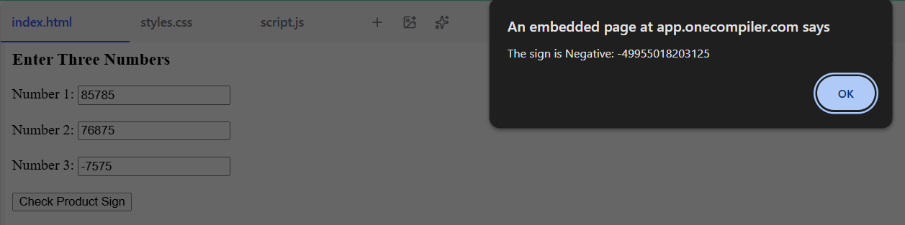
This code creates a simple webpage that multiplies three numbers together. When you type numbers into the three boxes and click the button, it calculates their total. Finally, it shows a pop-up message telling you the final answer and whether that answer is positive or negative.

b) To Sort 3 number using functions. Display on alert box to show the result.
CODE:
1. <!DOCTYPE html>
2. <html lang="en">
3. <head>
4. <meta charset="UTF-8">
5. <meta name="viewport" content="width=device-width, initial-scale=1.0">
6. <title>Sort 3 Numbers</title>
7. <style>
8. body {
9. font-family: sans-serif;
10. text-align: center;
11. margin-top: 50px;
12. }
13. button {
14. padding: 10px 20px;
15. font-size: 16px;
16. cursor: pointer;
17. background-color: #007BFF;
18. color: white;
19. border: none;
20. border-radius: 5px;
21. }
22. button:hover {
23. background-color: #0056b3;
24. }
25. </style>
26. </head>
27. <body>
28.
29. <h2>Sort Three Numbers</h2>
30. <p>Click the button below to sort the numbers <strong>42, 15, and 89</strong>.</p>
31.
32. <button onclick="runSort()">Sort Numbers</button>
33.
34. <script>
35.
36. function sortThreeNumbers(num1, num2, num3) {
37. let numbers = [num1, num2, num3];
38. numbers.sort((a, b) => a - b);
39. alert("The sorted numbers are: " + numbers.join(", "));
40. }
41.
42.
43. function runSort() {
44.
45. sortThreeNumbers(42, 15, 89);
46. }
47. </script>
48.
49. </body>
50. </html>
51.

OUTPUT
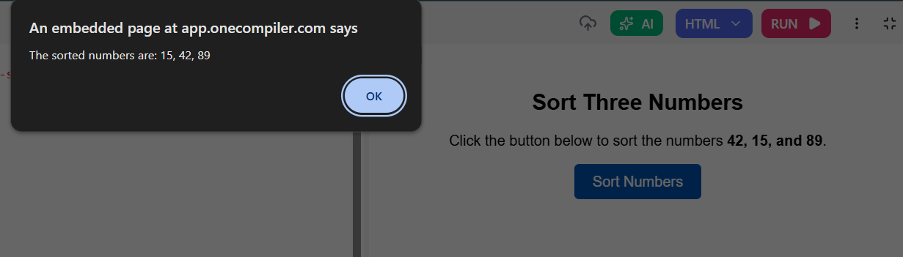
This code creates a simple webpage featuring a styled "Sort Numbers" button. When you click the button, it takes three specific numbers (42, 15, and 89), groups them together, and automatically arranges them in order from smallest to largest. Finally, it displays a pop-up alert on your screen showing the sorted result: "15, 42, 89".

c) To find the biggest of 5 numbers.
CODE:
1. <!DOCTYPE html>
2. <html lang="en">
3. <head>
4. <meta charset="UTF-8">
5. <meta name="viewport" content="width=device-width, initial-scale=1.0">
6. <title>Find Biggest Number</title>
7. <style>
8. body {
9. font-family: sans-serif;
10. text-align: center;
11. margin-top: 50px;
12. }
13. button {
14. padding: 10px 20px;
15. font-size: 16px;
16. cursor: pointer;
17. background-color: #28a745;
18. color: white;
19. border: none;
20. border-radius: 5px;
21. }
22. button:hover {
23. background-color: #218838;
24. }
25. </style>
26. </head>
27. <body>
28.
29. <h2>Find the Biggest of 5 Numbers</h2>
30. <p>Click the button below to find the largest number among <strong>12, 45, 7, 89, and 34</strong>.</p>
31.
32. <button onclick="runFindBiggest()">Find Biggest Number</button>
33.
34. <script>
35.
36. function findBiggestOfFive(num1, num2, num3, num4, num5) {
37.
38. let biggest = Math.max(num1, num2, num3, num4, num5);
39.
40.
41. alert("The biggest number is: " + biggest);
42. }
43.
44. function runFindBiggest() {
45. findBiggestOfFive(12, 45, 7, 89, 34);
46. }
47. </script>
48.
49. </body>
50. </html>
51.

OUTPUT
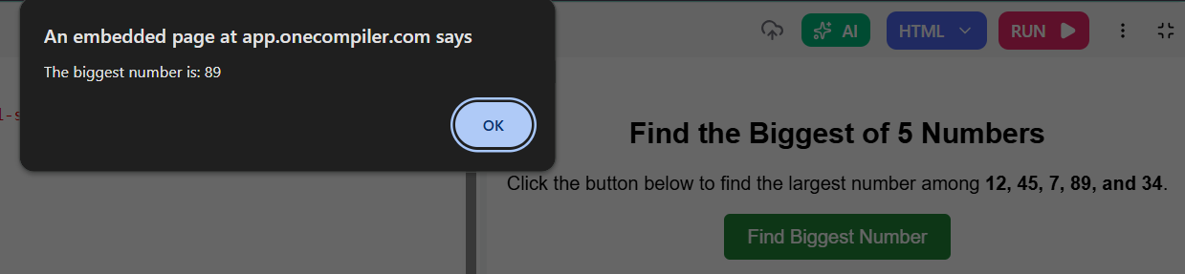

This code creates a webpage with a button designed to identify the highest value in a group. When clicked, it looks at five specific numbers (12, 45, 7, 89, and 34), compares them using a built-in math function, and displays a pop-up alert identifying 89 as the largest one.

d) To lterate the form 0 to 15, for each iteration to check if the current number is odd or even, and display the message to the screen.
CODE:
1. <!DOCTYPE html>
2. <html lang="en">
3. <head>
4. <meta charset="UTF-8">
5. <meta name="viewport" content="width=device-width, initial-scale=1.0">
6. <title>JavaScript Number Tasks</title>
7. <style>
8. body {
9. font-family: sans-serif;
10. margin: 20px auto;
11. max-width: 600px;
12. line-height: 1.6;
13. }
14. .task-container {
15. border: 1px solid #ccc;
16. padding: 20px;
17. margin-bottom: 20px;
18. border-radius: 8px;
19. background-color: #f9f9f9;
20. }
21. button {
22. padding: 10px 15px;
23. font-size: 14px;
24. cursor: pointer;
25. background-color: #007BFF;
26. color: white;
27. border: none;
28. border-radius: 5px;
29. }
30. button:hover {
31. background-color: #0056b3;
32. }
33. .even { color: blue; font-weight: bold; margin: 2px 0;}
34. .odd { color: red; font-weight: bold; margin: 2px 0;}
35. </style>
36. </head>
37. <body>
38.
39. <h1>JavaScript Tasks</h1>
40.
41. <div class="task-container">
42. <h2>1. Sort 3 Numbers</h2>
43. <p>Sorts the numbers: <strong>42, 15, 89</strong></p>
44. <button onclick="runSort()">Show Sorted Numbers (Alert)</button>
45. </div>
46.
47. <div class="task-container">
48. <h2>2. Find Biggest of 5 Numbers</h2>
49. <p>Finds the largest among: <strong>12, 45, 7, 89, 34</strong></p>
50. <button onclick="runFindBiggest()">Show Biggest Number (Alert)</button>
51. </div>
52.
53. <div class="task-container">
54. <h2>3. Even or Odd (0 to 15)</h2>
55. <p>Iterates from 0 to 15 and prints the result to the screen.</p>
56. <button onclick="runEvenOdd()">Display Even/Odd Sequence</button>
57.
58. <div id="resultBox" style="margin-top: 15px;"></div>
59. </div>
60.
61. <script>
62. function runSort() {
63. let numbers = [42, 15, 89];
64. numbers.sort((a, b) => a - b);
65. alert("The sorted numbers are: " + numbers.join(", "));
66. }
67.
68. function runFindBiggest() {
69. let biggest = Math.max(12, 45, 7, 89, 34);
70. alert("The biggest number is: " + biggest);
71. }
72.
73. function runEvenOdd() {
74. let displayArea = document.getElementById("resultBox");
75. let resultHTML = ""; // Start with an empty string
76.
77. for (let i = 0; i <= 15; i++) {
78. if (i % 2 === 0) {
79. resultHTML += "<p class='even'>" + i + " is even</p>";
80. } else {
81. resultHTML += "<p class='odd'>" + i + " is odd</p>";
82. }
83. }
84. displayArea.innerHTML = resultHTML;
85. }
86. </script>
87.
88. </body>
89. </html>
90.

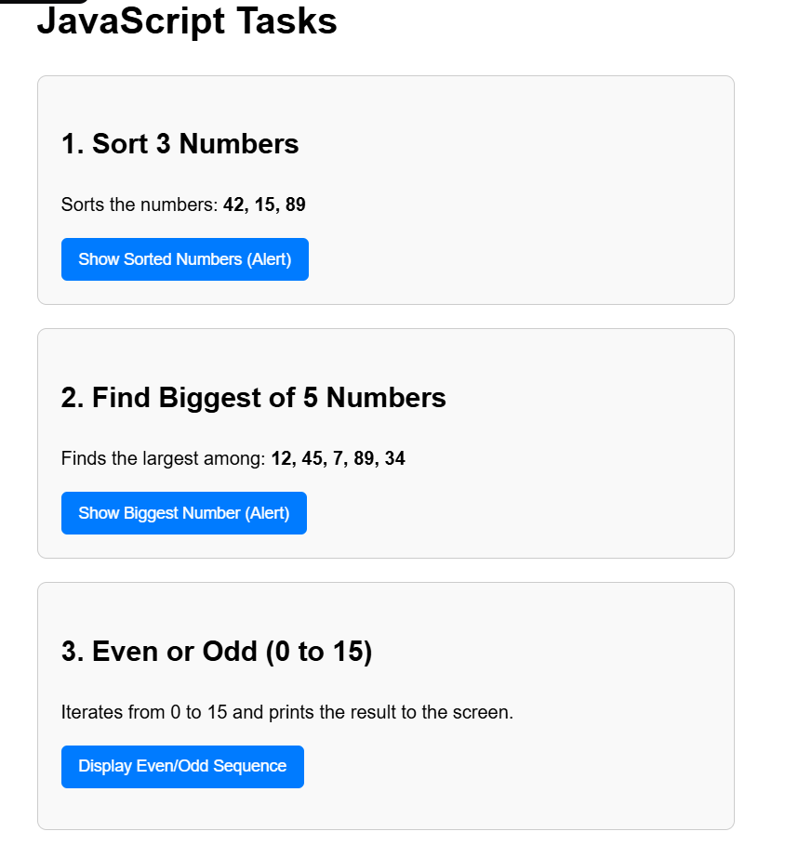

EXPLANATION:
This code builds a consolidated webpage that performs three distinct JavaScript tasks. Each task is triggered by its own button:
- Task 1 (Sort Numbers): Arranges a specific list of numbers in ascending order and shows the result in an alert box.
- Task 2 (Find Biggest): Uses a built-in math function to identify the largest number from a set and displays it via an alert.
- Task 3 (Even or Odd): Runs a loop from 0 to 15. It checks each number using the modulo operator (which finds the remainder of division) to determine if it is even or odd, then updates the webpage directly to display the list with color-coded labels.

e) To write a JS program to read 6 subject marks of a student and then compute the average marks of the student. Then the average is used to determine the corresponding grade.
CODE:
1. <!DOCTYPE html>
2. <html lang="en">
3. <head>
4. <meta charset="UTF-8">
5. <meta name="viewport" content="width=device-width, initial-scale=1.0">
6. <title>Grade Calculator</title>
7. <style>
8. body {
9. font-family: sans-serif;
10. max-width: 400px;
11. margin: 40px auto;
12. padding: 20px;
13. background-color: #f4f4f9;
14. border-radius: 8px;
15. box-shadow: 0 4px 8px rgba(0,0,0,0.1);
16. }
17. h2 { text-align: center; }
18. .input-group {
19. margin-bottom: 15px;
20. display: flex;
21. justify-content: space-between;
22. }
23. input {
24. width: 60px;
25. padding: 5px;
26. font-size: 16px;
27. }
28. button {
29. width: 100%;
30. padding: 10px;
31. font-size: 16px;
32. cursor: pointer;
33. background-color: #007BFF;
34. color: white;
35. border: none;
36. border-radius: 5px;
37. margin-top: 10px;
38. }
39. button:hover { background-color: #0056b3; }
40. #result {
41. margin-top: 20px;
42. padding: 15px;
43. background-color: white;
44. border-radius: 5px;
45. text-align: center;
46. font-weight: bold;
47. display: none;
48. }
49. </style>
50. </head>
51. <body>
52.
53. <h2>Grade Calculator</h2>
54.
55. <div class="input-group">
56. <label>Subject 1:</label>
57. <input type="number" id="sub1" value="0" min="0" max="100">
58. </div>
59. <div class="input-group">
60. <label>Subject 2:</label>
61. <input type="number" id="sub2" value="0" min="0" max="100">
62. </div>
63. <div class="input-group">
64. <label>Subject 3:</label>
65. <input type="number" id="sub3" value="0" min="0" max="100">
66. </div>
67. <div class="input-group">
68. <label>Subject 4:</label>
69. <input type="number" id="sub4" value="0" min="0" max="100">
70. </div>
71. <div class="input-group">
72. <label>Subject 5:</label>
73. <input type="number" id="sub5" value="0" min="0" max="100">
74. </div>
75. <div class="input-group">
76. <label>Subject 6:</label>
77. <input type="number" id="sub6" value="0" min="0" max="100">
78. </div>
79.
80. <button onclick="calculateGrade()">Calculate Average & Grade</button>
81.
82. <div id="result"></div>
83.
84. <script>
85. function calculateGrade() {
86. let m1 = parseFloat(document.getElementById("sub1").value);
87. let m2 = parseFloat(document.getElementById("sub2").value);
88. let m3 = parseFloat(document.getElementById("sub3").value);
89. let m4 = parseFloat(document.getElementById("sub4").value);
90. let m5 = parseFloat(document.getElementById("sub5").value);
91. let m6 = parseFloat(document.getElementById("sub6").value);
92.
93. let totalMarks = m1 + m2 + m3 + m4 + m5 + m6;
94. let average = totalMarks / 6;
95.
96. average = average.toFixed(2);
97.
98. let grade = "";
99. if (average >= 90) {
100. grade = "A";
101. } else if (average >= 80) {
102. grade = "B";
103. } else if (average >= 70) {
104. grade = "C";
105. } else if (average >= 60) {
106. grade = "D";
107. } else {
108. grade = "F";
109. }
110.
111. let resultBox = document.getElementById("result");
112. resultBox.style.display = "block";
113. resultBox.innerHTML = "Average Marks: " + average + "% <br><br> Final Grade: " + grade;
114. }
115. </script>
116.
117. </body>
118.
</html>
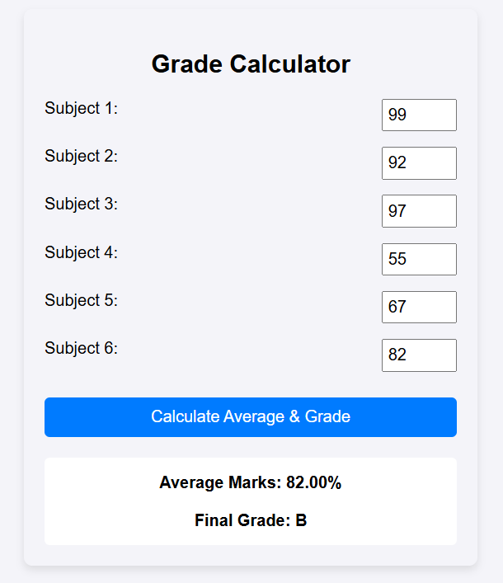

EXPLANATION
This code creates an interactive Grade Calculator webpage. It provides six input fields where you can enter subject marks (0–100), and when you click the "Calculate" button, it performs the following steps:
- Average Calculation: The script reads the numbers from all six fields, computes their sum, and divides by six.
- Grading Logic: It uses a series of conditional (if...else if) statements to assign a letter grade based on that average.
- Result Display: It dynamically updates a hidden results section on the page to show the final calculated percentage and the letter grade.

WEEK-11
1.AIM: A website requires users to enter a username. The system should display a message while typing if the username is less than 5 characters
CODE:
1. <!DOCTYPE html>
2. <html lang="en">
3. <head>
4. <meta charset="UTF-8">
5. <meta name="viewport" content="width=device-width, initial-scale=1.0">
6. <title>Username Validation</title>
7. <style>
8. * {
9. box-sizing: border-box;
10. margin: 0;
11. padding: 0;
12. }
13.
14. body {
15. font-family: 'Segoe UI', Roboto, Helvetica, Arial, sans-serif;
16. background: linear-gradient(135deg, #6a11cb 0%, #2575fc 100%);
17. height: 100vh;
18. display: flex;
19. justify-content: center;
20. align-items: center;
21. }
22.
23. .form-container {
24. background-color: #ffffff;
25. padding: 40px 30px;
26. border-radius: 16px;
27. box-shadow: 0 10px 25px rgba(0, 0, 0, 0.2);
28. width: 100%;
29. max-width: 350px;
30. text-align: center;
31. }
32.
33. .form-container h2 {
34. color: #333;
35. margin-bottom: 25px;
36. font-weight: 600;
37. }
38.
39. .input-group {
40. position: relative;
41. margin-bottom: 20px;
42. text-align: left;
43. }
44.
45. .input-group input {
46. width: 100%;
47. padding: 12px 15px;
48. font-size: 16px;
49. border: 2px solid #ddd;
50. border-radius: 8px;
51. outline: none;
52. transition: all 0.3s ease;
53. }
54.
55. .input-group input:focus {
56. border-color: #2575fc;
57. box-shadow: 0 0 8px rgba(37, 117, 252, 0.2);
58. }
59.
60. .feedback-msg {
61. display: block;
62. margin-top: 8px;
63. font-size: 13px;
64. min-height: 18px;
65. font-weight: 500;
66. transition: color 0.3s ease;
67. }
68.
69. .submit-btn {
70. width: 100%;
71. padding: 12px;
72. background: linear-gradient(135deg, #2575fc 0%, #6a11cb 100%);
73. color: white;
74. border: none;
75. border-radius: 8px;
76. font-size: 16px;
77. font-weight: 600;
78. cursor: pointer;
79. transition: transform 0.2s ease, box-shadow 0.2s ease;
80. }
81.
82. .submit-btn:hover {
83. transform: translateY(-2px);
84. box-shadow: 0 5px 15px rgba(106, 17, 203, 0.4);
85. }
86.
87. .submit-btn:active {
88. transform: translateY(0);
89. }
90. </style>
91. </head>
92. <body>
93.
94. <div class="form-container">
95. <h2>Set Username</h2>
96.
97. <div class="input-group">
98. <input type="text" id="usernameInput" placeholder="Enter your username..." autocomplete="off">
99. <span id="feedbackMessage" class="feedback-msg"></span>
100. </div>
101.
102. <button class="submit-btn">Continue</button>
103. </div>
104.
105. <script>
106. const inputField = document.getElementById('usernameInput');
107. const feedbackText = document.getElementById('feedbackMessage');
108.
109. inputField.addEventListener('input', function() {
110. const currentLength = inputField.value.length;
111.
112. if (currentLength === 0) {
113. feedbackText.textContent = '';
114. inputField.style.borderColor = '#ddd';
115. } else if (currentLength < 5) {
116. feedbackText.textContent = 'Username must be at least 5 characters.';
117. feedbackText.style.color = '#e74c3c';
118. inputField.style.borderColor = '#e74c3c';
119. } else {
120. feedbackText.textContent = 'Looks good!';
121. feedbackText.style.color = '#2ecc71';
122. inputField.style.borderColor = '#2ecc71';
123. }
124. });
125. </script>
126.
127. </body>
128. </html>
129.

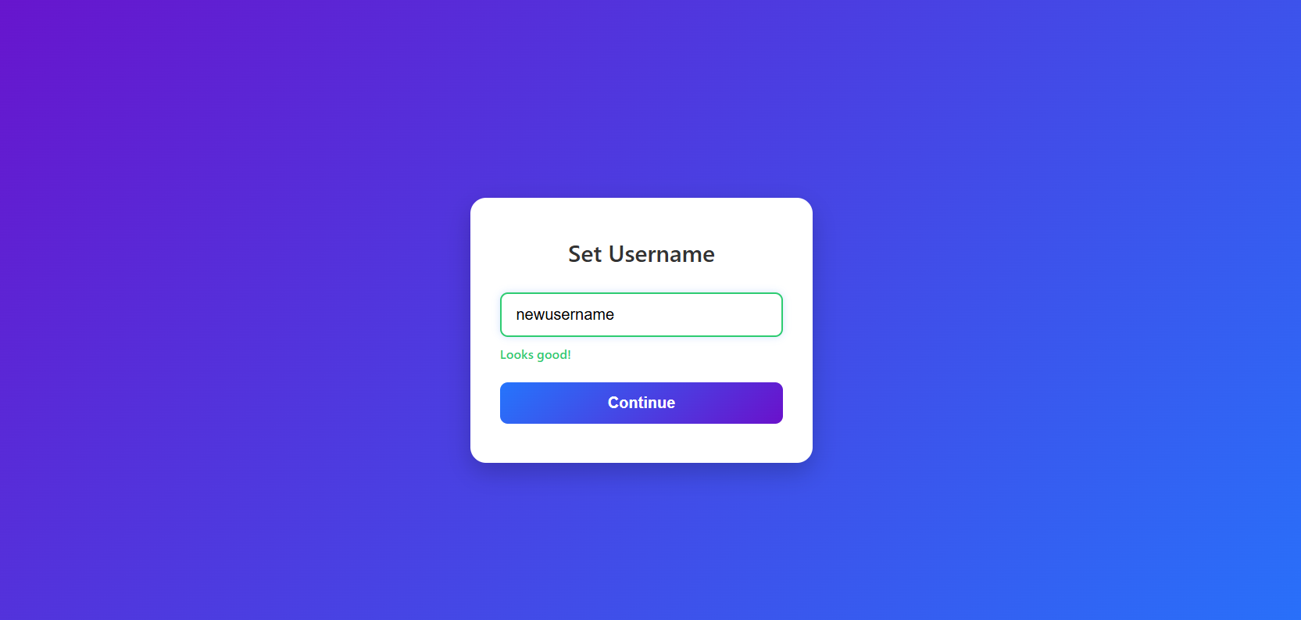
EXPLANATION:
This code provides a clean, interactive username validation interface. Here is how it functions:
- Real-time Feedback: Using the input event listener, the script monitors every keystroke in the username field.
- Validation Logic: It dynamically checks the length of the input:
  - Empty: No message is shown.
  - Less than 5 characters: It displays a warning message in red and colors the input border red.
  - 5 or more characters: It shows a success message in green and colors the input border green, indicating the input is valid.
- Visual Styling: The CSS includes hover and transition effects on the button and input field, ensuring a modern, responsive user experience.

2.AIM: A registration form should validate email format before submission. If invalid, the form should not be submitted.
CODE:
1. <!DOCTYPE html>
2. <html lang="en">
3. <head>
4. <meta charset="UTF-8">
5. <meta name="viewport" content="width=device-width, initial-scale=1.0">
6. <title>Registration Form</title>
7. <style>
8. * {
9. box-sizing: border-box;
10. margin: 0;
11. padding: 0;
12. }
13.
14. body {
15. font-family: 'Segoe UI', system-ui, sans-serif;
16. background: linear-gradient(135deg, #ff7e5f 0%, #feb47b 100%);
17. min-height: 100vh;
18. display: flex;
19. justify-content: center;
20. align-items: center;
21. }
22.
23. .form-card {
24. background: #ffffff;
25. padding: 40px;
26. border-radius: 20px;
27. box-shadow: 0 15px 30px rgba(0, 0, 0, 0.15);
28. width: 100%;
29. max-width: 400px;
30. }
31.
32. h2 {
33. text-align: center;
34. margin-bottom: 30px;
35. color: #333;
36. font-weight: 700;
37. }
38.
39. .input-group {
40. margin-bottom: 30px;
41. position: relative;
42. }
43.
44. input {
45. width: 100%;
46. padding: 15px;
47. border: 2px solid #eee;
48. border-radius: 10px;
49. font-size: 16px;
50. transition: all 0.3s ease;
51. outline: none;
52. }
53.
54. input:focus {
55. border-color: #ff7e5f;
56. box-shadow: 0 0 10px rgba(255, 126, 95, 0.1);
57. }
58.
59. input.invalid {
60. border-color: #ff4757;
61. background-color: #fff4f4;
62. }
63.
64. .error-msg {
65. color: #ff4757;
66. font-size: 13px;
67. position: absolute;
68. bottom: -22px;
69. left: 5px;
70. opacity: 0;
71. transition: opacity 0.3s;
72. pointer-events: none;
73. }
74.
75. .error-msg.visible {
76. opacity: 1;
77. }
78.
79. button {
80. width: 100%;
81. padding: 15px;
82. background: linear-gradient(135deg, #ff7e5f 0%, #feb47b 100%);
83. border: none;
84. border-radius: 10px;
85. color: white;
86. font-size: 16px;
87. font-weight: 600;
88. cursor: pointer;
89. transition: transform 0.2s, box-shadow 0.2s;
90. }
91.
92. button:hover {
93. transform: translateY(-2px);
94. box-shadow: 0 8px 20px rgba(255, 126, 95, 0.4);
95. }
96.
97. button:active {
98. transform: translateY(0);
99. }
100.
101. .success-msg {
102. display: none;
103. text-align: center;
104. color: #2ed573;
105. font-weight: 600;
106. margin-top: 20px;
107. }
108. </style>
109. </head>
110. <body>
111.
112. <div class="form-card">
113. <h2>Create Account</h2>
114. <form id="registrationForm" novalidate>
115. <div class="input-group">
116. <input type="text" id="fullName" placeholder="Full Name" required>
117. </div>
118.
119. <div class="input-group">
120. <input type="email" id="email" placeholder="Email Address" required>
121. <span class="error-msg" id="emailError">Please enter a valid email format.</span>
122. </div>
123.
124. <button type="submit">Register</button>
125. <div class="success-msg" id="successMsg">Registration Successful!</div>
126. </form>
127. </div>
128.
129. <script>
130. const form = document.getElementById('registrationForm');
131. const emailInput = document.getElementById('email');
132. const emailError = document.getElementById('emailError');
133. const successMsg = document.getElementById('successMsg');
134.
135. const emailRegex = /^[^\s@]+@[^\s@]+\.[^\s@]+$/;
136.
137. form.addEventListener('submit', function(e) {
138. e.preventDefault();
139.
140. emailInput.classList.remove('invalid');
141. emailError.classList.remove('visible');
142. successMsg.style.display = 'none';
143.
144. const emailValue = emailInput.value.trim();
145.
146. if (!emailRegex.test(emailValue)) {
147. emailInput.classList.add('invalid');
148. emailError.classList.add('visible');
149. } else {
150. successMsg.style.display = 'block';
151. // form.submit(); // Uncomment this to allow actual backend submission
152. }
153. });
154.
155. emailInput.addEventListener('input', function() {
156. emailInput.classList.remove('invalid');
157. emailError.classList.remove('visible');
158. successMsg.style.display = 'none';
159. });
160. </script>
161.
162. </body>
163. </html>
164.
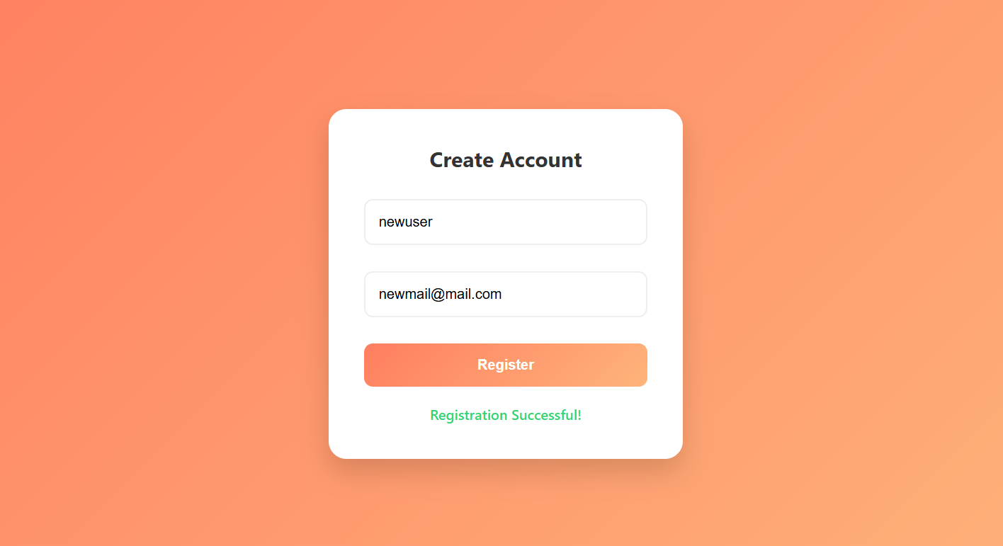
This code creates a stylish registration form featuring built-in validation for an email address. Here is how it functions:
- Modern Interface: It uses a gradient background and a shadow-styled card to create an appealing, modern look.
- Validation Logic: When you click "Register," the script prevents the page from refreshing and uses a Regular Expression (Regex) to check if the email follows a standard format (e.g., text@domain.extension).
- Dynamic Feedback: * If the email is invalid, the input border turns red and a hidden error message appears beneath it.
  - If the email is valid, a green success message is displayed.
- Reset Behavior: If you start typing in the email field again after seeing an error, the code automatically removes the error styling so you can try again.

3.AIM: 3. A system should check password strength while typing and display whether it is weak or strong.
CODE:
1. <!DOCTYPE html>
2. <html lang="en">
3. <head>
4. <meta charset="UTF-8">
5. <meta name="viewport" content="width=device-width, initial-scale=1.0">
6. <title>Password Strength Checker</title>
7. <style>
8. * {
9. box-sizing: border-box;
10. margin: 0;
11. padding: 0;
12. }
13.
14. body {
15. font-family: 'Segoe UI', Tahoma, Geneva, Verdana, sans-serif;
16. background: linear-gradient(135deg, #00c6ff 0%, #0072ff 100%);
17. height: 100vh;
18. display: flex;
19. justify-content: center;
20. align-items: center;
21. }
22.
23. .container {
24. background: #ffffff;
25. padding: 40px 30px;
26. border-radius: 16px;
27. box-shadow: 0 15px 30px rgba(0, 0, 0, 0.2);
28. width: 100%;
29. max-width: 380px;
30. text-align: center;
31. }
32.
33. h2 {
34. color: #2c3e50;
35. margin-bottom: 25px;
36. font-weight: 600;
37. }
38.
39. .input-box {
40. position: relative;
41. margin-bottom: 25px;
42. text-align: left;
43. }
44.
45. input {
46. width: 100%;
47. padding: 14px;
48. border: 2px solid #e0e0e0;
49. border-radius: 8px;
50. font-size: 16px;
51. outline: none;
52. transition: all 0.3s ease;
53. }
54.
55. input:focus {
56. box-shadow: 0 0 8px rgba(0, 114, 255, 0.2);
57. }
58.
59. .strength-bar {
60. height: 4px;
61. width: 0%;
62. background-color: transparent;
63. border-radius: 2px;
64. margin-top: 6px;
65. transition: width 0.4s ease, background-color 0.4s ease;
66. }
67.
68. .strength-text {
69. display: block;
70. margin-top: 8px;
71. font-size: 13px;
72. font-weight: 600;
73. min-height: 18px;
74. transition: color 0.3s ease;
75. }
76.
77. button {
78. width: 100%;
79. padding: 14px;
80. background: linear-gradient(135deg, #0072ff 0%, #00c6ff 100%);
81. color: #fff;
82. border: none;
83. border-radius: 8px;
84. font-size: 16px;
85. font-weight: bold;
86. cursor: pointer;
87. transition: transform 0.2s ease, box-shadow 0.2s ease;
88. }
89.
90. button:hover {
91. transform: translateY(-2px);
92. box-shadow: 0 8px 20px rgba(0, 114, 255, 0.4);
93. }
94.
95. button:active {
96. transform: translateY(0);
97. }
98. </style>
99. </head>
100. <body>
101.
102. <div class="container">
103. <h2>Secure Password</h2>
104.
105. <div class="input-box">
106. <input type="password" id="passwordInput" placeholder="Enter password...">
107. <div class="strength-bar" id="strengthBar"></div>
108. <span id="strengthMessage" class="strength-text"></span>
109. </div>
110.
111. <button>Save Password</button>
112. </div>
113.
114. <script>
115. const passwordInput = document.getElementById('passwordInput');
116. const strengthMessage = document.getElementById('strengthMessage');
117. const strengthBar = document.getElementById('strengthBar');
118.
119. passwordInput.addEventListener('input', () => {
120. const val = passwordInput.value;
121.
122. if (val.length === 0) {
123. strengthMessage.textContent = '';
124. strengthBar.style.width = '0%';
125. passwordInput.style.borderColor = '#e0e0e0';
126. return;
127. }
128.
129. const hasMinLength = val.length >= 8;
130. const hasUpper = /[A-Z]/.test(val);
131. const hasLower = /[a-z]/.test(val);
132. const hasNumber = /\d/.test(val);
133.
134. if (hasMinLength && hasUpper && hasLower && hasNumber) {
135. strengthMessage.textContent = 'Strong';
136. strengthMessage.style.color = '#2ecc71';
137. strengthBar.style.width = '100%';
138. strengthBar.style.backgroundColor = '#2ecc71';
139. passwordInput.style.borderColor = '#2ecc71';
140. } else if (val.length >= 5) {
141. strengthMessage.textContent = 'Medium';
142. strengthMessage.style.color = '#f39c12';
143. strengthBar.style.width = '50%';
144. strengthBar.style.backgroundColor = '#f39c12';
145. passwordInput.style.borderColor = '#f39c12';
146. } else {
147. strengthMessage.textContent = 'Weak';
148. strengthMessage.style.color = '#e74c3c';
149. strengthBar.style.width = '25%';
150. strengthBar.style.backgroundColor = '#e74c3c';
151. passwordInput.style.borderColor = '#e74c3c';
152. }
153. });
154. </script>
155.
156. </body>
157. </html>
158.

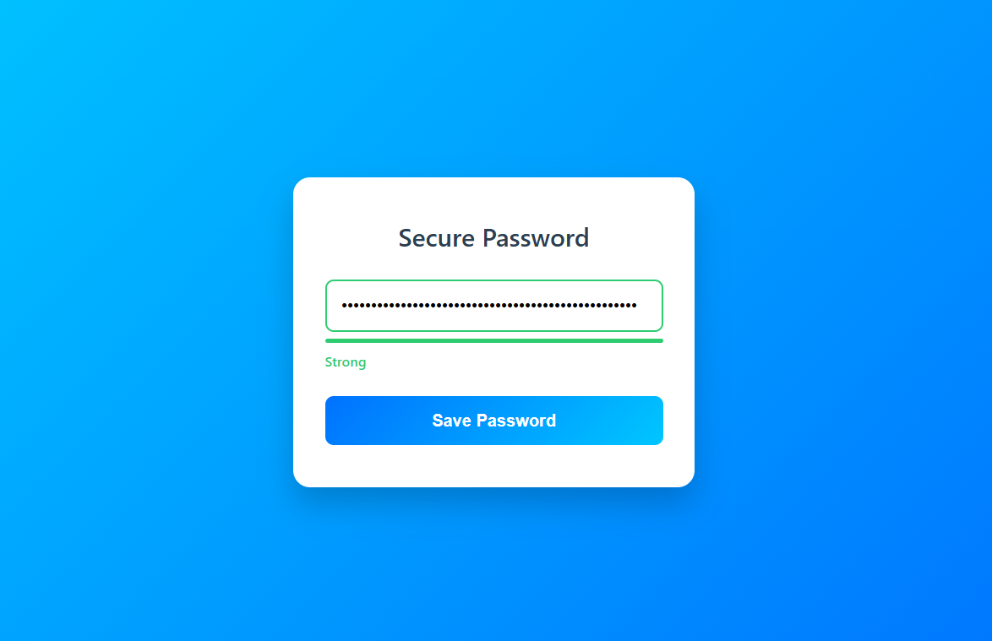
This code creates an interactive password strength checker that updates in real-time as you type.
- Real-time Analysis: The script listens for every keystroke and evaluates the input against specific security criteria, including minimum length (8 characters), presence of uppercase and lowercase letters, and a number.
- Visual Feedback:
  - Weak (Red): Displayed for short passwords.
  - Medium (Orange): Displayed for passwords with at least 5 characters.
  - Strong (Green): Displayed when the password meets all security requirements.
- Dynamic UI: The password input border color, the width and color of the strength indicator bar, and the status text all update automatically to provide immediate guidance to the user.
4.AIM: A form should validate a mobile number when the user leaves the input field. The number must be exactly 10 digits.

CODE:
1. <!DOCTYPE html>
2. <html lang="en">
3. <head>
4. <meta charset="UTF-8">
5. <meta name="viewport" content="width=device-width, initial-scale=1.0">
6. <title>Mobile Number Validation</title>
7. <style>
8. * {
9. box-sizing: border-box;
10. margin: 0;
11. padding: 0;
12. }
13.
14. body {
15. font-family: 'Segoe UI', Roboto, Helvetica, Arial, sans-serif;
16. /* Stylish indigo to purple gradient */
17. background: linear-gradient(135deg, #667eea 0%, #764ba2 100%);
18. height: 100vh;
19. display: flex;
20. justify-content: center;
21. align-items: center;
22. }
23.
24. .form-card {
25. background-color: #ffffff;
26. padding: 40px 35px;
27. border-radius: 16px;
28. box-shadow: 0 15px 35px rgba(0, 0, 0, 0.2);
29. width: 100%;
30. max-width: 380px;
31. text-align: center;
32. }
33.
34. h2 {
35. color: #333;
36. margin-bottom: 25px;
37. font-weight: 700;
38. }
39.
40. .input-group {
41. position: relative;
42. margin-bottom: 25px;
43. text-align: left;
44. }
45.
46. input {
47. width: 100%;
48. padding: 14px 16px;
49. font-size: 16px;
50. border: 2px solid #e2e8f0;
51. border-radius: 10px;
52. outline: none;
53. transition: all 0.3s ease;
54. background-color: #f8fafc;
55. }
56.
57. /* Focus state before validation */
58. input:focus {
59. background-color: #ffffff;
60. border-color: #667eea;
61. box-shadow: 0 0 10px rgba(102, 126, 234, 0.2);
62. }
63.
64. input.is-valid {
65. border-color: #10b981;
66. background-color: #f0fdf4;
67. }
68.
69. input.is-invalid {
70. border-color: #ef4444;
71. background-color: #fef2f2;
72. }
73.
74. .feedback-msg {
75. position: absolute;
76. bottom: -20px;
77. left: 5px;
78. font-size: 13px;
79. font-weight: 500;
80. opacity: 0;
81. transition: opacity 0.3s ease;
82. }
83.
84. .feedback-msg.show {
85. opacity: 1;
86. }
87.
88. .submit-btn {
89. width: 100%;
90. padding: 14px;
91. background: linear-gradient(135deg, #764ba2 0%, #667eea 100%);
92. color: white;
93. border: none;
94. border-radius: 10px;
95. font-size: 16px;
96. font-weight: 600;
97. cursor: pointer;
98. transition: transform 0.2s ease, box-shadow 0.2s ease;
99. }
100.
101. .submit-btn:hover {
102. transform: translateY(-2px);
103. box-shadow: 0 8px 20px rgba(118, 75, 162, 0.4);
104. }
105.
106. .submit-btn:active {
107. transform: translateY(0);
108. }
109. </style>
110. </head>
111. <body>
112.
113. <div class="form-card">
114. <h2>Contact Details</h2>
115.
116. <div class="input-group">
117. <input type="tel" id="mobileInput" placeholder="Enter 10-digit mobile number" autocomplete="off">
118. <span id="feedbackMessage" class="feedback-msg"></span>
119. </div>
120.
121. <button class="submit-btn">Verify Number</button>
122. </div>
123.
124. <script>
125. const mobileInput = document.getElementById('mobileInput');
126. const feedbackMessage = document.getElementById('feedbackMessage');
127. const tenDigitRegex = /^\d{10}$/;
128.
129. mobileInput.addEventListener('blur', function() {
130. const value = mobileInput.value.trim();
131.
132. mobileInput.classList.remove('is-valid', 'is-invalid');
133. feedbackMessage.classList.remove('show');
134.
135. if (value === '') return;
136.
137. if (tenDigitRegex.test(value)) {
138. mobileInput.classList.add('is-valid');
139. feedbackMessage.textContent = 'Valid mobile number.';
140. feedbackMessage.style.color = '#10b981';
141. feedbackMessage.classList.add('show');
142. } else {
143. // Error state
144. mobileInput.classList.add('is-invalid');
145. feedbackMessage.textContent = 'Please enter exactly 10 digits.';
146. feedbackMessage.style.color = '#ef4444';
147. feedbackMessage.classList.add('show');
148. }
149. });
150. mobileInput.addEventListener('focus', function() {
151. mobileInput.classList.remove('is-valid', 'is-invalid');
152. feedbackMessage.classList.remove('show');
153. });
154. </script>
155.
156. </body>
157. </html>
158.

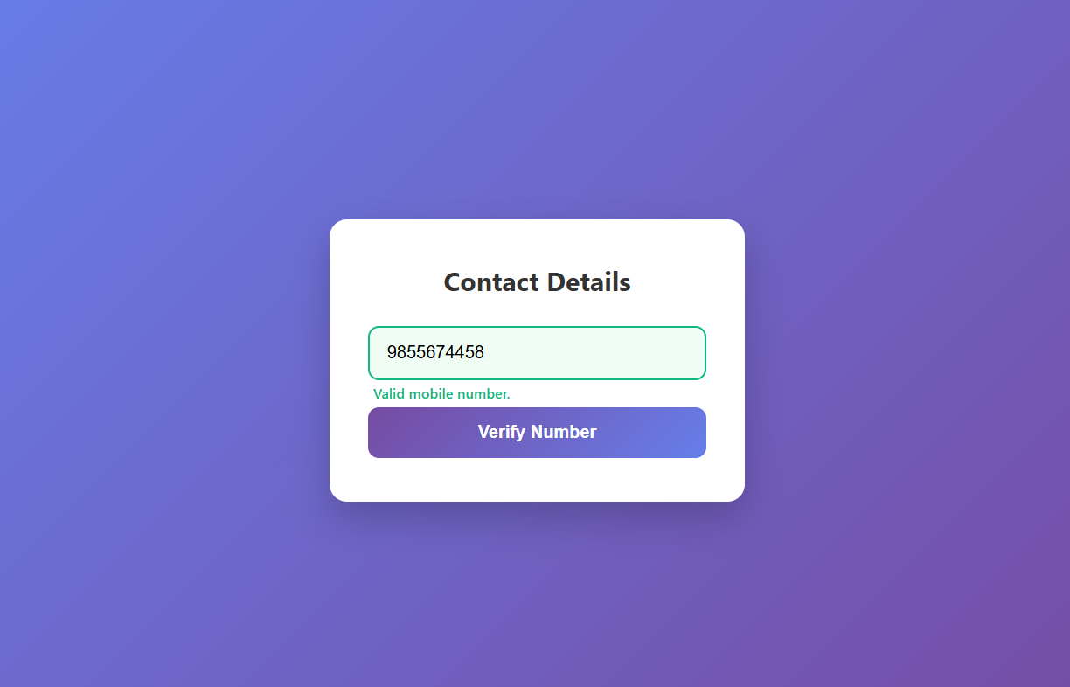

This code implements a polished interface for mobile number validation. Here is how it functions:
- Focus-Based Validation: Unlike real-time validation, this script uses the blur event, meaning the validation triggers only after you finish typing and click outside the input box.
- Regex Pattern Matching: It uses a Regular Expression (/^\d{10}$/) to ensure the input contains exactly ten digits and nothing else.
- Visual States:
  - Valid: If the input meets the criteria, the border turns green and a confirmation message appears.
  - Invalid: If the input is too short, too long, or contains non-numeric characters, the border turns red and an error message appears.
- UX Features: The styling includes smooth transitions, hover effects on the button, and a focus event that clears previous error messages to ensure a clean experience when correcting a mistake.

5.AIM: 5. Design an HTML page, such that the registration form must validate:
Name (not empty)
Email (valid format)
Password (minimum 6 characters)

1. <!DOCTYPE html>
2. <html lang="en">
3. <head>
4. <meta charset="UTF-8">
5. <meta name="viewport" content="width=device-width, initial-scale=1.0">
6. <title>Complete Registration Form</title>
7. <style>
8. * {
9. box-sizing: border-box;
10. margin: 0;
11. padding: 0;
12. }
13.
14. body {
15. font-family: 'Segoe UI', Roboto, Helvetica, Arial, sans-serif;
16. background: linear-gradient(135deg, #f093fb 0%, #f5576c 100%);
17. min-height: 100vh;
18. display: flex;
19. justify-content: center;
20. align-items: center;
21. padding: 20px;
22. }
23.
24. .form-card {
25. background-color: #ffffff;
26. padding: 40px 35px;
27. border-radius: 16px;
28. box-shadow: 0 15px 35px rgba(0, 0, 0, 0.2);
29. width: 100%;
30. max-width: 400px;
31. }
32.
33. h2 {
34. color: #333;
35. text-align: center;
36. margin-bottom: 30px;
37. font-weight: 700;
38. font-size: 24px;
39. }
40.
41. .input-group {
42. position: relative;
43. margin-bottom: 28px;
44. }
45.
46. input {
47. width: 100%;
48. padding: 14px 16px;
49. font-size: 15px;
50. border: 2px solid #e2e8f0;
51. border-radius: 10px;
52. outline: none;
53. transition: all 0.3s ease;
54. background-color: #f8fafc;
55. }
56.
57. input:focus {
58. background-color: #ffffff;
59. border-color: #f5576c;
60. box-shadow: 0 0 10px rgba(245, 87, 108, 0.15);
61. }
62.
63. /* Validation Colors */
64. input.error-border {
65. border-color: #ef4444;
66. background-color: #fef2f2;
67. }
68.
69. input.success-border {
70. border-color: #10b981;
71. }
72.
73. .error-msg {
74. color: #ef4444;
75. font-size: 12px;
76. font-weight: 500;
77. position: absolute;
78. bottom: -20px;
79. left: 5px;
80. display: none;
81. }
82.
83. .submit-btn {
84. width: 100%;
85. padding: 15px;
86. background: linear-gradient(135deg, #f5576c 0%, #f093fb 100%);
87. color: white;
88. border: none;
89. border-radius: 10px;
90. font-size: 16px;
91. font-weight: 600;
92. cursor: pointer;
93. margin-top: 10px;
94. transition: transform 0.2s ease, box-shadow 0.2s ease;
95. }
96.
97. .submit-btn:hover {
98. transform: translateY(-2px);
99. box-shadow: 0 8px 20px rgba(245, 87, 108, 0.4);
100. }
101.
102. .submit-btn:active {
103. transform: translateY(0);
104. }
105.
106. .success-banner {
107. display: none;
108. background-color: #10b981;
109. color: white;
110. text-align: center;
111. padding: 12px;
112. border-radius: 8px;
113. margin-bottom: 25px;
114. font-weight: 600;
115. }
116. </style>
117. </head>
118. <body>
119.
120. <div class="form-card">
121. <div class="success-banner" id="successBanner">Registration Successful!</div>
122. <h2>Create Account</h2>
123.
124. <form id="registerForm" novalidate>
125. <div class="input-group">
126. <input type="text" id="nameInput" placeholder="Full Name">
127. <span class="error-msg" id="nameError">Name cannot be empty</span>
128. </div>
129.
130. <div class="input-group">
131. <input type="email" id="emailInput" placeholder="Email Address">
132. <span class="error-msg" id="emailError">Please enter a valid email</span>
133. </div>
134.
135. <div class="input-group">
136. <input type="password" id="passwordInput" placeholder="Password (Min 6 characters)">
137. <span class="error-msg" id="passError">Password must be at least 6 characters</span>
138. </div>
139.
140. <button type="submit" class="submit-btn">Register</button>
141. </form>
142. </div>
143.
144. <script>
145. const form = document.getElementById('registerForm');
146. const successBanner = document.getElementById('successBanner');
147.
148.
149. const emailRegex = /^[^\s@]+@[^\s@]+\.[^\s@]+$/;
150.
151.
152. function setStatus(inputElement, errorElement, isError) {
153. if (isError) {
154. inputElement.classList.add('error-border');
155. inputElement.classList.remove('success-border');
156. errorElement.style.display = 'block';
157. } else {
158. inputElement.classList.remove('error-border');
159. inputElement.classList.add('success-border');
160. errorElement.style.display = 'none';
161. }
162. }
163.
164. form.addEventListener('submit', function(e) {
165. e.preventDefault();
166.
167. const nameVal = document.getElementById('nameInput').value.trim();
168. const emailVal = document.getElementById('emailInput').value.trim();
169. const passVal = document.getElementById('passwordInput').value.trim();
170.
171. let isValid = true;
172.
173. if (nameVal === '') {
174. setStatus(document.getElementById('nameInput'), document.getElementById('nameError'), true);
175. isValid = false;
176. } else {
177. setStatus(document.getElementById('nameInput'), document.getElementById('nameError'), false);
178. }
179.
180.
181. if (!emailRegex.test(emailVal)) {
182. setStatus(document.getElementById('emailInput'), document.getElementById('emailError'), true);
183. isValid = false;
184. } else {
185. setStatus(document.getElementById('emailInput'), document.getElementById('emailError'), false);
186. }
187.
188. if (passVal.length < 6) {
189. setStatus(document.getElementById('passwordInput'), document.getElementById('passError'), true);
190. isValid = false;
191. } else {
192. setStatus(document.getElementById('passwordInput'), document.getElementById('passError'), false);
193. }
194.
195. if (isValid) {
196. successBanner.style.display = 'block';
197. form.reset();
198.
199. document.querySelectorAll('input').forEach(input => {
200. input.classList.remove('success-border');
201. });
202.
203. setTimeout(() => {
204. successBanner.style.display = 'none';
205. }, 3000);
206. } else {
207. successBanner.style.display = 'none';
208. }
209. });
210. document.querySelectorAll('input').forEach(input => {
211. input.addEventListener('input', function() {
212. this.classList.remove('error-border');
213. this.nextElementSibling.style.display = 'none';
214. });
215. });
216. </script>
217.
218. </body>
219. </html>
220.

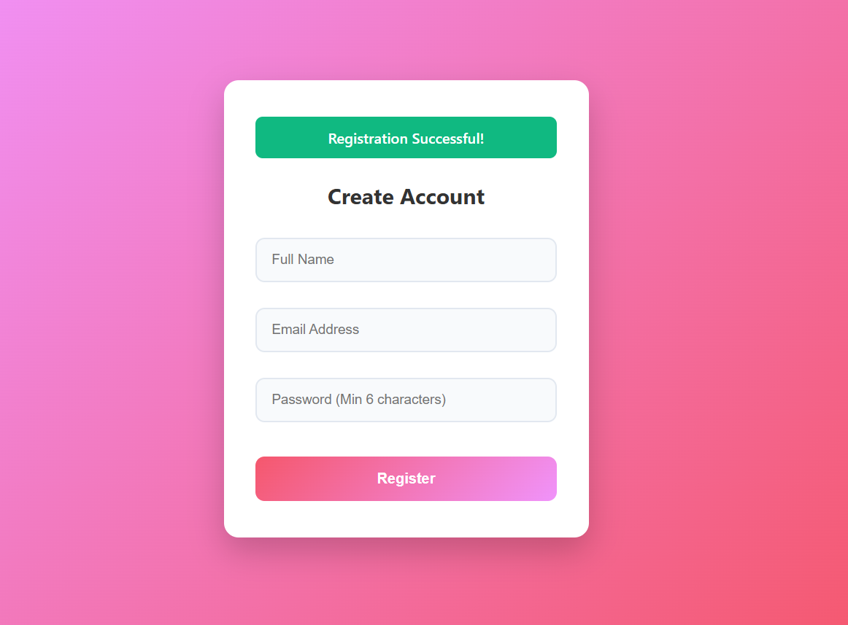
This code provides a comprehensive registration form that demonstrates professional client-side validation techniques.
- Form Submission Handling: It intercepts the submit event to perform manual validation on the name, email, and password fields before allowing the action to proceed.
- Dynamic Validation Logic:
  - Name: Checks for non-empty input.
  - Email: Uses a Regular Expression (Regex) to ensure the email structure is valid.
  - Password: Validates that the password length is at least six characters.
- State Management: The setStatus function standardizes how error and success states are applied, dynamically changing input borders and toggling the visibility of error messages.
- User Experience: Includes features like automatic clearing of error styles upon input, a temporary success banner upon valid submission, and a reset function to clear the form fields afterwards.

WEEK-12

Aim: To install and setup the Electron Framework application.

Procedure:
Step 1: Go to the web browser and download node.js.
Step 2: After installing the Node.js, complete the setup process.
Step 3: After installing node.js, Open the command prompt and navigate to the folder where your project is located.
Step 4: And give the prompt “node –v” and also "npm –v".
Step 5: If you get the versions then it is successfully installed.

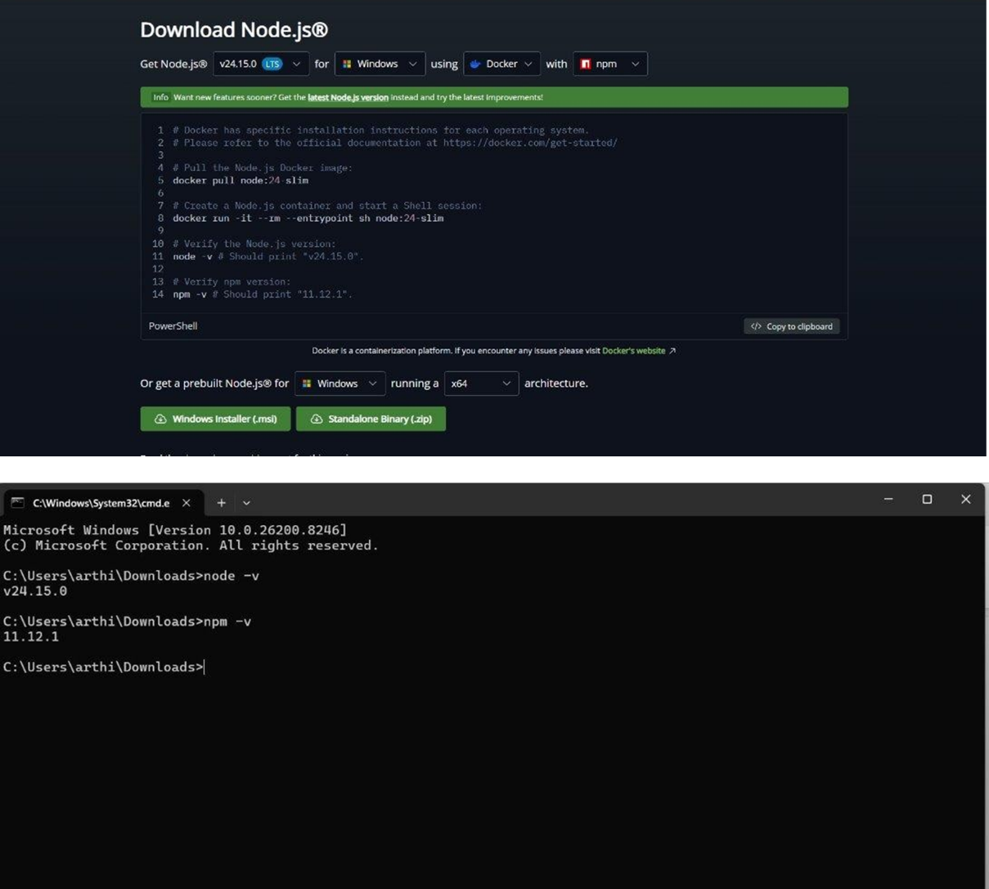

Step 6: Now open PowerShell as Administrator and give the prompt "Set-ExecutionPolicy RemoteSigned". 138
• This command allows local PowerShell scripts to run securely.
• And press Y.

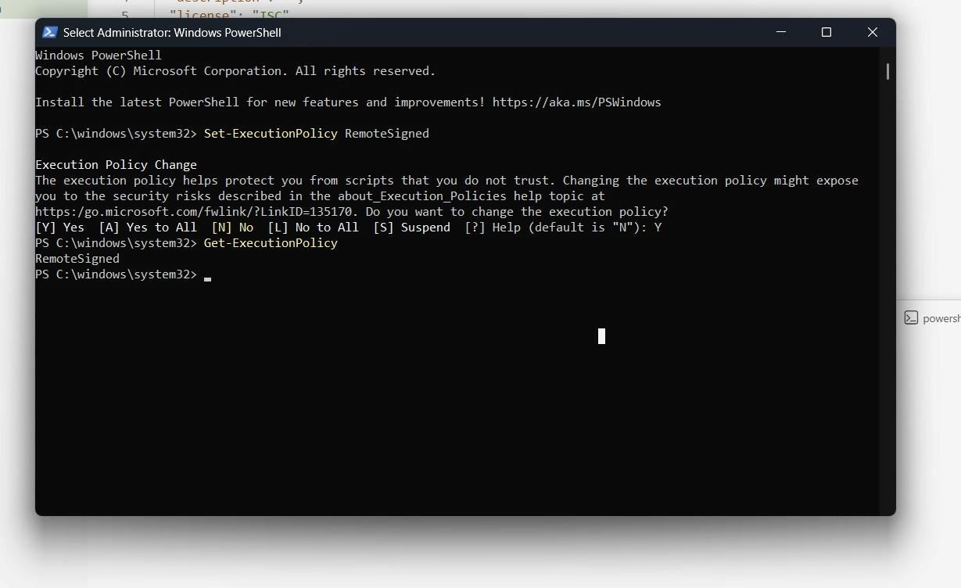
Create Project Folder :
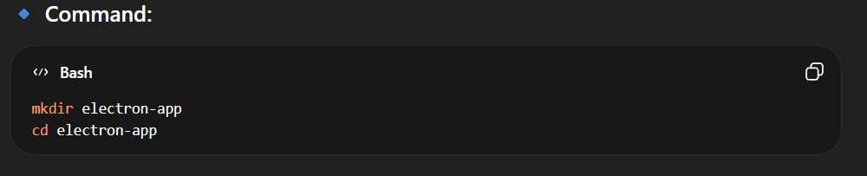
Step 7: Create a new folder for the Electron project using mkdir.
Step 8: Move into the project folder using cd.
- This helps keep all project files organized.
Step 9:
Initialize Node Project:
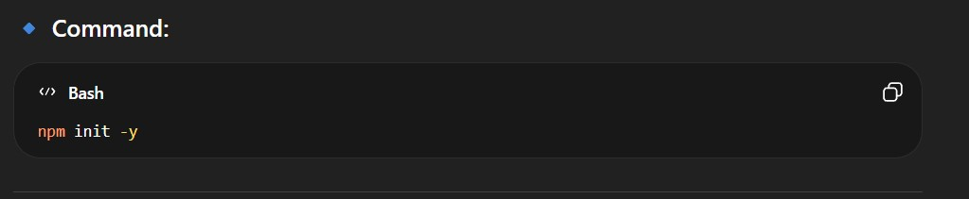
- The above command creates the package.json file.
- This file stores:
1. Project name
2. Version
- Main entry file
- Scripts
- Dependencies
- Without package.json file, npm cannot manage project properly.
Step 10:
Install Electron:
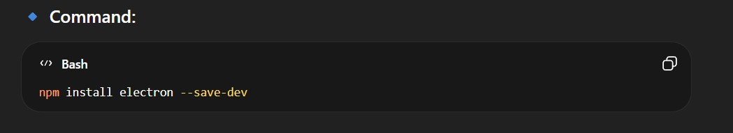
- Downloads Electron package
- Saves it in node_modules
- Adds it to devDependencies
- --save-dev→Because Electron is needed during development.
Step 11:
Configure package.json:
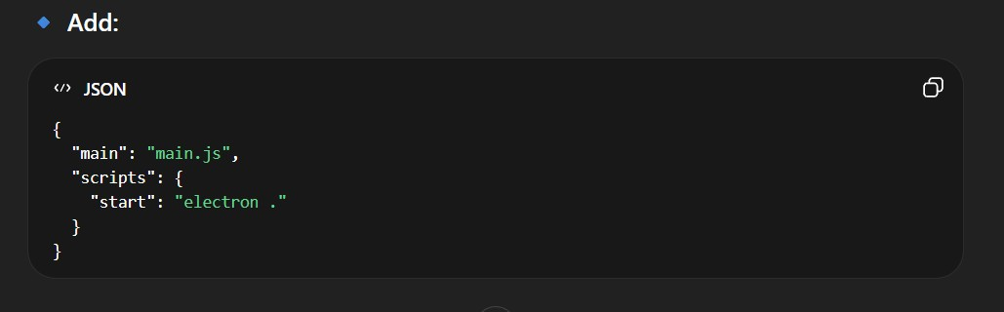
Main→Tells Electron which file starts the application.
Start→Defines command used when we run:
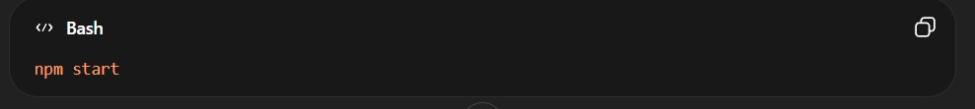
Electron → This command runs Electron in the current project folder.
Create Main Application Files:
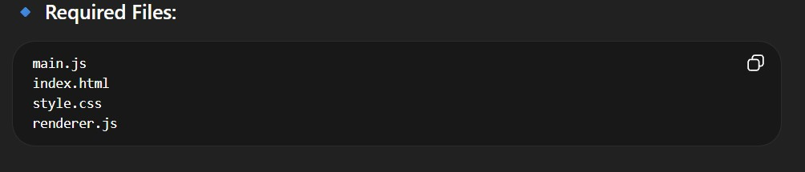
Step 12: main.js→Controls app lifecycle and creates windows
Step 13: index.html→User interface
Step 14: style.css→Design and layout
Step 15: renderer.js→Handles user interaction
Write main.js
- Imports Electron modules
- Creates application window
- Loads UI
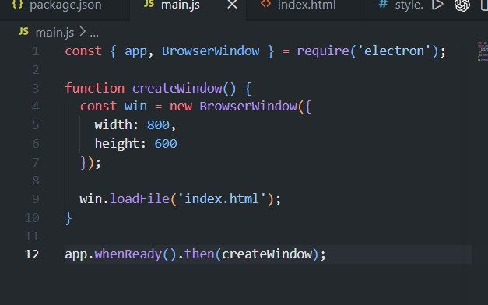
Run Application:
